1
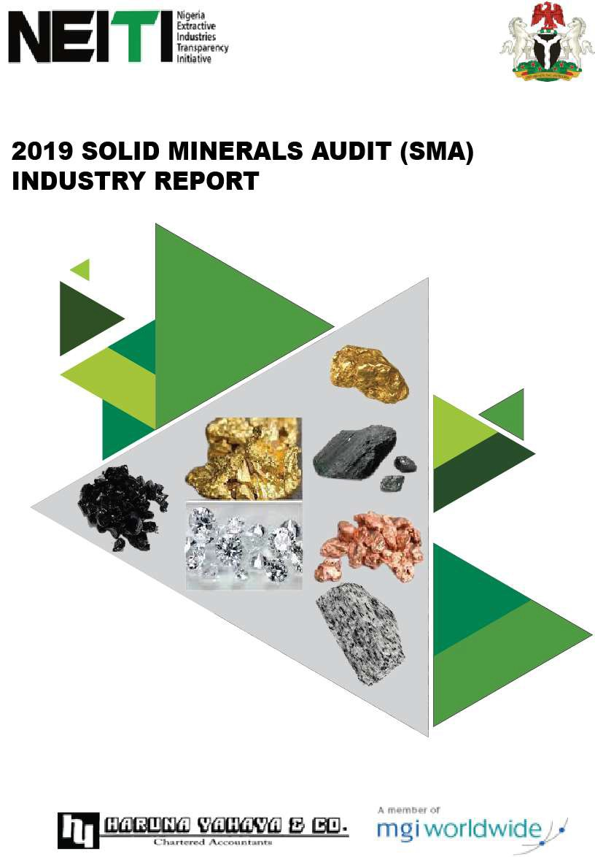

2

THIS REPORT

This report is prepared by Haruna Yahaya & Co in accordance with the procedures agreed with NEITI and in compliance with the 2019 EITI Standard for implementing countries. This report contains a reconciliation of payments made by extractive companies for the 2019 fiscal year.



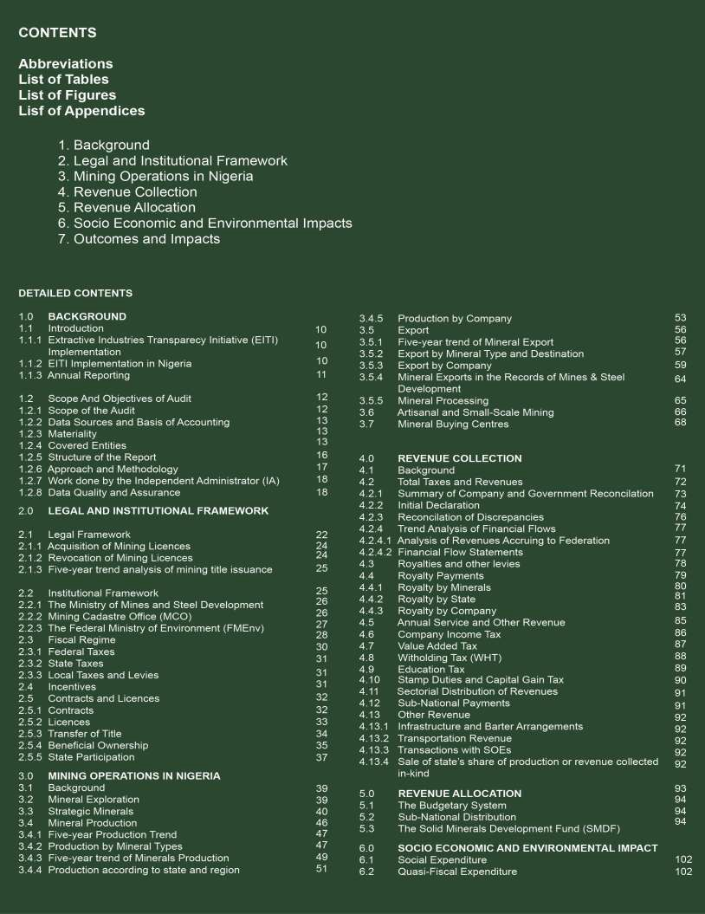

3

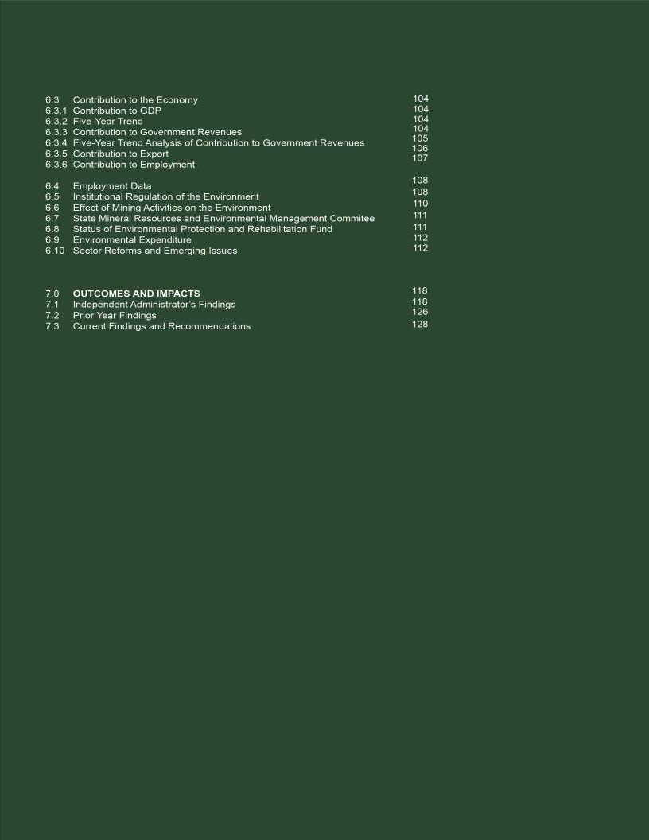

4

LIST OF ABBREVIATIONS

AFS Audited Financial Statements
ANFO Ammonia Fuel Oil
ASM Artisanal and Small-Scale Mining
BME Budget Monitoring and Evaluation
BO Beneficial Ownership
CAC Corporate Affairs Commission
CAMA The Company and Allied Matters Act 2020 (as amended)
CBN Central Bank of Nigeria
CCNN Cement Company of Northern Nigeria
CDA Community Development Agreement
CIT Company Income Tax
CITA Company Income Tax Act, 2007
EDT Education Tax
EIA Environmental Impact Assessment Act 2004
EITI Extractive Industries Transparency Initiative
EL Exploratory License
EPRH Environmental Protection and Rehabilitation Fund
FCT Federal Capital Territory
FIRS Federal Inland Revenue Service
FMEnv Federal Ministry of Environment
FMFNP Federal Ministry of Finance and National Planning
FoB Free On Board
IA Independent Administrator
IFRS International Financial Reporting Standards IPSAS International Public Sector Accounting Standards ISRS International Standards on Related services
LGA Local Government Area
MCO Mining Cadastre Office
MDAs Ministries, Departments and Agencies
MECD Mines Environmental Compliance Department
MID Mines Inspectorate Department
MIREMCO Mineral Resources and Environmental Management Committee
ML Mining Lease
MMSD Ministry of Mines and Steel Development
Mt Metric Ton
MoU Memorandum of Understanding
MTEF Medium Term Expenditure Framework
MSG Multi Stakeholder Group
NCS Nigeria Customs Service
NEITI Nigeria Extractive Industries Transparency Initiative
NGSA Nigeria Geological Survey Agency
NIPC Nigeria Investment Promotion Commission Act 2004
NMMA 2007 Nigerian Minerals and Mining Act 2007
NSWG National Stakeholders Working Group
PAGMI Presidential Artisanal Gold Mining Development Initiative
PAYE Pay As You Earn
PITA Personal Income Tax Act
PPP Public Private Partnership
QL Quarry Lease
RMAFC Revenue Mobilization Allocation and Fiscal Commission
RP Reconnaissance Permit
SBIR State Board of Internal Revenue
SG Specific Gravity
SMA Solid Minerals Industry Audit
SMDF Solid Minerals Development Fund
SOEs State-owned Enterprises
SSML Small Scale Mining Lease
ToR Term of Reference
VAT Value Added Tax
WHT Withholding Tax

LIST OF TABLES

TABLE |  | Page
1 | 13 - year trend of sector contribution | 11
2 | List of Companies | 14
3 | List of Government Entities | 16
4 | Data quality compliance Indicators | 19
5 | Schedule of Non-Responsive Companies | 19
6 | Laws and Regulations guiding operations in  Nigeria’s Solid Minerals sector | 22
7 | Titles issued by MCO in the past 5 years | 25
8 | Mineral Titles issued in 2019 | 27
9 | Institutions Regulating operations in Nigeria’s  Solid Minerals sector | 27
10 | Federal Tax Legislation | 30
11 | Total Mineral Titles issued by MCO in 2019 | 33
12 | Transferred Titles In 2019 | 34
13 | Exploration Licenses issued in 2019 | 40
14 | Valid Strategic Minerals Titles as at 2019 | 40
15 | State distribution of Gold mined in 2019 | 43
16 | Five-year Production Trend | 47
17 | Production Quantity by Mineral | 48
18 | Five-year Trend of Mineral Production | 49
19 | Analysis of Production Mineral by State | 51
20 | Summary of Minerals Produced by Companies | 53
21 | Five-year Trend of Mineral Export | 56
22 | Export by Mineral Type and Destination | 57
23 | Export of Mineral by Companies | 59
24 | Liabilities of Exported Minerals by Companies | 62
25 | Comparative Analysis of Exported Minerals | 64
26 | State Distribution of ASM Operators | 67
27 | Geo-Political Distribution of PMBC across Nigeria | 68
28 | Aggregate Financial Flows | 72
29 | Initial Declaration Data | 74
30 | Reconciliation of Discrepancies | 76
31 | Five-year trend analysis | 77

TABLE Page
32 | Five-year trend Financial Flows Statement 77
33 | Breakdown of Revenue to MMSD 79
34 | Five-year trend of Royalty payments 79
35 | Royalty by Mineral 80
36 | Royalty by States 82
37 | Company distribution of Royalty 83
38 | Total Revenue Received by MCO in 2019 85
39 | Five - year financial flow of CIT 87
40 | Five - year flow of VAT 87
41 | Five - year flow of WHT 88
42 | Five - year flow of EDT 89
43 | Other Taxes Paid 90
44 | Sectorial Distribution of Revenue 91
45 | Sub-National Payments 91
46 | Revenue Sharing Formulae 96
47 | Distribution of Derivation-based Transfers 96
48 | Reconciliation of Revenue Distribution 97  Account
49 | Solid Minerals Revenue Distribution 97
50 | State and LGA Distribution of Solid Minerals 98  Revenue
51 | Social Expenditure 102
52 | Contribution of Solid Minerals to the 104  Economy
53 | Five-Year Trend 104
54 | Solid Mineral Revenue Contribution to 105  Government Revenue
55 | Five-year trend analysis of Contribution to 105  Government Revenue
56 | Five-year trend analysis of solid mineral 106  Contribution to Government Revenue
57 | Employment and Gender 107
58 | Environmental Expenditure 112
59 | Summary of on-going projects in the sector 115
60 | Status or Prior Years’ Audit 118  Recommendations
61 | 126  Findings and Recommendations from the 2019 Audit

LIST OF FIGURES

FIGURE |  | Page
1 | EITI Implementation in Nigeria | 11
2 | 13-year Trend of SM Sector Contribution | 12
3 | Structure of the Report | 16
4 | Audit Approach and Methodology | 18
5 | Data Quality Compliance Indicators | 19
6 | Royalties paid by Non-Responsive Companies | 20
7 | Process of Acquisition of Title by Application | 25
8 | Process of Acquisition of Title by Competitive Bidding | 25
9 | Structure of Government Agencies | 26
10 | Government Revenue Streams | 29
11 | Beneficial Ownership Response | 36
12 | Mineral Deposits in Nigeria | 41
13 | Five-Year Production Trend | 47
14 | Production by Mineral Type | 47
15 | Production by Mineral Type | 49
16 | Production of Minerals by State | 51
17 | Five- Year Trend of Mineral Exports | 57
18 | Export by Mineral Type | 59
19 | The Geo-Political Distribution of PMBC across Nigeria | 69

FIGURE Page
20 | Revenue Streams Validated and Reconciled | 71
21 | Aggregate Financial Flows | 73
22 | Summary of Company and Government Reconciliation | 74
23 | Five years’ trend of Revenue to Federation | 77
24 | Five- years trend of Royalty Revenue 80
25 | Royalty by Mineral 81
26 | State Distribution of Royalty 83
27 | Company Distribution of Royalty 85
28 | Five - year financial flow of CIT  87
29 | Five- years flow of VAT  88
30 | Five- year flow of WHT  89
31 | Five- year flow of EDT 90
32 | Budget Process 95
33 | Solid Minerals Revenue Distribution 97
34 | Five-year trend of solid mineral 106  contribution to export
35 | Employment and Gender  108
36 | Environmental, Legal, Regulatory an Institutional Framework | d  108
37 | Mining Sector Roadmap | 113

LIST OF APPENDICES

Appendix 1 Terms of Reference
Appendix 2 Materiality Documents
Appendix 3 Projection Level Report
Appendix 4 Company Level Report
Appendix 5 MCO Register
Appendix 6 Minerals Buying Centre
Appendix 7 Transfer Fee Payment
Appendix 8 Production Data
Appendix 9 Export data
Appendix 10 Royalty Payment Data
Appendix 11 Social Expenditure Payment
Appendix 12 Exporters that Defaulted in Royalty Payment
Appendix 13 Pictorial Report of Environment Degradation
Appendix 14 Schedule of Reclaimed Abandoned Mine Sites in Nigeria
Appendix 15 List of Companies that Paid Royalty on Gold
Appendix 16 Beneficial Ownership Report
Appendix 17 List of Artisan Small-scale Miners Operators



9

1
BACKGROUND

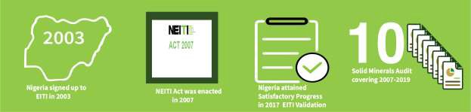

Introduction

This report sets out the results of reconciliation of the financial flow from activities in the solid minerals sector in Nigeria for the 2019 fiscal year. The report was commissioned as part of the implementation of the NEITI Act 2007 and the EITI Standard 2019.

EITI Implementation

The EITI is a global body committed to promoting high standard of transparency and accountability in the use of a country’s wealth from natural resources for the benefit of its citizens. Nigeria voluntarily signed up to EITI in 2003 to promote prudent management of revenues from its abundant natural resources, reduce poverty and ensure sustainable development. For more information on EITI, please visit: https://eiti.org/who-we-are

EITI Implementation in Nigeria

Nigeria Extractive Industries Transparency Initiative (NEITI) is responsible for implementing the EITI Standard in Nigeria. Nigeria signed up to the EITI in 2003 and the implementation began on February 2004. The Act establishing NEITI was enacted in 2007 with powers to enforce the implementation of the EITI Standard in the extractive sector in Nigeria. The NSWG is the governing body of NEITI, and consists of 15 members representing government, civil society, and the extractive Companies in Nigeria. It has the prime duty of formulating policies, programs and strategies for effective implementation of the NEITI Act in compliance with global best practices and the EITI Standard (visit: https://neiti.gov.ng for more information).

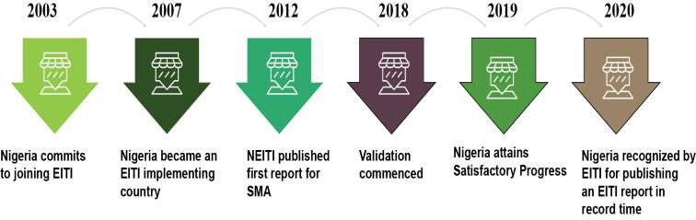

Fig 1: EITI Implementation in Nigeria

Annual Reporting

The 2019 SMA report is the tenth (10th) SMA report to be published since NEITI signed up to the EITI in 2003. The sector has contributed a total of N496.28 billion in the last 13 years as shown in Table 1.

Table 1: 13-year trend of sector contribution

S/N Reporting Number of Government Year Reporting Receipts  Companies |  |  |  |  | CBN  Exchange rate @ 31st | Government Receipts | Publication Dates
 | ₦’billion |  |  |  |  | US$’ million
1 | 2007 | 78 |  | 7.59 | 116.3 | 65.26 | 12-Dec
2 | 2008 | 78 |  | 10.57 | 130.75 | 80.82 | 12-Dec
3 | 2009 | 78 |  | 19.15 | 147.6 | 129.73 | 12-Dec
4 | 2010 | 78 |  | 17.10 | 148.67 | 115.00 | 12-Dec
5 | 2011 | 67 |  | 27.01 | 156.2 | 172.91 | 13-Jan
6 | 2012 | 65 |  | 25.57 | 155.27 | 164.67 | 15-Dec
7 | 2013 | 65 |  | 30.25 | 155.2 | 194.93 | 16-Mar
8 | 2014 | 39 |  | 49.17 | 167.5 | 293.57 | 16-Dec
9 | 2015 | 42 |  | 64.46 | 196.5 | 328.06 | 17-Jul
10 | 2016 | 56 |  | 43.22 | 304.5 | 141.94 | 18-Nov
11 | 2017 | 59 |  | 52.76 | 305.5 | 172.69 | 19-Oct
12 | 2018 | 69 |  | 69.47 | 306.5 | 226.66 | 20-Mar
13 | 2019 | 74 |  | 79.96 | 306.5 | 260.88 | 20-Dec
 | 496.28 |  |  |  |  | 2,347.12

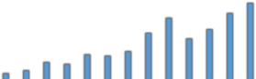
Government Receipts ( ₦’billion)
90
80
70
60
50
79.96
69.47
64.46
49.17
52.76
43.22
40
30
27.01
30.25
25.57
19.15
20
10
0
17.1
7.59
10.57
2007 2008 2009 2010 2011 2012 2013 2014 2015 2016 2017 2018 2019

Government Receipts ( ₦’billion)

Figure 2: Thirteen-Year Trend of SM Sector Contribution to Government revenue

Scope and Objectives of the Audit
    - Scope of the Audit

The audit covers payments made by companies to government in the solid minerals sector in the 2019 fiscal year. The full scope of work is detailed in the ToR for the audit (see Appendix 1).

The main objective of the audit is to produce a Solid Minerals Industry Audit (SMA) Report for 2019 in accordance with the NEITI Act, the EITI Standard 2019 and the ToR.

Other objectives that the audit aimed to achieve include:
      - Report on the quantities of minerals produced, utilized, and exported
      - Analyse payments made by mining companies to the Government;
      - Identify and analyse receipts by the Government;
      - Reconcile data on production and payments made by mining companies with receipts by the Nigerian government; and
      - Give a detailed financial statement on surpluses or deficits payable/receivable at the end of the audit period for transparency and accountability.

1.2.2. Data Sources and Basis of Accounting

The IA used the following data sources:

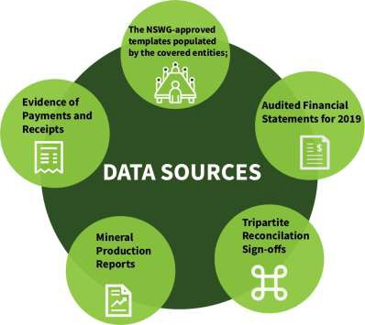
Secondary sources of data included previous NEITI audit reports; reports produced by government agencies and solid minerals extractive companies.
The report conforms to the International Standards on Auditing (ISA) as applied in the planning and collection of audit data; while all financial information was handled to comply to the International Standards on Related services (ISRS).

Materiality

The NSWG approved royalty payments as the basis for selection of companies that were covered by the audit. A materiality threshold of N3Million was set for the 2019 solid minerals audit by the NSWG. The IA agreed with the NSWG, that the condition and threshold set for the audit provided adequate coverage for the reconciliation report. See Appendix 2 for approved NSWG Materiality documents.

Covered Entities

The entities covered for the reconciliation report of the 2019 SMA include Extractive Companies and Government Agencies, and are listed in Tables 2 and 3 respectively.

      - Extractive Companies: A total of seven hundred and two (702) companies paid royalties in 2019, while seventy-four (74) met the materiality threshold of ₦3million set for the SMA. However, out of these 74 companies, 68 of them were in operations during the course of audit and were reconciled; they accounted for 87.63% of the total royalties paid in the year. The top five (5) companies paid 51.97% of the total royalties.
b)
Table 2: List of companies

S/N | NAME | Royalty Paid (N) | % Contribution
1 | Dangote Cement Plc | 635,515,563.95 | 25.40%
2 | Lafarge Plc | 320,111,882.50 | 12.79%
3 | Dangote industries | 142,760,695.26 | 5.71%
4 | Julius Berger Plc | 107,910,086.40 | 4.31%
5 | Reynolds Construction Company Nig. Ltd | 94,124,643.50 | 3.76%
6 | BUA-CCNN | 71,051,487.00 | 2.84%
7 | Setraco NIG. LTD | 69,922,112.07 | 2.79%
8 | BUA Cement Plc- Okpella | 64,164,260.00 | 2.56%
9 | Zeberced Limited | 62,146,170.00 | 2.48%
10 | First Patriot Limited | 49,292,317.50 | 1.97%
11 | CCECC Nig Ltd | 46,775,370.00 | 1.87%
12 | Solid Unit Nig. Ltd | 32,760,000.00 | 1.31%
13 | Triacta Nig Ltd | 32,708,042.00 | 1.31%
14 | Mother Cat Nig Ltd | 30,992,032.40 | 1.24%
15 | Mercury Mining Investment Ltd | 25,071,443.00 | 1.00%
16 | CGC Nig. Ltd | 21,080,336.00 | 0.84%
17 | Woda Mountain Invest. Nig. Ltd | 17,891,142.00 | 0.72%
18 | Zuma 828 Limited | 17,310,703.00 | 0.69%
19 | Ratcon Construction Company Ltd | 16,624,113.00 | 0.66%
20 | Arab Contractor Limited | 14,693,432.00 | 0.59%
21 | China Zhonghao Nig. Ltd | 14,163,250.00 | 0.57%
22 | Georgio Rocks Limited | 14,005,024.25 | 0.56%
23 | Mark-Sino Nig. Ltd | 12,923,672.00 | 0.52%
24 | CNC Mining Company Limited | 12,510,305.25 | 0.50%
25 | Z & Y Investment Company Ltd | 12,308,250.00 | 0.49%
26 | Levant Construction Ltd. | 12,200,000.00 | 0.49%
27 | Kopek Construction Limited | 11,942,700.00 | 0.48%
28 | Hitech Construction Ltd | 10,660,277.00 | 0.43%
29 | Datum Construction Ltd | 10,185,333.00 | 0.41%
30 | Gilmor Engineering | 9,464,126.00 | 0.38%
31 | Gitto Costruzioni Generau Nig. Ltd | 9,100,000.00 | 0.36%
32 | NBHH Nig Ltd | 9,046,271.00 | 0.36%
33 | Petra Quarries Ltd | 8,665,556.00 | 0.35%
34 | Jinziang Quarry Co. Ltd | 8,340,300.00 | 0.33%

35 | E. B. H. Granite Ltd | 8,048,280.00 | 0.32%
36 | Zhong Xing Mining Investment Ltd | 7,276,320.70 | 0.29%
37 | Crushed Rock Industries (Nig) Ltd | 6,876,310.59 | 0.27%
38 | Saliini Nigeria Ltd | 6,831,942.72 | 0.27%
39 | Saturn Mining Company Ltd | 6,609,104.00 | 0.26%
40 | Rock Waters Integrated Services Nig. Ltd | 6,491,467.50 | 0.26%
41 | Malcomines Ltd | 6,390,000.00 | 0.26%
42 | OFL Marble & Granite Ltd | 6,139,500.00 | 0.25%
43 | Platinum Asphalt and Crushing Co. Ltd | 5,592,802.00 | 0.22%
44 | Zhong Tai Mining (Nig.) Limited | 5,260,700.00 | 0.21%
45 | Rock King Construction Limited | 5,139,942.00 | 0.21%
46 | A.A.Y. International Mining Company ltd | 4,913,850.60 | 0.20%
47 | XVE GAO (Nig.) Limited | 4,800,000.00 | 0.19%
48 | Brothers Quarry Nig. Ltd | 4,562,940.63 | 0.18%
49 | Inorganic Earth Resources ltd | 4,521,987.98 | 0.18%
50 | Homaset Limited | 4,430,000.00 | 0.18%
51 | Venus Mining Co. | 4,391,950.00 | 0.18%
52 | XinXin Mining Resources | 4,378,678.00 | 0.17%
53 | Master Rock Ltd | 4,358,972.40 | 0.17%
54 | China Railway Construction Company | 4,350,400.00 | 0.17%
55 | Ganan Construction company Ltd | 4,350,000.00 | 0.17%
56 | Afdin Construction company Ltd | 4,322,227.00 | 0.17%
57 | Lake Petroleum Ltd | 4,200,157.50 | 0.17%
58 | Gerawa Global Engineering Ltd | 4,180,074.00 | 0.17%
59 | Balmore Trading Company Ltd | 4,116,910.27 | 0.16%
60 | CLC Technical and Engineering Nig. Ltd | 4,115,713.00 | 0.16%
61 | CCC Construction Nig. Limited | 4,096,133.20 | 0.16%
62 | Sizhe Global Ltd | 3,719,000.00 | 0.15%
63 | Kunlun Niigeria Limited | 3,442,360.00 | 0.14%
64 | Manhardi Nigeria Limited | 3,410,000.00 | 0.14%
65 | Dantata & Sawoe Construction Co. Nig | 3,393,275.00 | 0.14%
66 | Rockston Dredging and Allied Work Limited | 3,240,000.00 | 0.13%
67 | Rock Bottom Mines & Power | 3,234,129.50 | 0.13%
68 | Al'Sa'ab Quarry Multipurpose Cooperative Society | 3,099,075.00 | 0.12%
 | Subtotal Total | 2,192,705,099.67 | 87.63%
 | Unilateral payments of 6 companies above 3million threshold | 40,760,155.80 | 1.63%
 | Unilateral payments below 3million threshold | 268,763,758.42 | 10.74%
 | Grand total | 2,502,229,013.89 | 100.00%
Source: 2019 NEITI SMA Template& MID Record

c) Government Agencies: Information was obtained from six (6) government entities for the 2019 audit as enumerated in Table 3.

Table 3: List of Government Entities

S/N | Government collecting agencies | Data Extract
1 | Federal Inland Revenue Service (FIRS) | Company Income Tax (CIT), Value Added Tax (VAT), Withholding Tax (WHT), Education Tax (EDT)
2 | Mines Inspectorate Department (MID) | Royalty, permits
3 | Mining Cadastral Office (MCO) | Fees (e.g., Annual service fee, Application fees)
4 | Nigeria Custom Service (NCS) | Export Data
5 | Central Bank of Nigeria (CBN) | Export Data
6 | Revenue Mobilization Allocation and Fiscal Commission (RMAFC) | Revenue Distribution Data
Source: 2019 NEITI SMA Templates

Structure of the Report

The report is structured into seven sections. Section 1 captures the contextual information including the background of EITI in Nigeria, the scope and objectives of the report and an overview of the mining industry in Nigeria. It also highlights the methodology used for the audit, the materiality threshold, the work done by the IA and Data Quality and Assurance.

The Legal and Institutional framework including fiscal regime and incentives, allocation of contracts and licenses are captured in section 2. Section 3 highlights mining operations in Nigeria, including exploration, production, and export.

Section 4 details revenue collection and taxes paid to the government in the reporting period while revenue allocation is captured in Section 5. Section 6 sets out the social, economic and environmental impact of the solid mineral sector; the section also describes industry reforms and other emerging issues. Lastly, section 7 provides the Independent Administrator’s findings and recommendations.

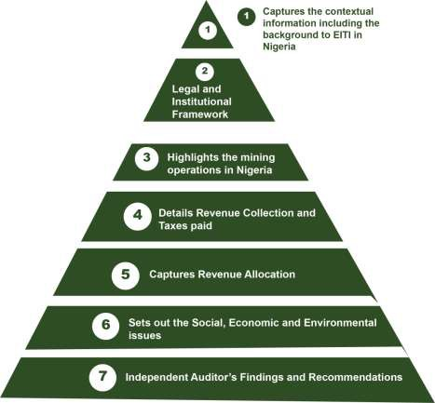

Figure 3: Structure of the report

Approach and Methodology

The approach and methodology to the audit involves five steps:
      - Preliminary planning and documentation;
      - Financial flow assessment and analysis;
      - Physical production and export volumes;
      - Reconciliation validation and investigation of discrepancies; and
      - Final Nigeria EITI report.

The preliminary planning and documentation involved the review of the companies operating in the industry and relevant government entities as well as assessing the materiality threshold set by the NSWG.

The IA compared government receipts with the payments disclosed by the mining companies and reported discrepancies. Major differences were subjected to further investigation and

reconciliation. Key financial flows including royalty, education tax, Company Income Tax (CIT), Value Added Tax (VAT), Withholding Tax (WHT), license fees, ground rent, levies and penalties were further validated in order to confirm the correctness and completeness of payments with the underlying records. There was also project level reporting of the 74 covered companies1.
The IA also assessed the production and export volumes with a view to determining the accuracy of the information provided. Analysis, findings and recommendations from previously completed solid minerals audits were built upon to update prior assessments of reporting structures and procedures to reflect information and findings for 2019; including analysis and reconciliation of financial and associated data.

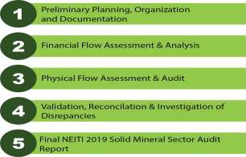
Figure 4: Audit approach and Methodology

Work done by the Independent Administrator (IA)

This report was planned and prepared based on the ToR, International Standards on Related Services (ISRSs), EITI Standard (2019) and the NEITI Act. The IA also obtained reasonable assurance that the data provided including information and explanations are free from material misstatement.
To ensure compliance with EITI Requirement 4.9 (2019), and to satisfy the credibility of the data submitted for the audit exercise, we held validation meetings with the covered entities during which all original receipts and other related supporting documents and records were confirmed for accuracy. The IA is satisfied that the records are prepared in conformity with International Financial Reporting Standards (IFRS) and other applicable financial reporting frameworks in Nigeria. The IA provides recommendations based on specific and general findings.

Data Quality and Assurance
All legal and regulatory frameworks on data quality and assurance in Nigeria, including the Nigeria data protection regulation 2019, were evaluated and complied with by the IA for the

1 See appendix 3 for project level reporting.

process to guarantee that data quality meets the EITI Standard. Other indicators employed for the assessment of data quality by the IA included availability of signed off templates by senior officers in the covered entities, presentation of audited financial statements (AFS), tripartite reconciliation sign-off and relevant documents for validation. Table 4 summarizes the
compliance level based on the evaluation criteria.

Table4: Data quality compliance indicators

S/N | Parameter | No of reporting companies | Provided | Not Provided | % Coverage
1 | Audited financial statement/ Management account | 68 | 18 | 56 | 26.47
2 | Template sign-off by senior officer | 68 | 60 | 8 | 88.23
3 | Tripartite reconciliation sign-off | 68 | 63 | 2 | 92.64
4 | Official receipts / General ledger | 68 | 68 | 0 | 100
Source: 2019 NEITI SMA Templates

80

70

60
Number of companies

50

40

30

20

10

0
Audited financial statement/ Management Account

Template sign off by senior officer

Tripartite reconciliation sign-off

Official receipts

Provided Not provided

Figure 5: Data quality compliance indicators

The IA assessed the responses obtained from the covered entities to evaluate the impact of the non-responsive companies. Of the 68 companies that met the N3 million materiality threshold, 6 companies were non-responsive, as shown in Table 5.

Table 5: Schedule of Non-Responsive Companies
Payments

S/N | Name of company | Royalty paid (N) | % of Contribution
1 | Imperial J V Ltd | 15,839,222.50 | 0.63%
2 | Prossy Investment Limited | 7,126,027.80 | 0.28%
3 | Pioneer Sinochino Investment Venture Ltd | 6,541,468.00 | 0.26%
4 | Asphalt Unity Construction Company | 4,584,300.00 | 0.18%
5 | Muhammad Idris Dankabo | 3,399,687.50 | 0.14%
6 | Cossel Construction company Nig. Ltd | 3,269,450.00 | 0.13%
 | 40,760,155.80 |  | 1.63%

3,269,450.00
3,399,687.50
4,584,300.00
6,541,468.00
7,126,027.80
15,839,222.50

Figure 6: Royalties paid by Non-Responsive Companies
Schedule of Non Responsive Companies
45,000,000.00

40,000,000.00
Cossel Construction company Nig. Ltd
35,000,000.00
Muhammad Idris Dankabo
30,000,000.00

25,000,000.00
Asphalt Unity Construction Company
20,000,000.00

15,000,000.00

10,000,000.00
Pioneer Sinochino Investment Venture
Ltd
Prossy Investment Limited
5,000,000.00
Imperial J V Ltd
0.00
Companies

The 6 non-responsive companies paid total royalties of N40,760,155.80 representing 1.63% of the reconciled revenue. The IA obtained the details of the revenue attributed to these companies from validated government records. Based on the IA’s assessment, the non- responsiveness of the companies did not impact on the accuracy of the report nor materially alter the total revenue flow to government in 2019.

A further review by the IA showed that 97.06% of the covered companies signed-off on their reports, while only 26% provided audited accounts. However, in order to mitigate this low level rate of return of AFS, the IA ensured that the companies concerned presented their official reciepts of payments as well as bank statements and general ledger; to ensure that information provided are in their books of account. The reason for non submission of AFS by some companies was attributed to the delay in preparation of their AFS due to the COVID-19 pandemic.

21

2
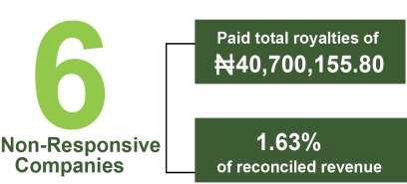LEGAL & INSTITUTIONAL FRAMEWORK

Legal Framework

The Nigerian constitution vested the ownership and control of all minerals in the country both on land and its territorial waters and exclusive economic zone in the Federal Government as provided in section 44(3) of the 1999 Constitution of the Federal Republic of Nigeria.

In order to effectively manage these mineral resources, there are legal and institutional frameworks prescribed by the National Assembly for implementation by the Federal Government. Some of these laws and legal framework are the 1999 Constitution of the Federal Republic of Nigeria (as amended), Nigerian Minerals and Mining Act, 2007, Nigerian Minerals and Mining Regulations of 2011, and the Company and Allied Matters Act, 2020 (as amended). Summary of the laws governing the solid minerals sector in Nigeria are set out in Table 6.

Table 6: Laws and Regulations Guiding Operations in Nigeria’s Solid Minerals Sector

S/NO | Law/Regulation Key Features
1 | 1999 Constitution of The Constitution places the control of all minerals, mineral oils, and natural gas in, the Federal Republic under or upon any land in Nigeria or in, under or upon the territorial waters and of Nigeria (as the exclusive economic zone of Nigeria under the authority of the Federal amended) Government (Section 44 (3)); with the same having the exclusive powers and  jurisdiction over all mineral resources in Nigeria (item 39, Schedule II) http://www.nigeria- law.Org/ConstitutionOfTheFederalRepublicOfNigeria.htm#Chapter_4
2 | Nigerian Minerals The Act vests control of all properties and minerals in the State and prohibits and Mining Act, 2007 unauthorized exploration or exploitation. It further provides that the use of land  for mining operations shall have a priority over other uses of land and be considered as constituting an overriding public interest within the meaning of Land Use Act.  See NMMA 2007 (www.minesandsteel.gov.ng )
3 | Nigerian Minerals and Mining Regulations of 2011 | The regulations provide guidelines on how mining operations should be conducted including obtaining mineral titles and sanctions for defaulters. See: Nigerian Minerals and Mining Regulations 2011 (minesandsteel.gov.ng)
4 | Land Use Act, 2004 | The Act gives authority over all land in the territory of each state solely to the governor of the state, except lands vested to the Federal Government or its Agencies. The governor exercises authority over land use in such a way that benefits all the citizens.  See https://www.lawyard.ng/wp-content/uploads/2015/11/LAND-USE-ACT- 2004.pdf.
5 | Environmental | The Act mandates that an impact assessment be done in respect of any

6 | Impact Assessment proposed project or activity (including mining) to evaluate likely environmental Act, 2004 effects before the commencement of the activity to propose appropriate  remedial actions.  See http://faolex.fao.org/docs/pdf/nig18378.pdf
6 | The Company and The Act establishes the Corporate Affairs Commission, deals with the  Allied Matters Act, incorporation of companies in Nigeria and incidental matters, registration of 2020(As amended) business names and the incorporation of trustees of certain communities,  bodies and association. It also relates to terms of partnerships and administrative proceedings of companies.  See: https://www.naijabusiness.com.ng/wp-content/uploads/2020/08/CAMA- 2020-Download.pdf
7  8  9 | Nigerian Investment The act establishes the Nigerian investment Promotion Commission (NIPC), to Promotion encourage and promote investment in the Nigerian economy; and for matters Commission Act, connected therewith, which includes mining of solid minerals. The NIPC is  2004 mandated to initiate and support measures which shall enhance the investment climate in Nigeria for both nationals and foreign investors.  See: Preface – Nigerian Investment Promotion Commission (nipc.gov.ng)
7  8  9 | Nigerian The Act establishes NESREA as the body to enforce appropriate and adequate Environmental regulations and sanctions for the protection of the environment. NESREA has Standard Regulation developed thirty-three (33) environmental regulations which have been  and Enforcement published in the official Gazette of the Federal Government of Nigeria. Agency (NESREA) Act See: www.nesrea.gov.ng/publications-downloads/laws-regulations/
7  8  9 | Company Income The company Income Tax Act (CITA) is the principal law that regulates the Tax Act taxation of companies in Nigeria. The Federal Inland Revenue Service (FIRS)  administers the income tax which is on the profits of registered companies in Nigeria.  See: C21.pdf (placng.org)
10 | Finance Act 2019 The Finance Act reviews and consolidates into one statute, many tax provisions from different statutes. The focus of the Act is to increase revenue of the Federal Government and to curb avenues by which tax has been evaded and avoided over the years.  See https://www.firs.gov.ng/finance-act-2019/ (2019) https://www.firs.gov.ng/wp-content/uploads/2021/01/finance-act- 2020_signed.pdf (2020)
11 | Personal Income Tax The Act guides the taxes paid on income of individuals, corporate, sole or body Act of individuals, communities, Families and trustees or executors of any  settlement. The rate of the tax ranges from 7% to 24%, depending on the amount of chargeable income and is administered by the State Inland Revenue

 | Service in respect of their residents. See: https://www.firs.gov.ng/personal- income-tax-pit/.
12 | Value Added Tax This is an Act to impose and charge Value Added Tax on certain goods and (VAT) services and to provide for the administration of the tax and matters related  thereto. The tax is computed at a specified rate on the value of all goods and services unless otherwise stated.  See: https://www.firs.gov.ng/value-added-tax-vat/

Acquisition of mining licences
All investors or companies wanting to engage in mining in Nigeria require a license to proceed. Acquisition of licenses in the extractive industry in Nigeria allows for either competitive bidding or application for title. In the solid minerals sector, the approvals are issued through title applications.
The Mining Cadastre Office (MCO) an agency under the supervision of the Ministry of Mines and Steel development (MMSD) is responsible for the issuance of licenses. Figures 5 and 6 illustrate the procedures for acquisition of titles. Further details can be found at: https://portal.minesandsteel.gov.ng/Home/Guidelines

Revocation of Mining Licence
Chapter 6, Section 151 of NMMA 2007 list conditions for the revocation of a mineral title as enumerated below:
- Where the title holder is convicted by a court of competent jurisdiction of an offence committed under the act.
- Where the title holder breaches any provision of the act.
- Where the title holder breaches an order or notice issued or given under the act.
- Where the title holder surrenders the mineral title in the manner prescribed under the act before the expiration of the term of the title.
- Where the title holder is declared insolvent or bankrupt or goes into insolvent liquidation except in circumstances involving a reorganisation, amalgamation or arrangement with creditors.
- In the case of small-scale mining lease, the title holder wholly discontinues operations under the lease during continues period of six months.
g)
Where the title holder fails to pay the prescribed fees which include annual fee, application fee, and other fees as may be prescribed from time to time by the MCO.

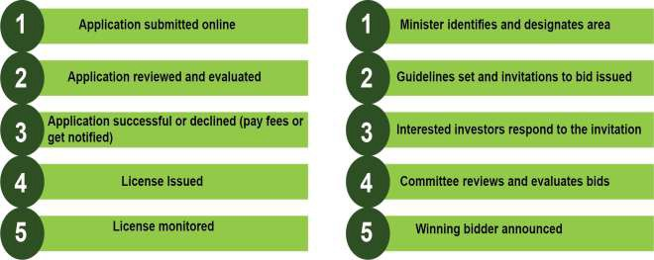

Fig 7: Process of Acquisition of Title by Fig 8: Process of Acquisition of Title by competitive bidding Application

2.1.3 Five-year trend analysis of mining titles issuance
A five-year trend analysis of titles issued up to 31 December 2019 is presented in Table 7. A total of 6,360 titles were issued by the MCO between 2015 and 2019. The year 2017 had the highest number of issuance 1,484 while 2015 had the least figure of 1,047.

Table7: Titles Issued by MCO in the past 5 years

S/N | TITLE | 2015 | 2016 | 2017 | 2018 | 2019 TOTAL
1 | Exploration License | 488 | 513 | 631 | 634 | 501 | 2767
2 | Mining Lease | 15 | 15 | 37 | 35 | 24 | 126
3 | Quarry Lease | 294 | 288 | 228 | 212 | 169 | 1191
4 | Small Scale Mining Lease | 250 | 337 | 588 | 499 | 602 | 2276
 | Total | 1047 | 1153 | 1484 | 1380 | 1296 | 6360
Source: 2019 MCO Record

2.2 Institutional Framework
The institutions and their organizational structures are designed to promote and organize the orderly conduct of mining operations in the solid minerals sector of Nigeria. Among those set up to direct and monitor the operations in the solid minerals sector of the Nigerian economy in line with global best practices are the institutions listed in Figure 9.

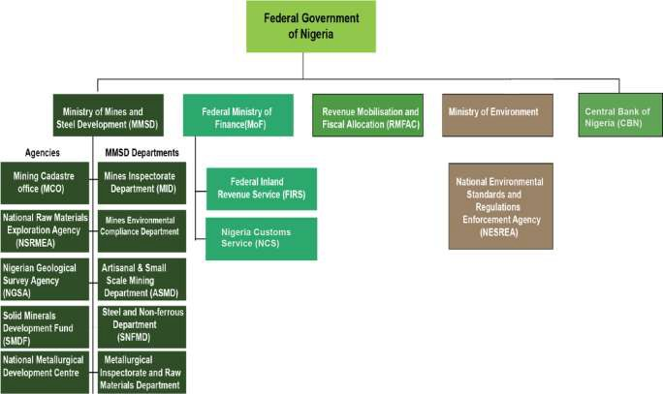

Fig 9: Structure of Government Agencies

2.2.1 The Ministry of Mines and Steel Development
The Ministry of Mines and Steel Development (MMSD) has overall responsibility for the sector and oversees departments with specific responsibilities. These include the Mines Inspectorate Department (MID), Mines Environmental Compliance Department (MECD), Artisanal and Small Scale Mining Department (ASMD), the Metallurgical Inspectorate and Raw Materials Department (MIRMD) and the Steel and Non-Ferrous Metals Department (SNFMD) respectively.

The Ministry also supervise other agencies such as Mining Cadastre Office, National Raw Materials Exploration Agency (NSRMEA), Nigerian Geological Survey Agency (NGSA), Solid Minerals Development Fund (SMDF) and the National Metallurgical Development Center (NMDC).

The Mining Cadastre Office (MCO)
The Mining Cadastre Office (MCO) is an agency under the supervision of MMSD and is the sole agency responsible for the management and administration of mineral titles in Nigeria. In 2019,

MCO issued a total of one thousand two hundred and ninety-Six (1,296) mineral titles to entities to carry out various operations in the sector.

A breakdown of the different license types is set out in Table 8. See appendix 5 for details MCO register.

Table 8: Mineral Titles issued in 2019

S/N | Mineral Title | Quantity
1 | Exploration License (EL) | 501
2 | Small scale Mining Lease (SSML) | 602
3 | Quarry Lease (QL) | 169
4 | Mining Lease (ML) | 24
 | Total | 1,296
Source: MCO Record

The Federal Ministry of Environment (FMEnv.)
The Federal Ministry of Environment (FMEnv.) is responsible for the regulation of environmental matters as well as the protection and development of the environment, biodiversity conservation and sustainable development of Nigeria's natural resources in general. It also ensures coordination and liaison with relevant stakeholders within and outside Nigeria on matters of enforcement of environmental standards, regulations, rules, laws, policies and guidelines.
The institutions that have regulatory control over the solid minerals sector are listed in Table 9.

Table 9: Institutions regulating Operations in Nigeria’s Solid Minerals Sector

S/NO | Law/Regulation | Key Functions
1 | Federal Ministry of Solid Minerals and Steel Development (MMSD) | The Federal Ministry of Solid Minerals and Steel Development (MMSD) is the ministry primarily saddled with the responsibility of monitoring and supervising the solid minerals sector of the country. MMSD was set up to unlock the economic potentials of the solid minerals sub sector in Nigeria. For Details of the ministry’s operations and agencies see Home | Ministry of Mines and Steel Development.
2 | The Mining Cadastral Office (MCO) | The MCO is an autonomous Agency under the supervisory responsibility of the Federal Ministry of Solid Minerals and Steel Development (MMSD) as provided by section 5(1) of the Nigerian Minerals and Mining Act, (2007). It is responsible for the management and administration of mineral titles, which is considered as the cornerstone of a secure mineral right system.  See Nigeria Mining Cadastre Office – The Official Website of the Nigeria Mining Cadastre Office for the details.
 | It is a geo-scientific information centre for investors and researchers in the

- Nigerian Steel Raw Materials Exploration Agency (NSRMEA)
solid minerals sector with a mandate amongst others to carry out exploration of steel raw materials in all parts of Nigeria and elsewhere for the iron and steel industry.
See: NSRMEA – National Steel Raw Materials Exploration Agency

- Federal Inland Revenue Service (FIRS)
The FIRS is statutory and administratively charged with the responsibility for the assessment, collection and accounting of taxes to the Federal government of Nigeria. Taxes collected relating to solid minerals sectors are Corporate Income Tax (CIT), Withholding Tax (WHT), Education Tax (EDT), Value Added Tax (VAT), Stamp Duty (SDT), Capital Gain Tax (CGT). Details of various taxes can be found at: https://www.firs.gov.ng/tax-laws/

- Nigerian Custom Service (NCS)
The Nigeria Customs Service (NCS) is an agency under the supervisory oversight of the Federal Ministry of Finance and National Planning (FMFNP). It has the responsibility of collecting of custom revenue such as imports, export and other excise duties on behalf of the Federal Government of Nigeria. Details of its operation can be seen at MANDATE OF NCS – Nigeria Customs Service https://customs.gov.ng/?page_id=3101

- Revenue Mobilisation, Allocation and Fiscal Commission (RMAFC)
This is a body established to handle revenue allocation and fiscal matters on a continuous basis. It is also mandated to advice on fiscal matters and to monitor effectively all remittances for equitable and fair disbursement to the beneficiaries to promote national unity and development through established fiscal structures under extant laws. See: Establishing Law | RMAFC, Solid Minerals | RMAFC

- Corporate Affairs Commission. (CAC).

Source: FIRS/NCS/CAC/RMAFC/MMSD
The Corporate Affairs Commission (CAC) oversees regulating the formation and management of companies in Nigeria. Therefore, every company (private or public) in the country must be duly registered with the CAC. The Corporate Affairs Commission (CAC) is the government agency in charge of registering companies and business in Nigeria. see https://www.cac.gov.ng/about/https://www.cac.gov.ng/about/

Fiscal Regime
Nigeria is structured as a Federal Republic consisting of three tiers of Government, that is the Federal, State and Local Governments as enshrined in the constitution. https://publicofficialsfinancialdisclosure.worldbank.org/sites/fdl/files/assets/law-library- files/Nigeria_Constitution_1999_en.pdf.

The constitution and other extant laws such as CAMA and CITA governing the solid mineral sector are set of laws that proscribe various taxes collectable in the solid minerals sector as
indicated in Figure 10.

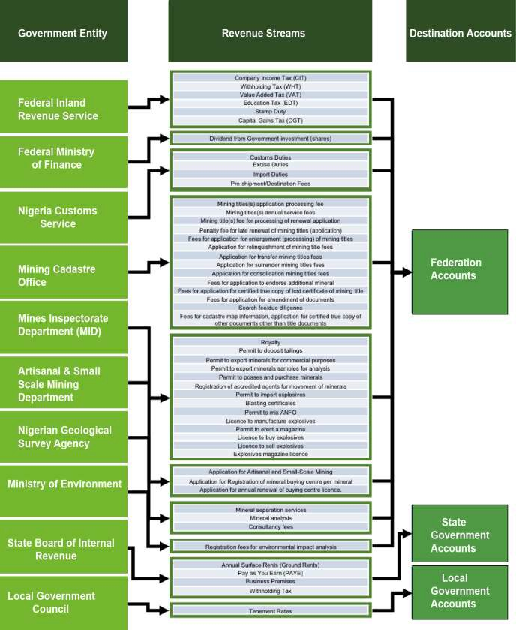

Fig 10: Government Revenue Streams

Federal Taxes

The Federal Inland Revenue Service (FIRS) is the institution mandated by law for tax administration at the Federal level. The agency oversees enforcement of the provisions of the Companies Income Tax Act (CITA), 2007 (as amended). A summary of federally administered taxes payable by companies in the solid minerals sector are listed in Table 10.

Table10: Federal Tax Legislation

S/N | ACT | Key Provisions
1 | Company Income Tax Act | The company Income Tax Act (CITA) regulates the taxation of companies in Nigeria and is administered by the Federal Inland Revenue Service (FIRS) on the profits of registered companies in Nigeria.  The CIT is currently charged at 30% for companies having more than ₦100 million turnovers and 20% for companies with turnover between ₦25-100 million. Companies having less than  ₦25 million turnovers are not liable to pay CIT. See: C21.pdf (placng.org)
2 | Finance Act 2019 | The aim of Finance Act 2019 is to amongst other things bring about changes to Nigeria’s tax laws by making them more responsive to tax reforms policies of Federal Government, enhance its implementation and effectiveness and improve the ease of doing business. See: https://www.firs.gov.ng/finance-act- 2019/ (2019)  https://www.firs.gov.ng/wp-content/uploads/2021/01/finance- act-2020_signed.pdf (2020)
3 | Personal Income Tax Act, 2011 | The Act guides the taxes paid on income of individuals, corporate, sole or body of individuals, communities, Families and trustees or executors of any settlement. It is administered by the State Inland Revenue Service in respect of their residents.  The rate of the tax ranges from 7% for annual income less than  ₦300000, 11% for income between ₦300000 and ₦500000, 15% or 19% for income between ₦500,000 and ₦1,600,000, 21% for income between ₦1,600,000 to ₦3,200,000 and 24% for annual income above ₦3200000. See: https://www.firs.gov.ng/personal- income-tax-pit/

4 | Value Added Tax Act- 2007 | This is a form of levy imposed by the federal government on the purchase and consumption of goods and services in Nigeria. The current rate of VAT is 7.5% of the total value of goods or services purchased. See: https://www.firs.gov.ng/value-added-tax-vat/
5 | Withholding Tax (WHT) | WHT is paid into the Federation account through FIRS designated banks. It is an advance payment of income tax. There are varying rates of WHT ranging from 2.5% to 10% for companies and 5% to 10% for individuals depending on the transaction. See: https://www.firs.gov.ng/withholding-tax-wht/
6 | Stamp Duties | These are taxes the government imposes on legal documents needed to record certain types of written or electronic transactions in Nigeria. It is charged at a flat rate or a percentage of the transaction/instrument value. Stamp duty is imposed at the rate of 0.75% on the authorised share capital at incorporation of the company or on registration of new shares. See https://www.firs.gov.ng/stamp-duty-sd/
Source: https://www.firs.gov.ng

State Taxes
The State Boards of Internal Revenue (SBIRs) administer taxes at the state levels. The Personal Income Tax Act (PITA) 2011 (as amended) is the principal instrument that governs taxation in this respect. Individuals and partnerships in the sector are assessed for tax under PITA 2011.

In addition, Withholding Tax and Capital gains Tax relating to individuals and partnerships are also collected by the state governments. See list of taxes and levies collectable by state https://lirs.gov.ng/tax-information/tax-collection.

Local Taxes and Levies
Taxes and levies collected by local authorities are restricted mainly to rights of occupancy, fees on lands in rural areas, and tenement rates (these exclude those in the jurisdiction of the Federal and State Governments). Schedule iv (4) to the 1999 constitution as amended (2011) provides a list of taxes and levies collectible by State and Local governments.

Incentives
Investment in the Nigerian mining sector attracts a bouquet of incentives, ranging from those offered by the NMMA 2007, NIPC, and to those under the CITA 2004. Furthermore, the Finance Act 2019 which became effective in February 2020 offers additional incentives to encourage the flow of investments to the sector for sustainable development. For incentives in the solid minerals sector in Nigeria, see http://www.minesandsteel.gov.ng/wp- content/uploads/2017/10/Nigeria-Ministry-of-Solid-Minerals-Investment-BrochureV14.pdf

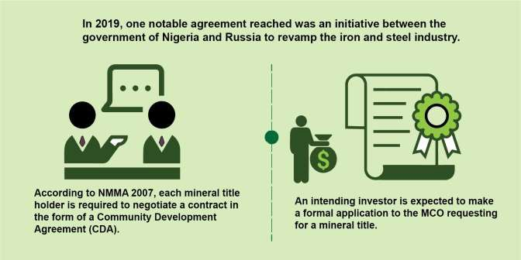

Contracts and Licences
    - Contracts
Nigeria’s solid minerals sector operates a cadastre system that promotes private sector investment in the sector. The government provides oversight function through policy direction and regulations for the improvement of the investment climate and attraction of foreign investors.

According to NMMA 2007, every mineral title holder is required to negotiate a contract in the form of a Community Development Agreement (CDA) that ensures the flow of economic and social benefits to the local community. A Community Development Agreement (CDA) contains undertakings with respect to the social and economic contributions that the project would make to the sustainability of such community; it as well addresses all or some of the issues relevant to the development of the host community i.e. educational scholarship, apprenticeship, technical training and employment opportunities, health or other community services, roads, water and power etc.

CDA is subject to renewal every 5 years. However, in the event of failure to reach an agreement by both parties, the Honourable minister of mines will be called upon to resolve the impasse. The CDA is between the title holder and the host community, with the ministry having a copy for reference and monitoring purpose.

In 2019, one notable agreement reached was an initiative between the government of Nigeria and Russia to revamp the iron and steel industry. see: https://portal.minesandsteel.gov.ng/home/viewnews/56

Licences

The Mining Cadastre Office (MCO) is the agency charged with the responsibility for the administration and management of mineral titles in Nigeria. An intending investor is expected to make a formal application to the MCO requesting for a mineral title. Section 2 (1) of NMMA prohibits ‘exploration or exploitation of minerals without authority’ evidenced by a grant of mineral title. However, in line with section 94 of the NMMA, a person can purchase or possess any mineral if he holds a license to purchase minerals. While proceeds of the minerals recovered under a small-scale mining Lease shall be Sold to a licensed Mineral Procurement Centre, which is referred to as Mineral Buying Centre. In addition to Licenses and leases, permits are also granted by the MCO. These are Reconnaissance Permit (RP) and Water Use Permit. See; https://www.miningcadastre.gov.ng/wp-content/uploads/2020/05/Guidelines-on- Mineral-Titles-App.-with-eMC-1-1.pdf.

Reconnaissance Permit (RP): This title is non-transferable and is valid for only one year.

Water Use Permit: It is granted only to holders of exploration licenses, mining lease, quarry lease or small-scale mining lease who may require access to the use of water for operations.
Table 11 provides a summary of active mineral titles in the Mining Cadastre Office register as at December 2019.

Table 11: Total Mineral Titles issued by MCO as at December 2019

Mineral Title | Purpose | Duration | Number Valid Titles
Exploration Licence (EL) | - To conduct exploration on the land within the area of the license - The holder is allowed to remove, conduct bulk sampling and testing, export and sell mineral resources not exceeding established limits.  - The mining area is not more than 200sqkm Please note that the mining activity is restricted to specified minerals. | 3 years initially; renewable two further periods of 2 years each. | 1,840
Small scale Mining Lease (SSML) | - Right to obtain access and enter the mining area.  - Exclusively use, occupy and carry out mining exploitation within the lease area.  - Mining Lease not to exceed 50 km2. | 5 years initially; renewable for further period of 5years only | 1,811
Quarry Lease (QL) | a) Quarrying under the Mining Act applies to all naturally occurring quarriable minerals, such as | 5 years and  renewable every 5 | 1,205

Mining Lease (ML)  Total | asbestos, clay, fuller’s earth, gypsum, marble, years. limestone, slate, sand, stone, gavel, etc.  b) Quarrying covers land area not exceeding 5 km2.
Mining Lease (ML)  Total | - The holder of the lease has the exclusive right to 25 years initially; carry out small-scale mining operations. renewable every 24  - The mining area is greater than 5 acres but less years. than 3km2. | 304
Mining Lease (ML)  Total | 5,160

Transfer of Title

In 2019, a total of 24 titles were transferred. These transfers followed due process as stipulated in section 147 subsections 3 and 4 of the Nigerian Minerals and Mining Act 20072. A review of the process showed that all applicable fees were paid; and all necessary documentations relating to the transfers duly made3. Table 12 shows the titles transferred and the new beneficiaries.

Table 12: Transferred Titles in 2019

S/N | Title Type | Title No | Cadastral Unit | Transferor | Transferee
1 | EL | 2801 | 50 | SAO ELLAS Energy and Petroleum Nig. Ltd | Africa Nonferrous Industries Ltd
2 | EL | 14273 | 6 | Greenfield Metals Ltd | Halfthor Minerals Ltd
3 | EL | 18633 | 40 | P.W Nigeria Ltd | Dagma Mining Ltd
4 | EL | 22036 | 930 | Kilbawo Kaoje Nigeria Ltd | Orient Mining Ltd
5 | EL | 23273 | 4 | Greenfield Metals Ltd | Arab Contractors OAO Ltd
6 | EL | 23505 | 17 | Syils Service Ltd | Syils Mining Ltd
7 | EL | 25093 | 872 | P.W Nigeria Ltd | Pamasa Mining Ltd
8 | EL | 26962 | 165 | Prime General Merchants Ltd | African Natural Resources and Mines Ltd
9 | EL | 27039 | 32 | P.W Nigeria Ltd | Dext Mining Ltd
10 | QLS | 3397 | 9 | Leenford Project Ltd | International Miners Concept Ltd
11 | QLS | 10125 | 2 | C and C Construction Company Ltd | HITEC Construction Company Ltd
12 | QLS | 22028 | 2 | Badeowo Rock Cowergence Ltd | CNBM Mining Investment Nig Ltd
13 | QLS | 22768 | 1 | Sahelian Granites Ltd | Ganan Construction Ltd
14 | QLS | 23523 | 1 | Smogu Integrated Ltd | CGC Nigeria Ltd

2http://www.miningcadastre.gov.ng/wp-
content/uploads/2020/07/Requirements_for_Transfer_of_Mineral_Title.pdf

3 See appendix 7 for Transfer fee payments

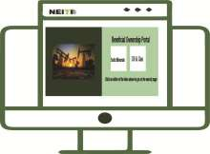
15 | QLS | 28031 | 4 | Groundwork Perfect Solution Ltd | Neon Tongho Enterprises Co. Ltd
16 | QLS | 28570 | 2 | Groundwork Perfect Solution Ltd | Neon Tongho Enterprises Co. Ltd
17 | QLS | 28571 | 2 | Groundwork Perfect Solution Ltd | Neon Tongho Enterprises Co. Ltd
18 | QLS | 28738 | 10 | Badeowo Rock Cowergence Ltd | CNBM Mining Investment Nig Ltd
19 | QLS | 29236 | 2 | Abubakar Audu Toro | Xusheng Global Ltd
20 | QLS | 29593 | 1 | Abubakar Audu Toro | Xusheng Global Ltd
21 | SSML | 21711 | 15 | SAO ELLAS Energy and Petroleum Nig. Ltd | Africa Nonferrous Industries Ltd
22 | SSML | 23951 | 6 | Abdul & Acituvo Enterprises | Huijin Mining Industries Ltd
23 | SSML | 26838 | 5 | Sadris Trading Co. Ltd | Hayupada Nigeria Ltd
24 | ML | 769 | 224 | Western Metal Product Co. Ltd | Orbit Exploration & National Products Ltd
Source: MCO Record

Beneficial Ownership



Beneficial ownership (BO) refers to natural persons who directly or indirectly own and derive financial benefits from a company or commercial activity. Transparency in BO prevents the true beneficiaries of extractive industry revenues from hiding behind opaque shell companies or using complex corporate or other legal structures to perpetuate non-disclosure of income, tax evasion and disguising conflicts of interest. Also, BO disclosure allows stakeholders to obtain a clear view of persons investing in the extractive sector, their status in society (e.g., politically exposed persons (PEPs), government employees) and their link (if any) to PEPs.

Requirement 2.5 of the EITI Standard 2019 mandates all implementing countries to publish information on the beneficial owners of all companies applying for and holding an interest in a license/ lease or permit to explore for or extract oil, gas, and mineral resources. Consequently, in fulfilment of the need for the establishment of a public register of beneficial owners of companies in Nigeria; section 119(3) of CAMA 2020 provides that the CAC shall maintain a register of persons with significant control in companies. The CAC as at the time of this report was set to implement these provisions.

NEITI has taken steps to make BO information more easily accessible and to mainstream the collection and public disclosure of BO information in line with EITI Requirement 2.5. On December 12, 2019, NEITI launched a BO portal for companies covered by the NEITI annual audits, this is found https://bo.neiti.gov.ng/sm_search.
Furthermore, the MCO now makes it a mandatory requirement for companies to provide beneficial ownership information as part of new license application process or renewal.

The Independent Administrator (IA) reviewed the initial BO data collection template in line with EITI requirement 2.5 as well as other relevant guidance notes and NSWG decisions. Based on the IA’s review, a BO template was sent out to 74 covered companies out of which only 68 companies responded for the 2019 NEITI solid minerals audit (SMA). The IA compared the data as contained in the companies’ populated BO templates and incorporation documents with Mining Cadastral office (MCO) documentation to ascertain the accuracy and completeness of information. Where incomplete information was provided, the IA contacted the entities to provide the missing details. Also, during the tripartite reconciliation such incomplete information was requested from the relevant companies, with some providing them.

Ownership information was received from 62 out of 68 responsive companies, i.e. a response rate of 91%. A total of 30 companies (48% of the 62 responsive companies) provided complete information on their beneficial owners, including the percentage of ownership. A further 21 companies (34%) provided partial BO information while a total of 17 companies failed to provide any beneficial ownership information. See appendix 16 for details.

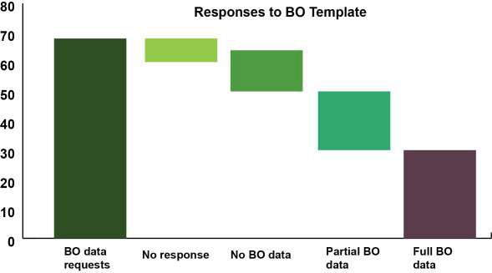
Figure 11: Beneficial Ownership Response

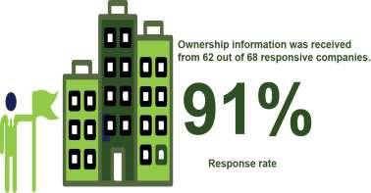

    - State Participation
A review of the activities in Nigeria solid minerals sector in 2019 indicated that there was no active state-owned enterprise.

38

3

MINING OPERATIONS IN NIGERIA

This section of the report provides an overview of the solid minerals industry in Nigeria, as well as data on exploration, production and strategic minerals in the country. It also provides information on export, reforms and recent developments in the sector.

3.1. Background

Organized mining activities in the solid minerals began in 1903 when the mineral survey of the Northern Protectorate was created by the British colonial government. In the first half of the 20th century, the mining of cassiterite and columbite in the Jos Plateau involved some medium to large-scale open-pit and hydraulic placer operations which continued until the late 1950s. In the South-East, some small scale open-cast mining of lead-zinc-barite veins and underground coal mines were common.

Currently, mining activity is limited mostly to small-scale (involving some mechanization) and artisanal (mostly manual) operations for gold, gemstones and tin-tantalite. Mining of metallic minerals is sporadic over large areas of the country involving small and artisanal operations of panning, pitting, or excavation of low bulk but high-value minerals, such as gold, lead-zinc, tin, columbite and manganese. The mining activities include but not limited to eluvial/alluvial placers, mechanized and hand-dug pitting and excavation through both legal and unlicensed activities.

A major aspect of the mining landscape in Nigeria today is quarrying and associated open-pit extraction of industrial minerals and rocks. Quarrying accounts for about 90% of the sector's production which involves the removal of bulky materials of low unit value, such as limestone, shale, granite, sand, and laterite. See details at (https://ngsa.gov.ng/mineral-exploration/).

Mineral Exploration

Nigeria possesses vast mineral resources spread across the states which are categorised as energy, industrial, metallic ores and precious stones. Their exploration is aimed at discovering viable minerals for exploitation as raw materials for industrial production. Currently, about 44 different minerals are found in commercial quantities in 450 locations across the country https://ngsa.gov.ng/mineral-exploration-evaluation/.

The MCO in 2019 issued a total of four hundred and ninety-one (491) Exploration Licenses (EL), were issued for strategic minerals as enumerated in Table 13.

Exploration Licenses (EL) for strategic minerals constituted 98% of the total 501 license issued; this is an indication of potential for the development of the identified strategic minerals.

Government effort towards the development of strategic minerals, especially gold, was reflected in the issuance of two license for gold refineries in 2019 namely, Kian Smith Refinery and Segilola Mines (Thor Explorations) for the production of gold bullion.

Table 13: Exploration Licences (EL) issued in 2019

S/N | TITLE | MINERAL | Number
1 | EL | Limestone | 33
2 | EL | Lead/Zinc Ore | 121
3 | EL | Coal | 13
4 | EL | Tin Ore | 128
6 | EL | Barites | 22
7 | EL | Gold | 168
8 | EL | Bitumen | 6
 | Total |  | 491
Source: MCO 2019 Records

Strategic minerals
Nigeria is endowed with over 155 mineral deposits across the country. Out of these mineral deposits, Nigeria has identified 44 types of minerals of various mix and proven qualities, some of which are concentrated in certain regions as presented in Figure 12.
In order to effectively develop these minerals, the Federal Government has identified seven (7) strategic minerals for development namely, Gold, Limestone, Barite, Lead/Zinc, Iron Ore, Bitumen, and Coal. These designated seven minerals are important in industrial processes as well as in the revenue diversification strategy of the government. It is believed that these minerals have the potential to make a significant contribution to Nigeria's economic development as captured in the Nigerian Mining Growth Roadmap 2016 (https://portal.minesandsteel.gov.ng/MarketPlace/Mineral). As at 2019, there were 2,586 valid Strategic Minerals Titles as presented in Table 14.

Table 14: Valid Strategic Minerals Titles as at 2019

S/N | MINERAL | EL | ML | SSML | QL | TOTAL
1 | Coal | 51 | 30 | 1 |  | 85
2 | Limestone | 141 | 45 | 42 | 43 | 271
3 | Lead/Zinc | 469 | 38 | 4 | 252 | 763
4 | Gold | 746 | 40 | 6 | 349 | 1,141
5 | Baryte | 54 | 8 | 0 | 62 | 124

6 | Bitumen | 11 | 7 |  |  | 18
7 | Iron ore | 130 | 12 | 1 | 41 | 184
 | Total | 1,602 | 180 | 54 | 750 | 2,586
Source: MCO 2019 Records

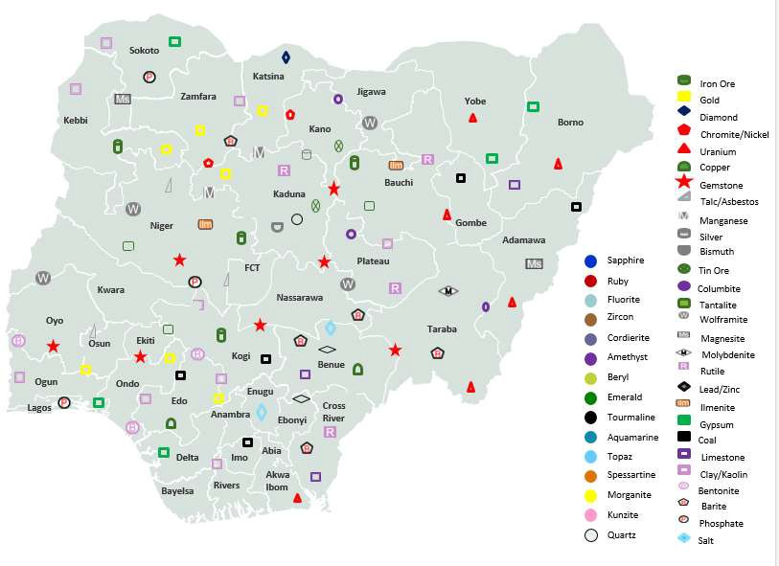
Figure 12: Mineral Deposits in Nigeria

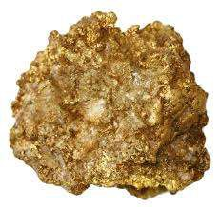

Gold: Gold occurrences are found within the schist belts in Zamfara, Kaduna, Niger, Kogi and Osun States. Many of the known gold occurrences are currently being worked on by ASM. To foster the formalization and integration of artisanal gold mining activities into Nigeria’s legal, economic and institutional frameworks the Federal Government of Nigeria in July 2020 inaugurated the Presidential Artisanal Gold Mining Development Initiative (PAGMI)4.

4 https://statehouse.gov.ng/news/everything-you-need-to-know-about-the-presidential-artisanal-gold-mining- development-initiative-pagmi/.

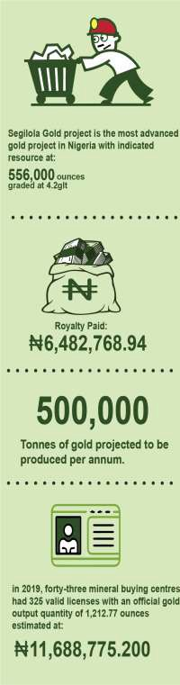PAGMI model is not unique to Nigeria; it is currently being practiced in several countries notably in Asia and Africa countries that have large artisanal gold mining activities. Some of these countries are Ethiopia, Zambia, Ghana, Mongolia, Philippines, Tanzania and Zimbabwe.

PAGMI is designed as a broader strategy to address the structural and institutional factors such as rural poverty, lack of alternative livelihoods, and difficulties in meeting legal and regulatory requirements that tend to push artisanal gold mining operators deeper into the informal economy.

The Segilola Gold Project located in Osun State Nigeria is considered Nigeria’s most advanced gold project with an indicated resource of 556,000 ounces graded at 4.2g/t, an inferred resource of 306,000 ounces graded at 4.7g/t and a probable reserve of 448,000 ounces graded at 4.2 g/t.
The Project comprises of an open pit gold mining project based on an indicated mineral resource.

The Water Storage Facility has been constructed to final height and the spillway construction is progressing. The facility is filling well and is expected to reach full capacity before the end of 2021. Procurement is 60% complete, with vendors re-confirming delivery times. Segilola Mines (Thor Explorations), with capital expenditure of $82.3 million and operating expenditure of $ 638 per once, intends to produce 500,000 tons of gold per annum for six years at prices of between $1,250 - $1,300/oz.

In 2019, forty-three mineral buying centers had 325 valid licenses with an official gold output quantity of 1,212.77 ounces estimated at ₦11,688,775,200, with a gross royalty payment of ₦6,462,768.94 by thirty-one companies.5

5 Appendix 15 list of companies that paid royalty on gold.

Eight states produced 1212.77 ounces of the mined gold in the country with Osun and Niger states contributing 70.36% of the total production as presented in the Table 15.

Table 15: State distribution of gold mined in 2019

S/NO | NAME OF STATE | QUANTITY (Ounce) | ROYALTY (₦) | % Contribution
1 | OSUN | 521 | 2,750,540.00 | 42.56%
2 | NIGER | 332.68 | 1,796,480.00 | 27.80%
3 | KWARA | 176.37 | 952,398.00 | 14.74%
4 | ZAMFARA | 95 | 490,000.00 | 7.58%
5 | KEBBI | 45.48 | 245,592.00 | 3.80%
6 | KANO STATE | 20 | 108,000.00 | 1.67%
7 | KADUNA STATE | 13.15 | 71,001.44 | 1.10%
8 | BAUCHI STATE | 9.09 | 48,757.50 | 0.75%
 | TOTAL | 1212.77 | 6,462,768.94 | 100.00%
Source: MID 2019 Records

Iron Ore

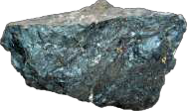
Nigeria is endowed with all the raw materials required for steel development. Ferruginous quartzites and oolitic ironstones are found in the Okene and Lokoja areas of Kogi State (Itakpe and Agbaja) respectively. More than 500 million tons of proven reserves and 3 billion tons of probable reserves exist in the area. Grades are low, ranging between 32 and 40% Fe, but can be upgraded to 65% by beneficiation for ore feed into steel processing plants at Ajaokuta and Aladja complexes. At the African-Russian summit held in Sochi, Russia in October 2019, an agreement was reached between Nigeria and Russia for METPRON, a Russian construction group to complete the Ajaokuta Steel Company. Also, a new Steel Plant is being established by the African Natural Resources and Mines Limited (ANRML) in Jere, Kaduna State.
The project is expected to mine over 5.4 mt of iron ore per annual. ANRML has carried out CDA with the host community including an Environmental Impact Assessment with the project expected to take off in 2023. Thirty licenses were issued for Iron exploration in 2019; but there was no record of production.

Lead-Zinc ores

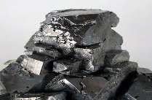

Estimated reserves are 10 million tons of lead-ore and 100,000 tons of zinc-ore spread over eight States. These two minerals are usually found together as fissure-filling veins within the cretaceous sediments of the Benue Trough, extending from the south of Abakaliki in the south- east to Gombe in the north-east. The best Pb- Zn mining prospects are found in the Abakaliki- Ishiagu areas of Ebonyi State.

In 2019, the total lead production was 38,750.12tonne, representing a decrease of 36.41% as against 60,944tonne produced in 2018. Lead and zinc accounted for 41% of the mineral export from Nigeria.

Coal

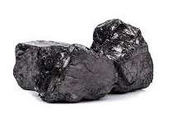
Nigeria is richly endowed with coal deposits that cut across 17 identified coalfields in thirteen states of the federation. The proven reserves of coal in the country are 639 million tonnes while the inferred reserves are about 2.75 billion tonnes, consisting approximately of 49% sub- bituminous, 39% bituminous, and 12% lignitic coals. Currently, there are 69 valid titles for coal comprising of 38 exploration licenses, 29 mining leases and 2 Small-Scale Mining leases.

In 2019, a total of 1,013,47 metric tons of coal was produced by eight companies namely Dangote Industry Ltd, Lafarge Plc, Rock Bottom, Zuma 828 Ltd, investment De-Rehoboth, Sanisami Farms Ltd, Sybstec Nig Ltd and Udomu Multipurpose Cooperative Ltd.

The major use of coal is in power generation as well as for the production of cement. Presently the aggregate Nigerian coal demands stand at about 15 million metric tonnes annually (https://bpe.gov.ng/nigerian-coal-corporation/).

Barite

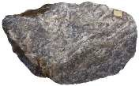
Barite is a non-metallic mineral with a relatively high specific gravity (SG = 3 to 4.4). Its occurrences in Nigeria are spread across the Cretaceous Benue Trough, which comprises of carbonaceous shales, limestone, siltstones, sandstones, as well as in the north-eastern, north- western and south-eastern parts of the Precambrian Basement Complex comprising of meta- sediments and granitoid. Azara Barite deposit in Nasarawa State has been actively mined by artisanal and small-scale miners. As an example of misuse of mineral licence, Maifata Nigeria Ltd., a Barite mining Company, operates on a revoked licence SSML 19413 sited at Ribi village in Awe local Government Area, Nasarawa State.

The company conducts open cast mining operation, using three excavators in addition to other motorized equipment, and only reported 250 tonnage of production with a payment of N100,000 as royalty in 2019. Another operator, Azara mines with licence SSML 30577, valid till 2024 also carries out mining activities yet it has no record of production or royalty payment in 2019 or the years before.

Limestone

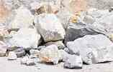
Nigeria has abundant Limestone covering 18 states namely: Cross-River, Ogun, Imo, Abia, Anambra, Ebonyi, Enugu, Benue, Ogun, Kogi, Edo Nasarawa, Yobe, Adamawa, Borno, Sokoto, Ondo and Kebbi States. Predominately, limestone is used in Cement production; it is also used as lime fertilizer, flux in glass, ceramics, iron and steel industries. In 2019, 31,729,954 tonnes of limestone were produced by 23 companies representing an increase of 23.92% over 2018 production of 25,604,581 tonnes.

Out of the 23 companies, three 3 cements manufacturing companies namely Dangote Cement Company plc, Lafarge Plc and BUA cement plc produced a total of 31,638,549 tonnes representing 99.71% of the total production. These three companies operate 10 cement factories across the nation. Thirty-six exploration licenses were issued in 2019.

Bitumen

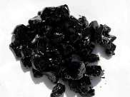

Nigeria has the sixth-largest bitumen deposit in the world which is estimated at 38 billion barrels. Nigeria’s bitumen occurs both on the surface and sub-surface, stretching to about 200km2. Bitumen occurs within the Quaternary Coastal Plain Sands of the Benin Formation dispersed along the coastal areas of South-western Nigeria in Ondo, Ogun, Edo and Lagos States. Bitumen is strategic to Nigeria as a major source of material for the development of its stock of road infrastructure as well as in the building industry, but it remains untapped. In 2019, there were 11 valid exploration licenses and 7 mining leases; none has commenced production. The earliest issued mining license was to Aspect Petroleum Ltd in 2016.

Mineral Production
Production data in the sector represents the quantity of minerals extracted, consumed or sold. This forms the basis for the computation of royalties in line with the provisions of the Nigeria Minerals and Mining Regulation 2011.

To obtain access to the desired mineral ore, the mining process requires the extraction of vast volumes of waste rock. In Nigeria, such mineral deposits are primarily mined using the open pit technique. The minerals obtained are used as raw materials for industrial and infrastructural growth as well as for import substitution. They are categorised as metallic minerals viz: precious metals (e.g. gold, Silver), ferrous metals (e.g. iron ore, Nickel) and base metals (e.g. lead/zinc, aluminum, tin) while the non-metallic minerals and rocks can be subdivided into industrial minerals (e.g. barite, salt, limestone, granite) and gemstones (e.g. sapphire, emerald, ruby). Energy minerals are those solid substances used for fuel (e.g. coal and uranium) See: Nigeria Mining Association Nigeria Ministry of Solid Minerals Investment Brochure - Nigeria Mining Association (minersassociation.org.ng)

In 2019, the total quantity of the minerals produced was 59.820million tons with royalty payment of N2.502 billion. See detailed breakdown in appendix 8.

Five-Year Production Trend
Table 16: Five-Year Production Trend

Year 2015 |  | 2016 | 2017 | 2018 | 2019 Total
Quantity | 39,272,591 | 43,087,164 | 35,326,690 | 46,680,658 | 59,820,953 | 224,188,056
Difference |  | 3,814,574 | (7,760,474) | 11,353,968 | 24,759,068 | 13,140,295
% Change | 9.71% |  | -18% | 32.14% | 28.15%
Source: NEITI SMA Reports

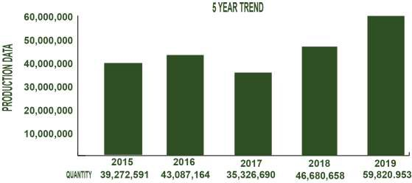
Figure 23: Five-Year Production Trend

Production by Mineral Types
The total production in 2019 was 59,820,953.07t with royalty payment of N2.502 billion, which represents an increase of 29.41% over 2018 production of 46.7 million tons.

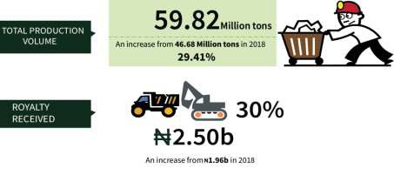
Figure 14: Production by Mineral type

Table17: Production by Mineral Type

S/N | Mineral | Quantity | Royalty (₦) | % Contribution (Ton)
1 | Limestone | 32,853,221.99 | 987,008,542.05 | 54.92%
2 | Granite Aggregate | 11,042,450.61 | 826,599,858.33 | 18.46%
3 | Laterite | 6,479,290.26 | 195,751,061.40 | 10.83%
4 | Clay | 2,874,504.38 | 57,506,754.21 | 4.81%
5 | Sand | 2,311,913.33 | 94,293,098.89 | 3.86%
6 | Granite Dust | 1,827,497.50 | 68,933,616.42 | 3.05%
7 | Shale | 1,092,124.15 | 27,303,103.65 | 1.83%
8 | Coal | 1,021,307.92 | 76,611,275.68 | 1.71%
9 | Marl Clay | 78,750.00 | 1,575,000.00 | 0.13%
10 | Tourmaline | 48,010.00 | 960,200.00 | 0.08%
11 | Lead/zinc Ore | 38,750.12 | 106,405,164.39 | 0.06%
12 | Dolomite | 34,505.79 | 1,725,289.50 | 0.06%
13 | Feldspar | 32,691.44 | 4,903,716.00 | 0.05%
14 | Gypsum | 22,637.09 | 5,536,115.00 | 0.04%
15 | Kaolin | 11,352.26 | 1,419,032.50 | 0.02%
16 | Quartz | 9,314.73 | 1,397,210.00 | 0.02%
17 | Zircon | 8,161.46 | 2,377,227.70 | 0.01%
18 | Fluorite | 5,930.83 | 889,625.00 | 0.01%
19 | Basalt | 5,266.67 | 395,000.00 | 0.01%
20 | Marble block | 4,571.78 | 4,571,780.00 | 0.01%
21 | Talc | 3,414.33 | 512,150.00 | 0.01%
22 | Granite Block | 3,257.67 | 4,886,500.00 | 0.01%
23 | Sapphire | 2,850.00 | 427,500.00 | 0.0048%
24 | Tin Ore | 1,786.76 | 2,816,519.00 | 0.0030%
25 | Topaz | 1,625.94 | 507,184.00 | 0.0027%
26 | Gemstones | 1,564.49 | 110,915.00 | 0.0026%
27 | Wolframite | 1,160.00 | 93,000.00 | 0.0019%
28 | Manganese | 1,100.00 | 330,000.00 | 0.0018%
29 | Columbite | 575.77 | 17,635,168.07 | 0.0010%
30 | Barites | 347.50 | 139,000.00 | 0.0006%
31 | Aquamarine | 301.60 | 15,080.00 | 0.0005%
32 | Mica | 212.00 | 15,900.00 | 0.0004%
33 | Graphite | 184.00 | 184,000.00 | 0.0003%
34 | Iron Ore | 160.29 | 31,257.50 | 0.0003%
35 | Lithium | 66.67 | 14,500.00 | 0.0001%
36 | Copper | 30.00 | 36,000.00 | 0.0001%
37 | Garnet | 26.00 | 26,000.00 | 0.0000%
38 | Cassiterite | 16.52 | 123,900.00 | 0.0000%

39 | Tantalite | 11.18 | 1,677,000.00 | 0.0000%
40 | Amethyst | 10.00 | 2,000.00 | 0.0000%
41 | Gold | 0.04 | 6,482,768.94 | 0.0000%
 | TOTAL | 59,820,953.07 | 2,502,229,013.23 | 100.00%
Source: 2019 NEITI SMA Templates

Production (Tons)
35,000,000.00
30,000,000.00
25,000,000.00
20,000,000.00
15,000,000.00
10,000,000.00
5,000,000.00
0.00
Limesto
ne
Granite
Aggrega Laterite te
Sand
Lead/zi Granite
nc Ore
Dust
Clay
Coal Shale Others
Production (Tons) 31,729,9 17,017,0 6,360,11 4,786,90 3,253,37 3,182,26 2,858,79 1,013,47 998,586. 239,240.
Figure 15: Production by Mineral Type

Five-year trend of minerals production

A five-year trend of mineral production shows that the total production in last five years was 224,188,056t. The highest production was in 2019 with 59,820,953.07t. This represents an increase of 29.41%, while the lowest production was in 2017 with 7,760,474t representing 18% reduction.

Table 18: Five-year trend of mineral production

S/N | Mineral Type | 2019 | 2018 | 2017 | 2016 | 2015
 | Tons |  | Tons | Tons | Tons | Tons
1 | Limestone | 32,853,222 | 25,604,581 | 19,433,558 | 26,996,569 | 21,454,966
2 | Granite Aggregate | 11,042,451 | 11,147,174 | 8,147,527 | 7,458,238 | 6,368,192
3 | Laterite | 6,479,290 | 3,483,564 | 2,702,365 | 2,074,013 | 2,377,975
4 | Lead/zinc Ore | 38,750 | 60,944 | 6,390 | 5,795 | -
5 | Granite Dust | 1,827,498 | - | 1,810,741 | 1,212,553 | 4,015,866
6 | Clay | 2,874,504 | 1,752,047 | 1,237,375 | 1,646,012 | 1,178,069

7 | Columbite | 576 | 1,300 | 873 | 1,044 | 289
8 | Sand | 2,311,913 | 1,486,134 | 205,733 | 1,508,705 | 2,008,035
9 | Coal | 1,021,308 | 1,909,813 | 638,062 | 104,425 | 121,316
10 | Shale | 1,092,124 | 1,026,279 | 849,868 | 1,882,676 | 1,075,870
11 | Granite Block | 3,258 | - | 7,628 | - | -
12 | Marble | 4,572 | 21,650 |  | 22,649 | -
13 | Feldspar | 32,691 | 26,409 |  | 35,092 | 13,238
14 | Dolomite | 34,506 | 23,664 |  | 33,364 | -
15 | Gypsum | 22,637 | 39,052 | 16,619 | 720 | 34,621
16 | Kaolin | 11,352 | 10,429 |  | 26,710 | 25,280
17 | Quartz | 9,315 | 2,900 |  | - | -
18 | Fluorite | 5,931 | - |  | - | -
19 | Basalt | 5,267 | - |  | - | -
21 | Wolframite | 1,160 | 50 | 4 | 15 | 52
22 | Sapphire | 2,850 | - |  | - | -
23 | Talc | 3,414 | 1,427 |  | 667 | -
24 | Graphite | 184 | - |  | - | -
25 | Topaz | 1,626 | 5 |  | 7 | -
26 | Tin Ore | 1,787 | 4,657 | 2,125 | 3,625 | 473
27 | Manganese | 1,100 | 58,666 | 37,346 | 70,107 | -
28 | Gemstones | 1,564 | - |  | - | -
29 | Aquamarine | 301.6 | - |  | - | -
30 | Barites | 347.5 | 83 |  | 1,712 | -
31 | Mica | 212 | 1,080 |  | - | -
32 | Tantalite | 11.18 | 6 |  | 29 | 32
33 | Lithium | 66.666697 | - |  | - | -
34 | Zircon | 8161.4623 | 120 | 1,799 | 1,073 | -
35 | Tourmaline | 48010 | - |  | - | -
36 | Garnet | 26 | - |  | - | -
37 | Amethyst | 10 | - |  | - | -
38 | Gold | 0.0381721 | - | - | - | -
39 | Copper | 30 | 30 |  | - | -
40 | Lead Ore |  | - | 1,470 | 700 | -
41 | Iron | 160.29487 | 3,198 |  | 665 | -
42 | Marl | 78750 | - | 227,508 | - | 595,044
43 | Rea Alluvium |  | - |  | - | 3,274
44 | Silica Sand |  | 12,059 |  | - | -
45 | Calcite |  | 3,168 |  | - | -

46 | Kunzite |  | 50 |  | - | -
47 | Cassiterite | 16.52
48 | coltan ore |  |  | 50
49 | Bentonite |  | 120 |  | - | -
 | Total | 59,820,953 | 46,680,659 | 35,327,040 | 43,087,165 | 39,272,592
Source: 2019 NEITI SMA Templates

Production according to State and region

The record of production of various minerals and their values according to the states and regions is presented in Table 19.
Table 19: Analysis of Production of Minerals by State

S/N
STATE
QUANTITY
ROYALTY PAID
% CONTRIBUTION REGION
PRODUCTION
1 | OGUN | 18,653,740 | 649,063,073 | 31.18% | SOUTH WEST
2 | KOGI | 12,777,507 | 414,996,602 | 21.36% | NORTH CENTRAL
3 | CROSS RIVER | 6,503,063 | 226,736,085 | 10.87% | SOUTH SOUTH
4 | EDO | 3,491,740 | 135,949,224 | 5.84% | SOUTH SOUTH
5 | SOKOTO | 2,404,804 | 72,446,835 | 4.02% | NORTH WEST
6 | OYO | 1,872,324 | 124,185,385 | 3.13% | SOUTH WEST
7 | FCT, ABUJA | 1,503,378 | 93,747,662 | 2.51% | NORTH CENTRAL
8 | ONDO | 1,484,643 | 98,038,573 | 2.48% | SOUTH WEST
9 | EBONYI | 1,472,016 | 150,465,038 | 2.46% | SOUTH EAST
10 | GOMBE | 1,304,948 | 51,880,093 | 2.18% | NORTH EAST
11 | KANO | 1,290,327 | 59,090,626 | 2.16% | NORTH WEST
12 | LAGOS | 791,166 | 35,402,183 | 1.32% | SOUTH WEST
13 | AKWA IBOM | 742,314 | 24,423,902 | 1.24% | SOUTH SOUTH
14 | KADUNA | 707,073 | 36,163,859 | 1.18% | NORTH WEST
15 | ZAMFARA | 593,834 | 27,920,173 | 0.99% | NORTH WEST
16 | ANAMBRA | 556,279 | 21,566,998 | 0.93% | SOUTH EAST
17 | KATSINA | 409,860 | 16,272,834 | 0.69% | NORTH WEST
18 | DELTA | 388,603 | 14,210,500 | 0.65% | SOUTH SOUTH
19 | BAUCHI | 372,371 | 45,746,966 | 0.62% | NORTH EAST
20 | NIGER | 334,482 | 24,915,362 | 0.56% | NORTH CENTRAL
21 | ABIA | 302,743 | 20,312,105 | 0.51% | SOUTH EAST
22 | NASARAWA | 273,819 | 24,286,350 | 0.46% | NORTH CENTRAL
23 | JIGAWA | 190,052 | 10,355,429 | 0.32% | NORTH WEST

24 | OSUN | 160,044 | 10,511,485 | 0.27% | SOUTH WEST
25 | KWARA | 155,623 | 12,116,513 | 0.26% | NORTH CENTRAL
26 | YOBE | 150,636 | 4,519,040 | 0.25% | NORTH EAST
27 | PLATEAU | 150,332 | 56,638,673 | 0.25% | NORTH CENTRAL
28 | EKITI | 136,898 | 9,411,483 | 0.23% | SOUTH WEST
29 | ADAMAWA | 131,829 | 7,349,113 | 0.22% | NORTH EAST
30 | ENUGU | 119,434 | 3,859,000 | 0.20% | SOUTH EAST
31 | IMO | 95,250 | 3,810,000 | 0.16% | SOUTH EAST
32 | TARABA | 79,480 | 4,649,067 | 0.13% | NORTH EAST
33 | BAYELSA | 75,146 | 3,005,828 | 0.13% | SOUTH SOUTH
34 | KEBBI | 53,301 | 3,547,399 | 0.09% | NORTH WEST
35 | RIVERS | 39,812 | 1,592,479 | 0.07% | SOUTH SOUTH
36 | BENUE | 32,082 | 1,543,076 | 0.05% | NORTH CENTRAL
37 | BORNO | 20,000 | 1,500,000 | 0.03% | NORTH EAST
 | TOTAL | 59,820,953 | 2,502,229,013 | 100.00%
Source: 2019 NEITI SMA Templates

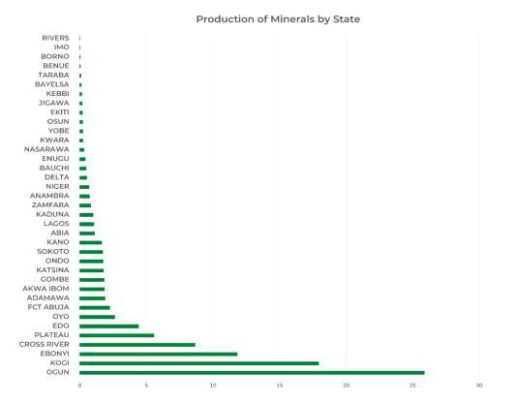

Figure 16: Production of Minerals by State

Production by Company

Records of mineral production by companies in 2019 are presented in Table 20. The total quantity produced by the 74 material companies was 55,209,434.02 tonnes which represents 92.3% of total production of 59,820,953.07tonnes.

Table 20: Summary of Minerals Produced by Companies

S/N
Minerals
1
A.A.Y. International Mining Company
ltd
Quantity
(T)
76,708.10
Mineral
2
AFIDIN Construction Ltd
141,925.72
3
Granite Aggregate
Granite Dust Granite Dust Laterite
Granite Aggregate
Quantity
(T)
54,327.92
22,380.18
8,592.72
133,333.00
41,321.00
4
Al'Sa'ab Quarry Multipurpose
Cooperative Society
Arab Contractors Limited
41,321.00

239,135.07
5
6
7
Asphalt Unity Construction
Balmore Trading Company Ltd Brothers Quarry Nigeria Limited
61,123.31
54,892.13
67,451.20
8
BUA Cement Plc.
2,282,585.83
9
BUA International
2,388,737.65
10
11
C. R. C. C
CCC Construction Nigeria Limited
108,760.00
110,132.76
12
CCECC Nig Ltd
979,282.52
13
CGC nig. Ltd
309,178.51
14
China Zhonghao nig. Ltd
190,043.33
15
CLC Technical and Engineering Nigeria
Limited
61,975.97
16
17
CNC Mining Company Ltd
Cossel construction company nig. Limited
Granite Aggregate
Granite Dust Laterite
Granite Aggregate Granite Aggregate Granite Aggregate Granite Dust Limestone
Clay Limestone Shale Sand
Granite Aggregate Laterite
Laterite
Granite Aggregate Granite Dust
Sand
Granite Aggregate Laterite
Granite Aggregate Laterite
Granite Aggregate Granite Dust
166,804.00 Granite Aggregate
43,592.66 Granite Aggregate
165,327.70
9,947.37
63,860.00
61,123.31
54,892.13
54,129.27
13,321.93
1,851,254.33
431,331.50
2,266,609.17
122,128.48
108,760.00
17,601.76
92,531.00
361,421.30
338,044.95
274,566.27
5,250.00
262,334.09
46,844.42
188,043.33
2,000.00
47,776.38
14,199.59
166,804.00
43,592.66

18 | Crushed Rock Industries (Nig) Ltd | 91,684.14 | Granite Aggregate | 91,684.14
19 | Dangote Cement | 21,959,186.06 | Laterite | 617,216.46
 |  |  | Limestone | 19,015,967.80
 |  |  | Clay | 2,326,001.80
20 | Dangote Industries | 1,903,476.52 | Granite Aggregate | 1,268,105.88
 |  |  | Coal | 635,370.64
21 | Dantata & Sawoe Construction Company | 113,109.14 | Laterite | 113,109.14
22 | Datum Construction Ltd | 136,303.90 | Granite Aggregate | 135,303.90
 |  |  | Granite Dust | 1,000.00
23 | EBH Granite Ltd | 107,318.00 | Granite Aggregate | 107,318.00
24 | First Patriot Limited | 17,924.48 | Lead/zinc Ore | 17,924.48
25 | Ganan Construction Company Limited | 80,000.00 | Granite Aggregate | 26,666.67
 |  |  | Granite Dust | 53,333.33
26 | Georgio Rock Limited | 217,742.31 | Granite Aggregate | 155,725.00
 |  |  | Granite Dust | 62,017.31
27 | Gerawa Global Engineering | 91,623.47 | Granite Aggregate | 30,844.00
 |  |  | Granite Dust | 5,779.48
 |  |  | Laterite | 54,999.99
28 | Gilmor Engineering Nigeria Limited | 144,687.63 | Granite Aggregate | 107,689.07
 |  |  | Granite Dust | 36,998.56
29 | Gitto Construzioni Generali Nigeria Ltd. | 213,328.20 | Granite Aggregate | 56,000.00
 |  |  | Granite Dust | 23,995.20
 |  |  | Laterite | 133,333.00
30 | Hitech Const. Ltd | 202,269.69 | Granite Aggregate | 80,803.69
 |  |  | Granite Dust | 121,466.00
31 | Homaset Limited | 59,066.67 | Granite Aggregate | 59,066.67
32 | Imperial J V Ltd | 5,759.72 | Lead/zinc Ore | 5,759.72
33 | Inorganic Earth Resources ltd | 81,317.93 | Granite Aggregate | 39,268.15
 |  |  | Granite Dust | 42,049.78
34 | jinziang Quarry Co. Ltd | 111,204.00 | Granite Aggregate | 111,204.00
35 | Julius Berger Nigeria Plc | 3,172,151.35 | Granite Aggregate | 187,666.97
 |  |  | Laterite | 2,554,425.16
 |  |  |  | 430,059.21
36 | Kopek Construction Limited | 158,906.00 | Granite Aggregate | 158,906.00
37 | Kunlun Nigeria Limited | 45,898.08 | Granite Aggregate | 45,898.08
38 | Lafarge Africa Plc | 10,483,927.33 | Limestone | 9,386,652.47
 |  |  | Gypsun | 18,884.00
 |  |  | Shale | 969,995.67
 |  |  | coal | 108,395.20
39 | Lake Petroleum Ltd | 105,000.00 | Sand | 105,000.00
40 | Levant Construction Limited | 162,666.67 | Granite Aggregate | 162,666.67

41 | Malcome mines limited | 555.94 | Tin Ore | 62.50
 |  |  | Columbite | 493.44
42 | Manhardi (nig.) Ltd | 45,465.50 | Granite Aggregate | 45,465.50
43 | Mark-Sino Nig. Ltd | 172,313.00 | Granite Aggregate | 172,313.00
44 | Master Rock Ltd. | 58,119.90 | Granite Aggregate | 58,119.90
45 | Mercury Mining Investment | 334,277.00 | Granite Aggregate | 334,277.00
46 | Mothercat Limited | 792,619.67 | Granite Aggregate | 147,183.77
 |  |  | Granite Dust | 48,249.67
 |  |  | Laterite | 574,356.23
 |  |  | Sand | 22,830.00
 | Muhammad Idris Dankabo | 75,015.51 | Granite Aggregate | 15,322.51
 |  |  | Granite Dust | 59,693.00
 | NBHH Nig Ltd | 120,000.00 | Granite Aggregate | 120,000.00
 | OFL Marble & Granite Ltd | 4,830.00 | Granite Block | 2,619.00
 |  |  | Marble Blocks | 2,211.00
49 | Petra Quarries Limited | 115,540.75 | Granite Aggregate | 115,540.75
50 | Pioneer Sinochino Investment Venture Ltd | 87,219.57 | Granite Aggregate | 87,219.57
51 | Platinum Asphalt & Crushing Company Ltd | 74,570.69 | Granite Aggregate | 74,570.69
52 | Prossy Investment Limited | 237,534.26 | Limestone | 237,534.26
53 | Ratcon Construction Company Limited | 237,222.66 | Granite Aggregate | 205,486.66
54 |  |  | Granite Dust | 31,736.00
55 | Reynolds Construction Company | 1,745,999.17 | Granite Aggregate | 881,729.55
 | Nigeria Limited |  | Granite Dust | 275,559.02
 |  |  | Laterite | 588,710.60
56 | Rock Bottom Mines and Power | 43,121.73 | Coal | 43,121.73
57 | Rock King Limited | 80,157.90 | Granite Aggregate | 56,884.80
 |  |  | Granite Dust | 23,273.10
58 | Rock waters integrated services nig. Limited | 86,552.90 | Granite Aggregate | 86,552.90
59 | Rockston Shelter Company Limited | 81,000.00 | Sand | 81,000.00
60 | Saliini Nigeria Ltd | 91,093.00 | Granite Aggregate | 91,093.00
61 | Saturn Mining Company Ltd | 88,121.00 | Granite Aggregate | 88,121.00
62 | Setraco nig. Ltd | 1,001,097.05 | Granite Aggregate | 881,438.06
 |  |  | Granite Dust | 29,626.66
 |  |  | Laterite | 90,032.33
63 | Sizhe Global Ltd | 49,582.00 | Granite Aggregate | 49,582.00
64 | Solid Unit Nigeria Limited | 11,912.73 | Lead/zinc Ore | 11,912.73
65 | Triacta Nig Ltd | 589,701.52 | Granite Aggregate | 307,434.75
 |  |  | Granite Dust | 156,991.00
 |  |  | Laterite | 124,775.77
 |  |  | Sand | 500.00

66 | Venus Mining Co. | 58,557.74 | Granite Aggregate | 58,557.74
67 | Woda Mountain Investment Limited | 238,544.00 | Granite Aggregate | 238,544.00
68 | XinXin Mining Resources | 58,382.65 | Granite Aggregate | 58,382.65
69 | XVE Gao Nig. Ltd. | 64,000.30 | Granite Aggregate | 64,000.30
70 | Z & Y INVESTMENT COMPANY LTD | 164,070.00 | Granite Aggregate | 164,070.00
71 | Zeberced Limited | 1,016,292.33 | Granite Aggregate | 640,938.67
 |  |  | Granite Dust | 375,353.67
72 | Zhong Tai Mining | 70,142.67 | Granite Aggregate | 70,142.67
73 | Zhong Xing Mining Investment Ltd | 97,017.61 | Granite Aggregate | 97,017.61
74 | Zuma 828 Limited | 230,602.22 | coal | 230,602.22
 | Total | 55,209,434.02 |  | 55,209,434.02
Source: 2019 NEITI SMA Templates

Export

Nigeria is promoting the export of solid minerals to support foreign exchange earnings for the country. Most of Nigeria’s minerals are exported in raw form with little or no beneficiation. The total exported mineral ores and concentrates in 2019 was 7,019,297.27t with a FoB value of US$2,531,910,885. Analysis of this is presented in Table 22, while further analysis of minerals export by type, destination and the exporting companies during the year under review is also presented in appendix 9.

Five Year-Trend of Mineral Export

A Five-year trend of mineral exports presented in Table 21 shows that 2018 recorded the highest percentage increase of 663% in total export, while the highest FOB increase of 1,653.66% was recorded in 2019.

Table 21: Five-Year Trend of Mineral Export

Year | 2015 | 2016 | 2017 | 2018 | 2019
Quantity (t) | 23,703,100.00 | 24,397,534.87 | 16,344,113.48 | 124,748,240 | 7,019,297.27
FOB (US$) | 206,520,058.98 | 40,924,053.00 | 29,901,420.00 | 144,378,580.00 | 2,531,910,885
% Change Quantity | 2.93% |  | (33.01)% | 663.26% | (94.37)%
% Change FOB | (80.18)% |  | (26.93)% | 382.85% | 1,653.66%
Source: CBN/NCS Record

0.00 | 2015 | 2016 | 2017 | 2018 | 2019
Quantity (t) | 23,703,100.00 | 24,397,534.87 | 16,344,113.48 | 124,748,240 | 7,019,297.27
FOB (US$) | 206,520,058.98 | 40,924,053.00 | 29,901,420.00 | 144,378,580.00 | 2,531,910,885

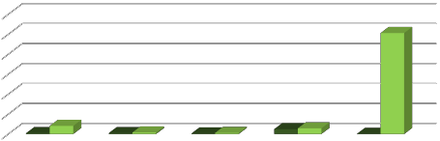Figure 17: Five-Year Trend of Mineral Export
Five-Year Export Trend
3,000,000,000.00
2,500,000,000.00
2,000,000,000.00
1,500,000,000.00
1,000,000,000.00
500,000,000.00
Quantity (t) FOB (US$)

Export by Mineral Type and Destination

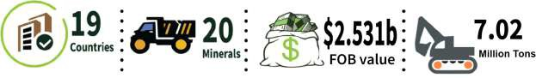

The total exported minerals in 2019 was 7,019,297.27t with an FOB Value of
$2,531,910,884.87; Silica and quartz sands constituted 59.09%, followed by Zinc and lead-ore with 36.2%.
Table 22: Export by Mineral Types and Destination

S/N | DESTINATION | EXPORTED PRODUCTS | GROSS WEIGHT (MT) | NESS FEE (NAIRA) | FOB VALUE(USD)
1 | Albania | Clays | 107 | 16,300.00 | 16,300.00
2 | Belgium | Lead Concentrate | 100 | 300,566.00 | 117,505.00
 | SUB TOTAL |  | 207 | 316,866 | 133,805
3 | Canada | Sandstone | 21 | 3,070.00 | 3,070.00
4 | China | Columbite | 2,350.32 | 3,928,071.90 | 2,550,545.60
4 | China | Crude mica and mica rifted into sheets or splitting | 186,900.71 | 20,886,214.00 | 21,223,915.00
4 | China | Fluorite and Lead Ore | 60 | 32,235.00 | 21,000.00
4 | China | Granite cut into blocks or sla in rectangular/ square | bs 10,153.00 | 158,569,166.00 | 176,980,916.00
4 | China | Lead ores and concentrates. | 2,177,973.59 | 1,153,370,391.23 | 1,148,565,407.51

 |  | Manganese Ore | 78,800.00 | 17,513,427.71 | 17,441,798.50
 |  | Silica sands and quartz sands | 4,147,444.50 | 733,656,247.00 | 817,216,070.00
 |  | Tin Ore | 127.6 | 81,606.20 | 51,559.20
 |  | Zinc and Lead Ore | 382,877.47 | 238,418,261.12 | 234,839,706.04
 |  | Zircon Sand | 3,371.32 | 477,790.94 | 324,107.96
 |  | SUB TOTAL | 6,990,058.51 | 2,326,933,411.10 | 2,419,215,025.81
5 | Gabon | Kaolin | 25,105.00 | 6,645,331.00 | 6,635,800.00
6 | Germany | Lead ores and concentrates. | 250 | 32,231,750.00 | 32,231,750.00
7 | Ghana | Dolomite, not calcined or sintered. | 293 | 932,360.00 | 932,360.00
 |  | Quartz | 50 | 2,302,500.00 | 2,609,500.00
 |  | SUB TOTAL | 343 | 3,234,860.00 | 3,541,860.00
8 | India | Zircon Sand | 19.97 | 13,931.87 | 8,547.16
 |  | Crude mica and mica | 800 | 4,757.00 | 543,391.00
 |  | SUB TOTAL | 819.97 | 18,688.87 | 551,938.16
9 | Kenya | Sandstone | 108 | 26,080.00 | 149,843.00
10 | Netherland | Zinc Ore | 50 | 32,565.63 | 21,250.00
11 | Poland | Lead ores and concentrates. | 180 | 66,301,200.00 | 63,463,898.20
12 | Republic of South Africa | Pebbles, gravel, broken or crushed | 2 | 17,357.00 | 17,357.00
13 | Russian Federation | Silica sands and quartz sands | 80 | 600 | 900
14 | South Korea | Lead Concentrate | 234.53 | 156,502.50 | 106,757.50
15 | Thailand | Columbite Concentrate | 26.26 | 440,031.99 | 286,759.20
16 | Turkey | Natural sands of all kinds, excluding silica and quartz | 1,556.00 | 5,000.00 | 5,050.00
17 | United Arab | Silica sands and quartz sands | 20 | 1,000.00 | 1,000.00
 | Emirates | Lead Ore | 24 | 25,319.25 | 16,500.00
 |  | SUB TOTAL | 44 | 26,319.25 | 17,500.00
18 | United States | Natural sands of all kinds, excluding silica and quartz | 12 | 3,221.00 | 3,221.00
19 | Vietnam | Lead ores and concentrates. | 200 | 5,525,100.00 | 5,525,100.00
 |  | Grand Total | 7,019,297.27 | 2,441,917,954.34 | 2,531,910,884.87
Source: CBN/NCS Record

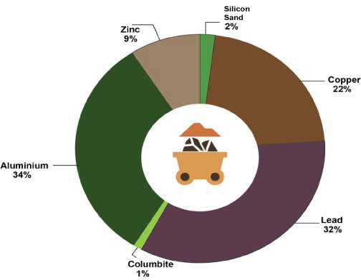

Figure 18: Export by Mineral Type

Export by Company

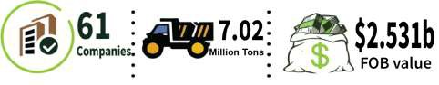

A total of Sixty-one (61) companies exported 7,019,297.27 Million tons with a FoB value of
$2,531,910,884.87 in 2019 as presented in Table 23.

Table 23: Export of Minerals By Companies

S/N | Exporter Name | Exported Products | Destination | Gross Weight (Mt) | FOB Value (USD)
1 | Abyem-Diva Intl Ltd. | Marble and travertine blocks | China | 3,000.00 | 4,052,400.00
2 | Adakunle Micheal Ayodele | Kaolin and other kaolinic clays | Gabon | 45 | 4,401,000.00
3 | Agrofix Intergrated | Lead ore | China | 250 | 156,250.00
 | Services Limited | Zinc ore | Netherland | 50 | 21,250.00
4 | Amocity And Enochris Global Services Ltd | Lead ores and concentrates. | China | 3,000.00 | 1,956,000.00

5 | Anglomittal Nig Lead ores and concentrates. Poland 180 66,301,200.00 Limited
6 | Anyang Kuangye Lead ores and concentrates. China 162,000.00 16,300,001.00 Investment Ltd  Abuja
7 | Aramex Delivery Clays Albania 107 16,300.00 Services Limited
8 | Backbone Kaolin Intergrated Services  Limited |  | Gabon | 60 18,000.00
9 | Barinua Kaolin  Communication Co Ltd |  | Gabon | 25,000.00 2,216,800.00
10 | Can Long Mining Columbite China 24 36,816.00 Limited
11 | Century Mining Co. Columbite-Nb Concentrate Thailand 26.26 286,759.20 Limited
12 | Charzom Concept Lead Concentrate Belgium 100 117,505.00 Limited
13 | Cosood Global Crude Mica and Mica Rifted China 28,140.11 4,253,760.00 Resources Limited
14 | Divine Austine Intl Crude Mica and Mica Rifted Ventures Ltd |  | China | 28,198.00 2,168,318.20
15 | Dove Quest Crude Mica and Mica Rifted International Ltd |  | China | 27,650.00 2,148,014.00
16 | Dto Commodity Lead Ore China 976.2 235,000.00 Trade Nigeria  Limited
17 | Everest Metal Lead Concentrate South Korea 210.15 94,567.50 Nigeria Limited
18 | F.Y.O. Alamm & Lead Concentrate South Korea 24.38 12,190.00 Sons Nigeria  Limited
19 | First Patriot Limited | Lead Concentrate |  | 6,098.72 6,479,071.51
19 | First Patriot Limited | Zinc Concentrate |  | 13,818.72 12,202,697.91
19 | First Patriot Limited | Columbite - Nb Concentrate |  | 104.5 1,596,090.00
20 | Flem Viotad Nigeria Crude Mica and Mica Rifted Ltd |  |  | 50,000.00 3,681,001.00
21 | Fujian Stone Granite Cut into Blocks Or Slabs Company Ltd |  |  | 6,313.00 111,896,916.00
22 | Futura Polyesters Dolomite Ghana 293 932,360.00 and Polymers  Limited
23 | G.C.C. Vanguard Ltd Granite Cut into Blocks or Slabs China 3,840.00 65,084,000.00
24 | Great Focus Nigeria Investments Ltd | Beryllium Ore and Zircon Sand | China | 20 7,000.00
24 | Great Focus Nigeria Investments Ltd | Flourite And Lead Ore | China | 60 21,000.00
24 | Great Focus Nigeria Investments Ltd | Zinc and Lead Ore | China | 80 28,000.00
24 | Great Focus Nigeria Investments Ltd | Lead Ore | China | 128 102,400.00
25 | Hanker Nonferrous Lead Ores and Concentrates. China 220,000.00 35,669,502.00 Metals Company  Ltd.
26 | Ijiyemi Victor Zinc ores and concentrates. China 25,000.00 12,322,800.00 Kolawole
27 | Iji International Zinc ore Investment Ltd |  | China | 42 37,800.00
28 | Imperial Jv Limited Zinc ore |  | China | 326,200.84 2,871,043.13
29 | International Sandstone Kenya 108 149,843.00

 | Fertilizer Development Center & Agriculture Development
30 | Jachillins Manganese ore China 300 43,200.00 International  Nigeria Ltd
31 | Juri Logistics Zircon sand India 19.97 8,547.16 Limited
32 | Kenyang Mining Company Ltd | Columbite | China | 249.46 101,927.60
32 | Kenyang Mining Company Ltd | Zircon sand | China | 1,511.22 161,757.53
33 | Kurian Link Lead Ores and Concentrates. China 440 181,023,700.00 Ventures Ltd
34 | Lead Freight & Lead Ores and Concentrates. Vietnam 200 5,525,100.00 Forwards Nig Ltd
35 | Lima Enterprises Natural Sands of All Kinds, Turkey 1,556.00 5,050.00 Limited Excluding Silica and Quartz
36 | Malcomines Ltd Lead Ores and Concentrates. China 1,427,207.67 809,408,904.00
37 | Metaminera Nigeria Zinc ore China 1,071.00 492,695.00 Limited
38 | Muahad Global Zinc / Lead Ore Concentrates. China 15,000.00 1,630,000.00 Resources Nig. Ltd.
39 | Nasibi International Zinc / Lead Ore Concentrates. China 49,957.00 1,085,580.00 Ltd
40 | Newrest Asl Epze Silica Sands and Quartz Sands Russian 80 900  Federation
41  42 | Oriental International Transport Nig. Ltd | Lead ore | China | 1,302.00 213,750.00
41  42 | Oriental International Transport Nig. Ltd | Zircon sand | China | 300 24,000.00
41  42 | Palladium Mining Lead Ores and Concentrates. Germany 250 32,231,750.00 Limited
43 | Peter Ekunwe Crude Mica and Mica Rifted into China 53,000.00 4,228,220.00 Sheets Or Splitting
43 | Phoenix Steel Mills Quartz Ghana 50 2,609,500.00 Limited,Ogijo-Remo
44 | Pu-Well Zinc ore International  Nigeria Ltd |  | China | 40 32,000.00
45 | Rexomorph Limited  Sunray Mining Investment Co. Ltd | Crude Mica and Mica Rifted | China | 54.6 1,657,800.00
 | Rexomorph Limited  Sunray Mining Investment Co. Ltd | Lead ore | China | 30 10,500.00
46 | Rexomorph Limited  Sunray Mining Investment Co. Ltd | Columbite | China | 1,296.68 524,512.00
46 | Rexomorph Limited  Sunray Mining Investment Co. Ltd | Tin ore | China | 76.1 30,759.20
46 | Rexomorph Limited  Sunray Mining Investment Co. Ltd | Zircon sand | China | 1,540.10 131,350.43
47 | Synee Alumony Zinc ore Mining Ltd |  | China | 54.91 15,000.00
48 | S.B Olatunji Global Lead Ores and Concentrates. Nigeria Ltd |  | China | 50 7,335,000.00
49 | Spectrum Products Limited | Zinc Ores and Lead Ore Concentrates | China | 1,400.00 205,131,170.00
50 | Tarka Minerals Lftz Enterprises | Zinc Ores and Lead Ore Concentrates | China | 303,279.00 86,983,874.00
51 | The Shell Petroleum Natural Sands of All Kinds, Development Excluding Silica and Quartz Company of Nigeria  Limited |  | United States 12 3,221.00
52 | Teromont Mining Columbite China 675.68 291,200.00

 | Company Nig Ltd | Tin ore |  | 51.5 | 20,800.00
53 | Uay Int'l Investments Limited | Lead ore | United Arab Emirates | 24 | 16,500.00
54 | Unr Mining Limited | Manganese ore | China | 500 | 83,798.50
55 | Ups Nigeria Limited | Pebbles, Gravel, Broken or Crushed Stone Other | Republic of South Africa | 2 | 17,357.00
 |  | Sandstone | Canada | 21 | 3,070.00
 |  | Silica Sands and Quartz Sands | United Arab Emirates | 20 | 1,000.00
56 | Venus World Class Limited | Lead ore | China | 3,215.00 | 1,573,875.00
57 | Wolbrys International Limited | Crude Mica and Mica Rifted | India | 800 | 543,391.00
58 | Yan Global Limited | Crude Mica and Mica Rifted | China | 28 | 326,000.00
59 | Yygc Energy Technology Company Limited | Silica Sands and Quartz Sands |  | 4,147,444.50 | 817,216,070.00
60 | Zeeny Global Resources Ltd | Manganese Ores/Concentrates, Including Ferruginous Manganese' Dry Content =>20 % |  | 75,000.00 | 13,262,400.00
61 | Zovin 83 Logistics Ltd | Lead ore |  | 40 | 32,000.00
 |  |  |  | 7,019,297.27 | 2,531,910,884.87
Source: CBN/NCS/MID Records

A further review of the record of mineral exports by companies showed that out of the Sixty- one (61) companies that exported mineral ores and concentrates (solid minerals) in 2019 as presented in Table 24. A total of 25 companies did show evidence of paying royalty; these companies have a royalty liability of N482,005,247.55.

Table 24: Liabilities of Exported minerals by companies

S/N | Exporter Name | Exported Products | Destination | Gross Weight (Mt) | FOB Value (US$) | Royalty Rate | Royalty Payable ()
1 | AGROFIX INTERGRATED SERVICES LIMITED | COLUMBITE | China | 49.6 | 19,857.20 | 12,000 | 595,200.00
1 | AGROFIX INTERGRATED SERVICES LIMITED | ZINC ORE | Netherland | 50 | 21,250.00 | 1,350 | 67,500.00
1 | AGROFIX INTERGRATED SERVICES LIMITED | LEAD ORE | China | 250 | 156,250.00 | 1,350 | 337,500.00
2 | BACKBONE INTERGRATED SERVICES LIMITED | KAOLIN | Japan | 60 | 18,000.00 | 125 | 7,500.00
3 | CAN LONG MINING LIMITED | COLUMBITE | South Korea | 24 | 36,816.00 | 12,000 | 288,000.00
4 | CENTURY MINING CO. LIMITED | COLUMBITE- NB CONCENTRATE | South Korea | 26.26 | 286,759.20 | 61,650 | 1,618,929.00
5 | CHARZOM CONCEPT LIMITED | LEAD CONCENTRATE | South Korea | 100 | 117,505.00 | 2,700 | 270,000.00
6 | DTO COMMODITY TRADE NIGERIA | LEAD ORE | China | 976.2 | 235,000.00 | 1,350 | 1,317,870.00

LIMITED
- EVEREST METAL NIGERIA LIMITED
- F.Y.O. ALAMM & SONS NIGERIA LIMITED
- GREAT FOCUS NIGERIA INVESTMENT CO.LTD

LEAD CONCENTRATE LEAD CONCENTRATE

FLOURITE AND LEAD ORE BERYLLIUM ORE AND ZIRCON SAND ZINC AND LEAD ORE

China 210.15 94,567.50 2,700 567,405.00

South Korea 24.38 12,190.00 2,700 65,826.00

China 60 21,000.00 1,350.00 81,000.00

China 20 7,000.00 300 6,000.00

208 130,400.00 1,350.00 280,800.00

- IJI
INTERNATIONAL INVESTMAENT LTD
- IMPERIAL JOINT VENTURE LIMITED
ZINC ORE China 42 37,800.00 1,350.00 56,700.00

ZINC ORE Indonesia 326,200.84 2,871,043.13 1,350.00 440,371,127.25

- JACHILLINS INTERNATIONAL NIGERIA LTD
MANGANESE ORE
China 300 43,200.00 300 90,000.00

- JURI LOGISTICS LIMITED
- KENYANG MINING COMPANY LTD
- METAMINERA NIGERIA LIMITED
- ORIENTAL INTERNATIONAL TRANSPORT NIG. LTD
ZIRCON SAND India 19.97 8,547.16 300 5,991.00

COLUMBITE South Korea 249.46 101,927.60 12,000.00 2,993,556.00
ZINCON SAND India 1,511.22 161,757.53 300 453,364.80
ZINC ORE Benin 1,071.00 492,695.00 1,350.00 1,445,850.00

LEAD ORE China 1,302.00 213,750.00 1,350.00 1,757,700.00
ZIRCON SAND China 300 24,000.00 300 90,000.00

- PU-WELL INTERNATIONAL NIGERIA LTD
ZINC ORE China (Hong Kong)
40 32,000.00 1,350.00 54,000.00

- SOMIATEA VENTURES NIGERIA LIMITED
- SUNRAY MINING
INVESTMENT CO. LTD

- SYNEE ALUMONY MINING LTD
- TEROMONT MINING COMPANY NIG LTD
LEAD ORE China 30 10,500.00 1,350.00 40,500.00

COLUMBITE China 1,247.08 504,654.80 12,000.00 14,964,960.00
ZIRCON SAND China 1,540.10 131,350.43 300 462,030.00
TIN ORES Indonesia 76.1 30,759.20 7,500.00 570,750.00
ZINC ORE China 54.91 15,000.00 1,350.00 74,128.50

COLUMBITE China 675.68 291,200.00 12,000.00 8,108,160.00
TIN ORE 51.5 20,800.00 7,500.00 386,250.00

- UAY INT'L INVESTMENTS LIMITED
LEAD ORE United Arab Emirates
24 16,500.00 1,350.00 32,400.00

- UNR MINING LIMITED
MANGANESE ORE
China 500 83,798.50 300 150,000.00

- VENUZ WORLD CLASS NIGERIA
LEAD ORE China 3,215.00 1,573,875.00 1,350.00 4,340,250.00

 | LIMITED
25 | ZOVIN 83 LEAD ORE China 40 32,000.00 1,350.00 54,000.00 LOGISTICS LTD
 | 340,549.45 7,853,753.25 167,225.00 482,005,247.55
Source: CBN/NCS/MID Records

Mineral Export in the Records of the Ministry of Mines and Steel Development

Sections 131 and 132 of the Nigerian Minerals and Mining Regulation 2011 confer on the Director of Mines Inspectorate Department (MID) of the Ministry of Mines and Steel Development (MMSD) the authority to issue permits to exporters of minerals for either commercial or analysis purposes.

In 2019, the MMSD record showed that a total of 37,220t of minerals were commercially exported, while 1.2mt of minerals were exported for analysis and sample purposes as contained in appendix 9. A further review of the permits issued for commercial export showed that a greater proportion of the exported minerals in the Nigeria Customs Service records are not in the MMSD records.

There is a cumulative difference of 6,982,076.7mt between NCS and MMSD records as contained in Table 25.
Table 25: Comparative analysis of exported minerals

S/N | Minerals | NCS Records | MMSD Records | Variance
 | MT |  | MT | MT
1 | Amethyst | 0 | 0.008986 | (0.0)
2 | Aquamarine | 0 | 0.050984 | (0.1)
3 | Beryl, | 0 | 0.000259 | (0.0)
4 | Citrine | 0 | 0.000002 | (0.0)
5 | Coal Ore | 0 | 10,000.00 | (10,000.0)
6 | Columbite | 2,377 | 179.73 | 2,197.3
7 | Crude mica & mica | 187,700 | 0 | 187,700.0
8 | Dolomite, not calcined or sintered | 293 | 0 | 293.0
9 | Emerald | 0 | 0.0000399 | (0.0)
10 | Flourite | 60 | 0 | 60.0
11 | Garnet | 0 | 0.00601 | (0.0)
12 | Gold | 0 | 0.07241 | (0.1)
13 | Green Tourmaline | 0 | 0.0085 | (0.0)
14 | Iron Ore | 0 | 0.00031 | (0.0)

15 | Kaolin | 25,105 | 0 | 25,105.0
16 | Lead Zinc Concentrate | 6,433 | 25,120.00 | (18,687.0)
17 | Lead/Zinc Ore | 2,172,528 | 1,700 | 2,170,828.0
18 | Manganese Ore | 75,800 | 0 | 75,800.0
19 | Marble cut into blocks/ rectangular shape | 13,260 | 0 | 13,260.0
20 | Natural sands excluding silica & quartz | 1,568 | 0 | 1,568.0
21 | Pebbles, gravel, broken or crushed stone | 2 | 0 | 2.0
22 | Quartz | 50 | 0 | 50.0
23 | Ruby. | 0 | 0.0001 | (0.0)
24 | Sapphire | 0 | 0.0000432 | (0.0)
25 | Sandstone | 129 | 0 | 129.0
26 | Silica sands and quartz sands | 4,147,545 | 0 | 4,147,545.0
27 | Tantalite Concrete | 0 | 0.01 | (0.0)
28 | Tin ore | 128 | 95.22 | 32.8
29 | Topaz | 0 | 0.190422 | (0.2)
30 | Zinc and lead ore | 369,109 | 125 | 368,984.0
31 | ZINC CONCENTRATE | 13,819 | 0 | 13,819.0
32 | ZIRCON SAND | 3,391 | 0 | 3,391.0
 | TOTAL | 7,019,297 | 37,220 | 6,982,076.7
Source: NCS/CBN/MID Record

From Table 25 above, there is a cumulative variance of 6,982,076.7 t of exported minerals between Nigeria Custom Service (NCS) and Mines Inspectorate Department (MID) record.

For instance, a total of 0.07241MT of gold was exported as per MID record, while NCS records shows that no gold was exported in 2019. Similarly, fourteen (14) exported minerals type as per NCS record are not in MID records, which implies that these minerals were exported without obtaining permits from MID.

Mineral Processing

Mineral processing significantly increases the value and income of minerals from their exploitation. Under private or public arrangements, Nigeria has few mineral processing plants being operated. Thus, the Federal Government plans to create solid minerals processing hubs in the six geopolitical zones in order to maintain the value addition initiatives. To this end, various projects/collaborations were undertaken towards promoting value addition:

In line with the concept of value addition on run-of mine-ore, a tin-ore Processing Plant was established by MMSD in response to a request made by Kaduna Mining Development Company Ltd in November 2019 (see Appendix 17 for details). Another flotation plant was installed and commissioned in 2017/2018 in Furfuri, Bungudu L.G.A, Zamfara State by a company called Surajabul Nigeria Limited for mineral processing. In 2019, Symbol Mining Ltd (ASX:SL1) constructed a density separation processing plant at its high-grade zinc and lead Macy Project, costing about $225,000. Mining at Macy Project started in July and ore is currently being mined above the resource grade of 18.3% zinc. Macy is part of the Imperial Project, a joint venture with Goidel Resources (40%). https://portal.minesandsteel.gov.ng/Home/ViewNews/30.

Artisanal and Small-Scale Mining

Artisanal and Small-scale Mining (ASM) activities involve groups of people who exploit mineral deposits with little capital, skill and technical know-how. The Artisanal and Small-scale mining (ASM) Department of the MMSD oversees and supervises ASM activities to ensure that they are restricted to the established zones of mineralisation, among other functions as specified in chapter 2 Section 90(3) of the Nigerian Mineral and Mining Act (2007), and the Nigerian Minerals and Mining Regulations (2011).

Artisanal and Small-scale miners operating in Nigeria solid minerals sector actively engage in mining of gold, tourmaline, topaz, lead/zinc, and other precious minerals which are highly priced internationally (https://africacheck.org/reports/digging-up-the-numbers-on-informal- mining-in-nigeria.). In the year under review, the Ministry of Mines and Steel Development (MMSD) through the ASM department reportedly carried out some critical sectorial activities aimed at developing and coordinating the activities of artisanal miners. These activities were:

a) Nationwide formalization and regularisation of Artisanal miners: The ministry, with funding from the world bank project; Mineral Sector Support for Economic Diversification (MinDiver), commenced the process for the comprehensive mapping of ASM sites, trading centres and registered co-operatives, through the establishment of remote sensing monitoring systems. This was aimed at formalization of the artisanal miners.

b) Provision of extension services to registered artisanal miners: The services included the distribution of safety equipment, capacity building on best safe mining practice, empowerment and clean-up of polluted environment.

- Development of National Action plan on the elimination of mercury in Mining: Due to the hazardous nature of the use of mercury in mining, a pilot scheme was launched in Osun State for the elimination of mercury in mining.

- Establishment of Child labour and Gender desk: This programme was launched in two states namely Niger and Kogi States to address the effect of child labour in communities where there is prevailing incidence of child labour.

As at 2019, there were 1,273 registered artisanal mining operators in Nigeria.6 Summary Table 26 shows state distributions of these operators

Table 26: State distribution of ASM Operators

S/N | State | No of Operators | Zone
1 | Kogi | 83 | North Central
2 | Nasarawa | 50 | North Central
3 | Plateau | 81 | North Central
4 | Benue | 26 | North Central
5 | Kwara | 19 | North Central
6 | Niger | 73 | North Central
7 | FCT | 23 | North Central
8 | Yobe | 20 | North East
9 | Adamawa | 20 | North East
10 | Bauchi | 59 | North East
11 | Gombe | 67 | North East
12 | Taraba | 12 | North East
13 | Borno | 6 | North East
14 | Kaduna | 34 | North West
15 | Jigawa | 13 | North West
16 | Kano | 25 | North West
17 | Kastina | 21 | North West
18 | Kebbi | 3 | North West
19 | Sokoto | 77 | North West
20 | Zamfara | 63 | North West
21 | Enugu | 26 | South East
22 | Abia | 33 | South East
23 | Ebonyi | 44 | South East
24 | Anambra | 33 | South East

6 Appendix 17 List of registered ASM operators in Nigeria

25 | Imo | 34 | South East
26 | Edo | 49 | South-South
27 | Delta | 23 | South-South
28 | Bayelsa | 4 | South-South
29 | Akwa Ibom | 17 | South-South
30 | Cross Rivers | 36 | South-South
31 | Rivers | 17 | South-South
32 | Oyo | 37 | South West
33 | Ekiti | 12 | South West
34 | Lagos | 15 | South West
35 | Ogun | 32 | South West
36 | Ondo | 14 | South West
37 | Osun | 72 | South West
 | Total | 1273
Source: MMSD-ASM

Mineral Buying Centres
The Nigerian Minerals and Mining Act, 2007 (Chapter 3: section 95) provided for the establishment of Mineral Buying Centres (MBCs) for the purpose of purchasing minerals recovered under small scale mining leases. The centres indirectly ensure the enforcement of compliance by mining operators on payment of royalties and mining taxes on mineral production.

As at 2019, Government transferred 3 MBCs to state Governments in Zamfara, Cross River and Taraba States. Currently, Nigeria has 284 certified Private Mineral Buying Centres as enumerated in Table 27. See appendix 6 for detail list of mineral buying centres across Nigeria.

Table 27: The Geo-Political Distribution of PMBC Across Nigeria

North Central
North West
NORTH EAST
SOUTH WEST
SOUTH EAST
SOUTH SOUTH
State | Total | State | Total | State | Total | State | Total | State | Total | State | Total
Plateau | 129 | Kaduna | 13 | Borno | 0 | Lagos | 18 | Abia | 1 | Rivers |  | 1
Kogi | 13 | Kano | 3 | Bauchi | 6 | Ogun | 0 | Anambra | 8 | Cross River |  | 0
FCT | 39 | Zamfara | 14 | Yobe | 0 | Oyo | 6 | Imo | 1 | Bayelsa |  | 0
Nasarawa | 17 | Jigawa | 0 | Taraba | 0 | Osun | 4 | Enugu | 0 | Akwa Ibom |  | 0
Niger | 1 | Sokoto | 1 | Adamawa | 0 | Ondo | 0 | Ebonyi | 3 | Delta |  | 0
Kwara | 5 | Katsina | 0 | Gombe | 0 | Ekiti | 0 |  |  | Edo |  | 1
Benue | 0 | Kebbi | 0
Total | 204 | Total | 31 | Total | 6 | Total | 28 | Total | 13 | Total |  | 2

Source: MMSD- ASM Records
Grand Total A+B+C++D+E+F
284

250
204
PMBC Distribution
200

150

100

50
31
28
6
13
2
0
North Central
North west
NORTH EAST
SOUTH WEST
SOUTH EAST SOUTH SOUTH
Figure 19: The Geo-Political Distribution of PMBC across Nigeria

REVENUE COLLECTION

71

4

REVENUE COLLECTION

This chapter covers revenue collection as well as report on all financial flows and all revenue that accrued to both Federal and State governments from the solid minerals sector.

4.1. Background

There are several streams through which government collects revenues from companies that operate in the solid minerals sector in Nigeria. The 2019 audit considered thirty-one (31) revenue streams which were reconciled using both primary source documents and third-party confirmations to ensure completeness, accuracy and reliability of data. Twenty-five (25) company level financial flows were reconciled, while six (6) flows were unilaterally disclosed. The unilaterally disclosed revenues were validated but not reconciled.

Validated and Reconciled Revenue Flows

Validated Unilateral Disclosed Reconciled Revenue Flows

1. | Royalty | 16. | Application for | 1. | Pay As You Earn (PAYE)
2. | Company Income Tax |  | Surrender Mining Titles | 2. | Annual Surface Rents
 | (CIT) | 17. | Renewal of Quarry |  | (Ground Rents)
3. | Education Tax (EDT) |  | Lease | 3. | Business Premises Fee
4. | Value Added Tax (VAT) | 18. | Fees for Application for | 4. | Environmental Fee
5. | Annual Service Tax |  | Certifies True Copy of | 5. | Air Quality & Waste
6. | Withholding Tax (WHT) |  | Lost Certificate |  | Permit
7. | Capital Gains Tax (CGT) | 19. | Application for | 6. | Registration Fees for
8. | Stamp Duties |  | Relinquishment of Title |  | Environmental Impact
9. | Renewal of Detonating | 20. | Licence to Buy |  | Analysis
 | Magazine |  | Explosives
10. | Blasting Certificates | 21. | Renewal Ammonium
11. | Permit to Mix ANFO |  | Nitrate Magazine
12. | Storage Facility | 22. | Explosives Magazine
13. | Permit to Erect |  | Licence
 | Magazine | 23. | Permit to Export
14. | Mining Title(s) |  | Mineral
 | Application Processing | 24. | Renewal of Buying
15. | Fee  Fee for Processing | 25. | Centre Fee  ASM Annual Fee
 | Renewal Application

Figure 20: Revenue Streams Validated and Reconciled

Overall reconciled receipts stood at N 72,488,081,000 while un-reconciled receipts stood at N.7,472,146,000. Also, a sectoral analysis shows that the FIRS collected the highest revenue of

₦69,918,427,563.00 in 2019, followed by the MID, MCO and FMoEnv respectively. State Board
of Internal Revenue Services (SBIRS) collected the sum of ₦5,092,349,020.00. See fig. 21 below.

Total Taxes and Revenues

The total revenue accrued to the Federation and other sub-national entities from the sector in 2019 was N79,960,226,962; revenue flow to the federation contributed 93.63% (N 74,867,877,942) while other sub-national entities contributed 6.3% (N5,092,349,020) as presented in Table 28. The aggregate financial flows comprise of revenue from FIRS, MCO, MID, FMoEnv and State Board of Internal Revenue Services (SBIRS). See appendix 4 content details of company level report.

Table 28: Aggregate Financial Flows

S/N | Description | Table | 2019 |  | % Contribution
 |  | Ref. | Naira |  | Naira
A | PAYMENT FLOWS TO FIRS
I | Value Added Tax (VAT) | 40 |  | 41,913,013,072 | 52.42%
II | Corporate Income Tax (CIT) | 39 |  | 4,557,019,391 | 5.70%
III | Education Tax | 42 |  | 5,214,490,072 | 6.52%
IV | Withholding Tax Credit | 41 |  | 17,194,837,946 | 21.50%
V | Capital Gain Tax | 43 |  | 589,554,787 | 0.74%
VI | Stamp Duties | 43 |  | 449,512,295 | 0.56%
 | Sub Total of payment to FIRS (A) |  |  | 69,918,427,563 | 87.44%
B | PAYMENT FLOWS TO MCO
I | Annual Service Fees | 38 |  | 1,756,578,500 | 2.20%
II | Application Fees | 38 |  | 226,909,815 | 0.28%
III | Transfer Fee | 38 |  | 161,140,000 | 0.20%
IV | Assignment | 38 |  | 95,757,000 | 0.12%
V | Renewal of Licence | 38 |  | 81,040,000 | 0.10%
VII | other fees and payments | 38 |  | 58,095,000 | 0.07%
 | Sub Total of payment to MCO (B) |  |  | 2,379,520,315.00 | 2.98%
C | PAYMENT FLOWS TO MID
I | Royalty | 33 |  | 2,502,229,014 | 3.13%
II | Explosives magazine licence | 33 |  | 20,170,630 | 0.03%
III | other fees and licences | 33 |  | 30,400,020 | 0.04%
 | Sub Total of payment to MID (C) |  |  | 2,552,799,664 | 3.19%
D | PAYMENT FLOWS TO MINISTRY OF ENVIRONMENT
I | Environmental fee | 58 |  | 13,138,400 | 0.02%

II | Air quality & waste Permit | 58 | 290,000 | 0.00%
III | Registration fees for environmental impact analysis | 58 | 3,702,000 | 0.00%
 | Sub Total of payment to Moe (D) | 17,130,400 |  | 0.02%
 | TOTAL FLOW TO FEDERAL GOVERNMENT | 74,867,877,942 |  | 93.63%
E | OTHER SUB NATIONAL ENTITIES (STATES)
I | Annual surface rents (Grounds Rents) | 45 | 525,381,008 | 0.66%
II | Pay as You Earn (PAYE) | 45 | 4,549,836,609 | 5.69%
III | Business Premises | 45 | 17,131,403 | 0.02%
 | Sub Total of payment to States (E) |  | 5,092,349,020 | 6.37%
 | Grand total (A+B+C+D+E) | 79,960,226,962 |  | 100.00%

Source: 2019 NEITI SMA Templates

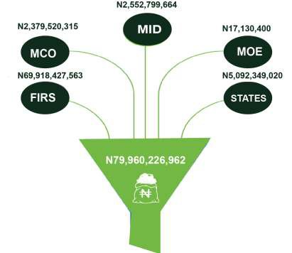
Figure 21: Aggregate Financial Flows

Summary of Company and Government Reconciliation

The total company payments to the government was N79.960billion of which N72.488billion representing 90.66% was reconciled against government records, while N7.472billion representing 9.34% was unilaterally disclosed. Table 29 shows the summary of company level payments by revenue streams. The unilaterally disclosed revenue comprises government disclosed revenue of N2.363 billion while company level disclosure N5.109 billion.

Table 30 shows the adjustment the IA made to arrive at the reconciled position. In arriving at the final reconciled position, the initial templates submitted by both the companies and government agencies were validated against source documents. Thereafter, the validated companies and government records were reconciled; where there were differences, further investigation was carried out and necessary adjustments made to arrive at the final reconciled position.

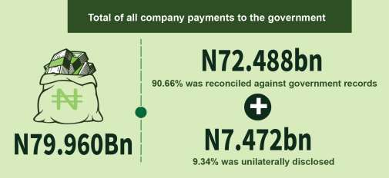

Unilateral Disclosures

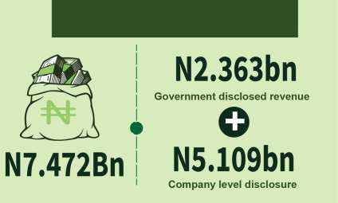
Figure 22:: Summary of Company and Government Reconciliation

Initial Declaration

The initial payments declared by the companies through the populated templates in 2019 was N58.633 billion, while intial reciepts as reported by Government was N69.889 billion. This gave rise to a reconciliation difference of N16,365 billion.

Table 29: Initial Declaration data

Revenue Stream | Government |  | Company | Differences
 | N’000 |  | N’000 | N’000
Value Added Tax (VAT) | 35,225,805 |  | 28,123,272 | 7,102,532
Corporate Income Tax (CIT) | 4,539,659 |  | 4,330,019 | 209,640
Education Tax | 5,534,590 |  | 5,025,780 | 508,810
Withholding Tax Credit | 17,283,798 |  | 17,165,738 | 118,060
Capital Gain Tax | 573,555 |  | 542,555 | 31,000
Stamp Duties | 449,512 |  | 449,512 | -
Mining titles(s) application processing fee | 2,940 |  | 2,040 | 900
Fee for processing of renewal application | 550 |  | 130 | 420
Annual service fees | 1,667,926 |  | 967,926 | 700,000
Application for relinquishment | 50 |  | 50 | -
Application for surrender mining titles | 20 |  | 20 | -
Fees for cadastre map information | 600 |  | 800 | -200
Fees for application for certified true copy of lost certificate | 250 |  | 250 | -
Renewal of Quarry Lease | 200 |  | 200 | -
Royalty | 2,233,465 |  | 2,013,465 | 220,000
Renewal of detonating magazine | 160 |  | 160 | -
Blasting certificates | 1,463 |  | 103 | 1,360
Permit to mix ANFO | 1,030 |  | 603 | 427
Storage facility | 150 |  | 150 | -
Permit to erect a magazine | 10 |  | 10 | -
License to buy explosives | 1,830 |  | 1,450 | 380
Renewal Ammonium nitrate magazine | 50 |  | 50 | -
Explosives magazine license | 9,320 |  | 9,320 | -
Renewal of Buying Centre | 170 |  | 170 | -
 | - |  | - | -
Total (reconcilable flow) | 67,527,104 |  | 58,633,774 | 8,893,329
Unilateral Disclosed | - |  | - | -
Annual surface rents (Grounds Rents)- company | - |  | 525,381
Pay as You Earn (PAYE)- company | - |  | 4,549,837
Business Premises- company | - |  | 17,131
Environmental fee- company | - |  | 13,138
Air quality & waste Permit- company | - |  | 290
Registration fees for EIA- company | - |  | 3,702

ASM fee- Government | 1,120 | -
Unilateral Disclosed payments to MCO- Government | 2,057,516 | -
Unilateral Disclosed payments to MID- Government | 304,031 | -
Sub Total | 2,362,667 | 5,109,479 | 7,472,146
Grand Total | 69,889,771 | 63,743,253 | 16,365,475
Source: 2019 NEITI SMA Templates

4.2.3. Reconciliation of Discrepancies

The initial declared information as provided by both government and the companies were validated against sourced documents, while the established differences were investigated and reconciled. The un-reconciled differences of 16.625 billion were reconciled as contained in Table 30:
Table 30: Reconciliation of Discrepancies

S/N | Revenue Stream | Government | Company | Difference
 | N’000 |  | N’000 | N’000
1 | Value Added Tax (VAT) | 6,687,208.00 | 13,789,741.00 | 7,102,533
2 | Corporate Income Tax (CIT) | 17,360.00 | 227,000.00 | 209,640
3 | Education Tax | -320,100.00 | 188,710.00 | 508,810
4 | Withholding Tax Credit | -88,961.00 | 29,099.00 | 118,060
5 | Capital Gain Tax | 15,999.00 | 46,999.00 | 31,000
6 | Mining titles(s) application processi | ng fee 0.00 | 900.00 | 900
7 | Fee for processing of renewal application 0.00 |  | 420.00 | 420
8 | Annual service fees | -1,350,730.00 | -650,730.00 | 700,000
9 | Fees for cadastre map information | 200.00 | 0.00 | -200
10 | Royalty | 0.00 | 220,000.00 | 220,000
11 | Blasting certificates | 0.00 | 1,360.00 | 1,360
12 | Permit to mix ANFO | 0.00 | 427.00 | 427
13 | License to buy explosives | 0.00 | 380.00 | 380
14 | Total Reconciled flow | 4,960,976.00 | 13,854,306.00 | 8,893,330
 | Unilateral Disclosed | -
15 | Annual surface rents (Grounds Rents | ) - |  | 525,381
16 | Pay as You Earn (PAYE) | - |  | 4,549,837
17 | Business Premises | - |  | 17,131
18 | Environmental fee | - |  | 13,138
19 | Air quality & waste Permit | - |  | 290
20 | Registration fees for EIA | - |  | 3,702
21 | ASM fee | - |  | 1,120
22 | Unilateral Disclosed payments to M | CO - |  | 2,057,516

23 | Unilateral Disclosed payments to MID |  | - | 304,031
 | Sub Total Unilateral |  | - | 7,472,146
 | Grand Total | 4,960,976 | 13,854,306 | 16,365,476
Source: 2019 NEITI SMA Templates

Trend Analysis of Financial Flows
      - Analysis of Revenues Accruing to Federation

Five-year analysis of revenues accruing to the Federation from the sector from 2015 to 2019 shows that the aggregate revenue earned was N304.8billion as presented in Table 24. Revenue that accrued to the Federation increased from 2018 to 2019, by 7.77%.

Table 31: Five-year trend analysis

Year | 2015 | 2016 | 2017 | 2018 | 2019 | Total
 | N bn | N bn | N bn | N bn | N bn | N bn
Amount | 64.46 | 43.22 | 52.78 | 69.47 | 74.87 | 304.8
%Variance |  | -32.95% | 22.11% | 31.63% | 7.77%
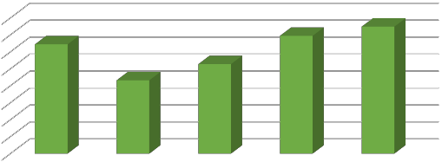Source: 2019 NEITI SMA Templates& NEITI Reports
Trend Analysis
74.87
80
70
60
50
40
30
20
10
0
69.47
64.46
52.78
43.22
2015 2016 2017 2018 2019
Amount (N'bn)

Figure 23: Five-Year Trend of Revenue to Federation

Financial flow statements
Table 32 presents a comprehensive distribution of revenue flow over the last 5 years:

Table 32: Five-Year Trend Financial Flows Statement

S/N | 2015 | 2016 | 2017 | 2018 | 2019
 | Naira | Naira | Naira | Naira | Naira
A | PAYMENT FLOWS TO FIRS
I | Value Added Tax (VAT) 32,851,491,914 | 20,244,510,690 | 34,024,831,429 | 39,578,311,277 | 41,913,013,072

Ii | Corporate Income Tax (CIT) | 16,004,390,555 | 10,575,945,892 | 2,360,603,443 | 10,034,683,377 | 4,557,019,391
Iii | Education Tax | 4,493,118,698 | 2,284,103,976 | 2,521,937,272 | 3,790,263,831 | 5,214,490,072
Iv | Withholding Tax Credit | 9,244,744,177 | 7,175,636,760 | 10,250,628,327 | 12,285,696,533 | 17,194,837,946
V | Capital Gain Tax | - | - | - | - | 589,554,787
 | Others 4,007,857
Vi | Stamp Duties | - | - | - | - | 449,512,295
 | Sub Total of payment to FIRS (A) | 62,593,745,344 | 40,280,197,318 | 49,162,008,329 | 65,688,955,017 | 69,918,427,563
B | PAYMENT FLOWS TO MCO
I | Annual Service Fees | 123,287,500 | 840,107,100 | 275,978,000 | 1,186,423,290 | 1,756,578,500
Ii | Other Fees | 431,586,500 | 310,757,000 | 1,732,788,950 | 384,675,975 | 622,941,815
 | Sub Total of payment to MCO (A | ) 554,874,000 | 1,150,864,100 | 2,008,766,950 | 1,571,099,265 | 2,379,520,315
C | PAYMENT FLOWS TO MID
I | Royalty | 1,102,238,511 | 1,641,018,938 | 1,561,405,717 | 2,147,215,780 | 2,502,229,014
Ii | Permits & Others | 212,762,123 | 49,193,280 | 24,996,754 | 63,552,225 | 50,570,652
 | Sub Total of payment to MID (C) | 1,315,000,634 | 1,690,212,218 | 1,586,402,471 | 2,210,768,005 | 2,552,799,666
D | PAYMENT FLOWS TO MINISTRY OF ENVIRONMENT
I | Environmental fee | - | - | - | - | 13,138,400
Ii | Air quality & waste Permit | - | - | - | - | 290,000
Iii | Registration fees for environment impact analysis | al - | - | - | - | 3,702,000
 | Sub Total of payment to FMEnv ( | D) | 0 | 0 | 0 | 17,130,400
 | 64,463,619,978 |  | 43,121,273,636 | 52,757,177,750 | 69,470,822,287 | 74,867,877,944
E | OTHER SUB NATIONAL ENTITIES (STATES & LGA)
I | Annual surface rents (Grounds Rents) – LGA | 17,897,060 | 12,785,260 | 96,181,011 | 105,279,305 | 525,381,008
Ii | Pay as You Earn (PAYE) - State | 4,249,764,595 | 3,969,874,652 | 2,446,949,420 | 10,090,735,434 | 4,549,836,609
Iii | Property Rates (Tenement Rate) – 92,537,198 LGA |  | 690,000 | 21,397,620 | 13,865,620 | -
Iv | Withholding Tax Credit - State | 253,235,212 | 94,672,593 | 284,580,290 | 464,716,808 | -
V | Operation Fee -– LGA | - | - | 1,650,000 | - | -
Vi | National Inland Water Ways Authority (NIWA) - State | 26,158,000 | - | 5,341,320 | - | -
Vii | Development Levy - State | 100,000 | - | 2,317,000 | - | -
Viii | Environment Support - State | - | - | 360,000 | - | -
Ix | Ind. Affluent Discharge Fee – Stat | e - | - | 240,000 | - | -
X | Fire Service – State | - | - | 3,000,000 | - | -
Xii | Fees - Ministry of Public Transportation | - | 592,500 | - | - | -
Xiii | Business Premises | 505,000 | 300,000 | 15,257,206 | 13,715,000 | 17,131,403
 | Sub Total of payment to States (E) 4,640,197,065 |  | 4,078,915,005 | 2,877,273,866 | 10,688,312,167 | 5,092,349,020
 | Grand total (A+B+C+D+E) | 69,103,817,044 | 47,200,188,641 | 55,634,451,616 | 80,159,134,454 | 79,960,226,964
 | Percentage increase/(decrease) |  | -31.70% | 17.87% | 44.08% | -0.25%
Source: 2019 NEITI SMA Templates& NEITI Reports

Royalty and other levies

The total revenue attributable to the solid minerals sector from the Ministry of Mines and Steel Development (MMSD) in 2019 was N4,932,319,981 with royalty contributing N2,502,229,014 representing 50.73%, and revenue from Mining Cadastre Office (MCO) contributing 2,379,520,315 representing 48.24%. Other revenue streams contributed N 50,570,652 representing 1.03% as presented in Table 33.

Table 33: Breakdown of Revenue to MMSD

S/N | Revenue Flow | Naira | % Contribution
I | Royalty | 2,502,229,014 | 50.73%
Ii | Renewal of detonating magazine | 160,000 | 0.00%
Iii | Blasting certificates | 6,838,288 | 0.14%
Iv | Permit to mix ANFO | 1,450,000 | 0.03%
V | Storage facility | 150,000 | 0.00%
Vi | Permit to erect a magazine | 500,000 | 0.01%
vii | Licence to buy explosives | 4,716,789 | 0.10%
viii | Renewal Ammonium nitrate magazine | 50,000 | 0.00%
Ix | Explosives magazine licence | 20,170,630 | 0.41%
X | Renewal of Buying Centre | 170,000 | 0.00%
Xi | ASM fee | 1,120,000 | 0.02%
xii | other fees and licenses | 15,244,945 | 0.31%
xiii | MCO revenue | 2,379,520,315 | 48.24%
 | Total | 4,932,319,981 | 100.00%
Source: 2019 NEITI SMA Templates

Royalty Payments

Total royalty earned in 2019 was N2,502,229,0147 showing an increase of N292 million over 2018 receipts, representing a 13.21% increase. Table 34 shows five-year trend analysis of royalty payments.

Table 34: 5 years Trend of royalty payments

Year | 2015 |  | 2016 | 2017 | 2018 | 2019 | Total
 | N bn |  | N bn | N bn | N bn | N bn
Revenue |  | 1.32 | 1.69 | 1.61 | 2.21 | 2.502 |  | 9.32
Difference |  |  | 0.37 | (0.08) | 0.6 | 0.292
% Increase/Decrease |  |  | 28.52% | (4.97) % | 37.61% | 13.21%
Source: 2019 NEITI SMA Templates& NEITI Reports

7 Appendix 10 breakdown of royalty payment

0 | 2015 | 2016 | 2017 | 2018 | 2019
Revenue (N'bn) | 1.32 | 1.69 | 1.61 | 2.21 | 2.502

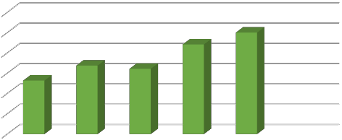Figure 24: Five-Year Trend of Royalty Revenue
3

2.5

2

1.5

1

0.5
Royalty Revenue
₦’billion

Royalties by Minerals
In 2019 Limestone contributed 37.68% of the total royalty earned, followed closely by granite which contributed 31.31% as presented in Table 35.

Table 35: Royalty by Mineral

S/N | Minerals | Royalty (N) | % Contribution
1 | Limestone | 942,784,724.00 | 37.68%
2 | Granite Aggregate | 783,458,628.52 | 31.31%
3 | Laterite | 181,596,429.58 | 7.26%
4 | Granite Dust | 129,591,332.00 | 5.18%
5 | Lead/zinc Ore | 106,190,157.14 | 4.24%
6 | Sand | 83,514,574.98 | 3.34%
7 | Coal | 76,613,525.68 | 3.06%
8 | Shale | 127,303,103.65 | 5.09%
9 | Columbite | 14,395,352.27 | 0.58%
10 | Clay | 11,035,718.00 | 0.44%
11 | Tin Ore | 8,605,477.25 | 0.34%
12 | Gold | 6,482,768.94 | 0.26%
13 | Gypsum | 5,536,115.00 | 0.22%
14 | Granite Block | 4,811,500.00 | 0.19%
15 | Feldspar | 4,803,716.00 | 0.19%
16 | Marble | 2,365,780.00 | 0.09%
17 | Granite Marbles | 2,211,000.00 | 0.09%
18 | Dolomite | 1,725,289.50 | 0.07%
19 | Tantalite | 1,677,000.00 | 0.07%
20 | Kaoline | 1,590,157.50 | 0.06%
21 | QUARTZ | 1,397,210.00 | 0.06%
22 | Fluorite | 889,625.00 | 0.04%

23 | Tormaline | 860,200.00 | 0.03%
24 | Topaz | 507,184.00 | 0.02%
25 | Sapphire | 427,500.00 | 0.02%
26 | Basalt | 395,000.00 | 0.02%
27 | Talc | 391,550.00 | 0.02%
28 | Manganese | 330,000.00 | 0.01%
29 | Barites | 209,500.00 | 0.01%
30 | Graphite | 184,000.00 | 0.01%
31 | Gemstones | 110,915.00 | 0.004%
32 | Wolframite | 93,000.00 | 0.004%
33 | Copper | 36,000.00 | 0.001%
34 | Zircon | 31,500.00 | 0.001%
35 | Garnet | 26,000.00 | 0.001%
36 | Mica | 15,900.00 | 0.001%
37 | Aquamarine | 15,080.00 | 0.001%
38 | Lithium | 14,500.00 | 0.001%
39 | Amethyst | 2,000.00 | 0.000%
 | Total | 2,502,229,014.00 | 100.00%

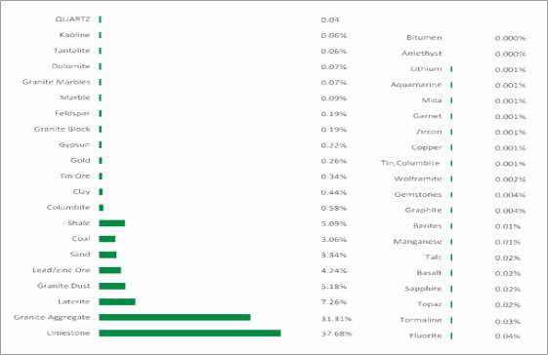
Figure 25: Royalty by Mineral

Royalties by State
The disaggregated royalties by state shows that, Ogun state provided the largest share of royalties, contributing 25.94% of the total royalty earned in 2019; while the lowest royalty was paid by Borno state with 0.06% contribution.

Table 36: Royalties by States

S/N | State | Total | % Contribution | Region
1 | Ogun | 649,063,073 | 25.94% | South West
2 | Kogi | 414,996,602 | 16.59% | North Central
3 | Cross River | 226,736,085 | 9.06% | South South
4 | Ebonyi | 150,465,038 | 6.01% | South East
5 | Edo | 135,949,224 | 5.43% | South South
6 | Oyo | 124,185,385 | 4.96% | South West
7 | Ondo | 98,038,573 | 3.92% | South West
8 | FCT, Abuja | 93,747,662 | 3.75% | North Central
9 | Sokoto | 72,446,835 | 2.90% | North West
10 | Kano | 59,090,626 | 2.36% | North West
11 | Plateau | 56,638,673 | 2.26% | North Central
12 | Gombe | 51,880,093 | 2.07% | North East
13 | Bauchi | 45,746,966 | 1.83% | North East
14 | Kaduna | 36,163,859 | 1.45% | North West
15 | Lagos | 35,402,183 | 1.41% | South West
16 | Zamfara | 27,920,173 | 1.12% | North West
17 | Niger | 24,915,362 | 1.00% | North Central
18 | Akwa Ibom | 24,423,902 | 0.98% | South South
19 | Nasarawa | 24,286,350 | 0.97% | North Central
20 | Anambra | 21,566,998 | 0.86% | South East
21 | Abia | 20,312,106 | 0.81% | South East
22 | Katsina | 16,272,834 | 0.65% | North West
23 | Delta | 14,210,500 | 0.57% | South South
24 | Kwara | 12,116,513 | 0.48% | North Central
25 | Osun | 10,511,485 | 0.42% | South West
26 | Jigawa | 10,355,429 | 0.41% | North West
27 | Ekiti | 9,411,483 | 0.38% | South West
28 | Adamawa | 7,349,113 | 0.29% | North East
29 | Taraba | 4,649,067 | 0.19% | North East
30 | Yobe | 4,519,040 | 0.18% | North East
31 | Enugu | 3,859,000 | 0.15% | South East
32 | Imo | 3,810,000 | 0.15% | South East
33 | Kebbi | 3,547,399 | 0.14% | North West
34 | Bayelsa | 3,005,828 | 0.12% | South South
35 | Rivers | 1,592,479 | 0.06% | South South
36 | Benue | 1,543,076 | 0.06% | North Central
37 | Borno | 1,500,000 | 0.06% | North East
 | 2,502,229,014.00 |  | 100.00%
Source: 2019 NEITI SMA Templates

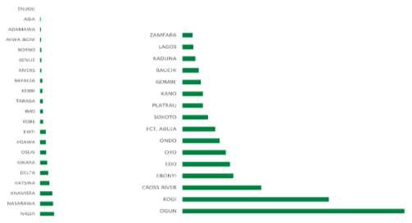

Figure 26: State Distribution of Royalty.

Royalties by Company

In 2019 the total royalty received was N2,502,229,014.00. Sixty-Eight (68) reconciled companies paid N2,192,705,099.67 representing 87.63% while 634 companies below the materiality threshold paid N309,523,914.22. The Dangote group comprising Dangote Cement Plc and Dangote Industries contributed 31.11% of the total royalties, followed by Lafarge plc with 12.79%.

Table 37: Company distribution of royalty

S/N | Name | Royalty Paid (N) | % Contribution
1 | Dangote Cement Plc | 635,515,563.95 | 25.40%
2 | Lafarge Plc | 320,111,882.50 | 12.79%
3 | Dangote industries | 142,760,695.26 | 5.71%
4 | Julius Berger Plc | 107,910,086.40 | 4.31%
5 | Reynolds Construction Company Nig. Ltd | 94,124,643.50 | 3.76%
6 | BUA-CCNN | 71,051,487.00 | 2.84%
7 | Setraco NIG. LTD | 69,922,112.07 | 2.79%
8 | BUA Cement Plc- Okpella | 64,164,260.00 | 2.56%
9 | Zeberced Limited | 62,146,170.00 | 2.48%
10 | First Patriot Limited | 49,292,317.50 | 1.97%
11 | CCECC Nig Ltd | 46,775,370.00 | 1.87%
12 | Solid Unit Nig. Ltd | 32,760,000.00 | 1.31%
13 | Triacta Nig Ltd | 32,708,042.00 | 1.31%
14 | Mother Cat Nig Ltd | 30,992,032.40 | 1.24%
15 | Mercury Mining Investment Ltd | 25,071,443.00 | 1.00%
16 | CGC Nig. Ltd | 21,080,336.00 | 0.84%
17 | Woda Mountain Invest. Nig. Ltd | 17,891,142.00 | 0.72%
18 | Zuma 828 Limited | 17,310,703.00 | 0.69%
19 | Ratcon Construction Company Ltd | 16,624,113.00 | 0.66%
20 | Arab Contractor Limited | 14,693,432.00 | 0.59%
21 | China Zhonghao Nig. Ltd | 14,163,250.00 | 0.57%

22 | Georgio Rocks Limited | 14,005,024.25 | 0.56%
23 | Mark-Sino Nig. Ltd | 12,923,672.00 | 0.52%
24 | CNC Mining Company Limited | 12,510,305.25 | 0.50%
25 | Z & Y Investment Company Ltd | 12,308,250.00 | 0.49%
26 | Levant Construction Ltd. | 12,200,000.00 | 0.49%
27 | Kopek Construction Limited | 11,942,700.00 | 0.48%
28 | Hitech Construction Ltd | 10,660,277.00 | 0.43%
29 | Datum Construction Ltd | 10,185,333.00 | 0.41%
30 | Gilmor Engineering | 9,464,126.00 | 0.38%
31 | Gitto Costruzioni Generau Nig. Ltd | 9,100,000.00 | 0.36%
32 | NBHH Nig Ltd | 9,046,271.00 | 0.36%
33 | Petra Quarries Ltd | 8,665,556.00 | 0.35%
34 | Jinziang Quarry Co. Ltd | 8,340,300.00 | 0.33%
35 | E. B. H. Granite Ltd | 8,048,280.00 | 0.32%
36 | Zhong Xing Mining Investment Ltd | 7,276,320.70 | 0.29%
37 | Crushed Rock Industries (Nig) Ltd | 6,876,310.59 | 0.27%
38 | Saliini Nigeria Ltd | 6,831,942.72 | 0.27%
39 | Saturn Mining Company Ltd | 6,609,104.00 | 0.26%
40 | Rock Waters Integrated Services Nig. Ltd | 6,491,467.50 | 0.26%
41 | Malcomines Ltd | 6,390,000.00 | 0.26%
42 | OFL Marble & Granite Ltd | 6,139,500.00 | 0.25%
43 | Platinum Asphalt and Crushing Co. Ltd | 5,592,802.00 | 0.22%
44 | Zhong Tai Mining (Nig.) Limited | 5,260,700.00 | 0.21%
45 | Rock King Construction Limited | 5,139,942.00 | 0.21%
46 | A.A.Y. International Mining Company ltd | 4,913,850.60 | 0.20%
47 | XVE GAO (Nig.) Limited | 4,800,000.00 | 0.19%
48 | Brothers Quarry Nig. Ltd | 4,562,940.63 | 0.18%
49 | Inorganic Earth Resources ltd | 4,521,987.98 | 0.18%
50 | Homaset Limited | 4,430,000.00 | 0.18%
51 | Venus Mining Co. | 4,391,950.00 | 0.18%
52 | XinXin Mining Resources | 4,378,678.00 | 0.17%
53 | Master Rock Ltd | 4,358,972.40 | 0.17%
54 | China Railway Construction Company | 4,350,400.00 | 0.17%
55 | Ganan Construction company Ltd | 4,350,000.00 | 0.17%
56 | Afdin Construction company Ltd | 4,322,227.00 | 0.17%
57 | Lake Petroleum Ltd | 4,200,157.50 | 0.17%
58 | Gerawa Global Engineering Ltd | 4,180,074.00 | 0.17%
59 | Balmore Trading Company Ltd | 4,116,910.27 | 0.16%
60 | CLC Technical and Engineering Nig. Ltd | 4,115,713.00 | 0.16%
61 | CCC Construction Nig. Limited | 4,096,133.20 | 0.16%
62 | Sizhe Global Ltd | 3,719,000.00 | 0.15%
63 | Kunlun Niigeria Limited | 3,442,360.00 | 0.14%
64 | Manhardi Nigeria Limited | 3,410,000.00 | 0.14%
65 | Dantata & Sawoe Construction Co. Nig | 3,393,275.00 | 0.14%
66 | Rockston Dredging and Allied Work Limited | 3,240,000.00 | 0.13%

67 | Rock Bottom Mines & Power | 3,234,129.50 | 0.13%
68 | Al'Sa'ab Quarry Multipurpose Cooperative Society | 3,099,075.00 | 0.12%
 | Subtotal Total | 2,192,705,099.67 | 87.63%
 | Unilateral payments | 309,523,914.22 | 12.37%
 | Grand total | 2,502,229,013.89 | 100.00%
Source: 2019 NEITI SMA Templates& NEITI Reports

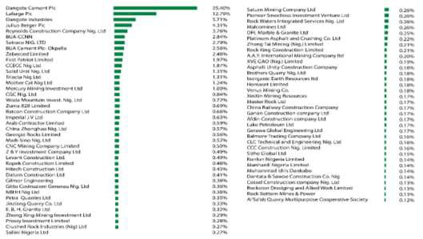
Figure 27: Company Distribution of Royalty

Annual Service and Other Revenue
In the year under review MCO collected the sum of N2,379,520,315 with annual service fee contributing 73.82% which is N1,756,578,500.00. There was a 40.58% increase when compared with 2018 collection.

Table 38: Total Revenue Received By MCO In 2019

S/N | Description | 3 Million & Above Threshold Companies (N) | Other Companies (N) | Total (N) | % Contribution
1 | Annual Service Fees | 317,196,000.00 | 1,439,382,500.00 | 1,756,578,500 | 73.82%
2 | Application Fees | 2,940,000.00 | 223,969,815.00 | 226,909,815 | 9.54%
3 | Transfer Fee | 0 | 161,140,000.00 | 161,140,000 | 6.77%
4 | Assignment | 0 | 95,757,000.00 | 95,757,000 | 4.02%
5 | Renewal of License | 200,000.00 | 80,840,000.00 | 81,040,000 | 3.41%
6 | Late Renewal of License | 0 | 26,752,000.00 | 26,752,000 | 1.12%
7 | Reconnaissance Permit | 0 | 11,757,000.00 | 11,757,000 | 0.49%
8 | Processing Fee | 550,000.00 | 5,450,000.00 | 6,000,000 | 0.25%
9 | Due Diligence Fees | 0 | 2,710,000.00 | 2,710,000 | 0.11%
10 | Search Fees | 0 | 2,000,000.00 | 2,000,000 | 0.08%

11 | Enlargement Fees | 0 | 1,980,000.00 | 1,980,000 | 0.08%
12 | Loss of Certificate | 0.00 | 1,110,000.00 | 1,110,000 | 0.05%
13 | Relinquishment Fees | 50,000.00 | 950,000.00 | 1,000,000 | 0.04%
14 | Certified True Copy | 250,000.00 | 718,000.00 | 968,000 | 0.04%
15 | Conversion | 0 | 750,000.00 | 750,000 | 0.03%
16 | Consolidation Fees | 0 | 550,000.00 | 550,000 | 0.02%
17 | Additional Mineral Fees | 0 | 300,000.00 | 300,000 | 0.01%
18 | Surrender Fees | 20,000.00 | 190,000.00 | 210,000 | 0.01%
19 | Printing of Maps | 0 | 8,000.00 | 8,000 | 0.00%
20 | Cadastral Map Fees | 800,000.00 | 1,200,000.00 | 2,000,000 | 0.08%
 | Total | 322,006,000.00 | 2,057,514,315.00 | 2,379,520,315 | 100.00%
Source: 2019 NEITI SMA Templates& MCO Records

Company Income Tax
Company Income Tax is levied on the profits of incorporated bodies in Nigeria. Prior to the Finance Act 2019, the general applicable CIT rate in Nigeria was 30% of taxable profits; now the act introduced a new progressive CIT rate regime.
The Finance Act 2019, provides for amendments to CITA such that: start-ups and Small Companies (SC) with annual gross turnover less than N25 million are exempted from paying CIT, Medium Size Company (MSC) whose turnover exceeds N25million but is less than N100 million are subject to CIT of 20%, while Large Companies (LC) with annual gross turnover of N100 million and above which are defined by the Act as “Large companies” pay a standard CIT rate of 30%. The total Company Income Tax received from the solid minerals sector in 2019 was N4,557,019,391 as against N10,034,683,377 received in 2018, representing a decrease of 54.57%.
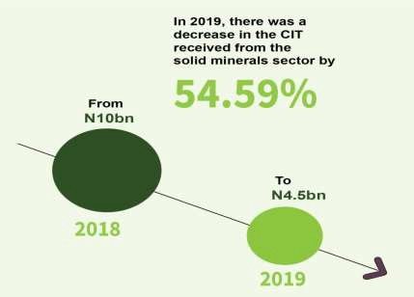

Table 39: Five-year financial flow of CIT

Year | 2015 | 2016 | 2017 | 2018 | 2019
 | N"000 | N"000 | N"000 | N"000 | N"000
Amount | 16,000,000 | 10,580,000 | 2,360,000 | 10,030,000 | 4,557,019
Variance | (5,420,000) |  | (8,220,000) | 7,670,000 | -5,472,981
% Variance | -33.88% |  | -77.69% | 325.00% | -54.57%
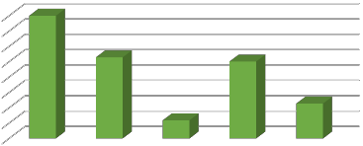Source: 2019 NEITI SMA Templates& NEITI Report
5 year financial flow of CIT
16,000,000
14,000,000
12,000,000
10,000,000
8,000,000
6,000,000
4,000,000
2,000,000
Amount (N'000)

0 | 2015 | 2016 | 2017 | 2018 | 2019
Amount (N'000) | 16,000,000 | 10,580,000 | 2,360,000 | 10,030,000 | 4,557,019

Figure 28: Five- Year Financial Flow of CIT

Value Added Tax

Value Added Tax (VAT) is charged on the supply of goods and services which is eventually borne by the final consumer but collected at each stage of the production and distribution chain.

The standard rate of VAT based on the Finance Act 2019 is 7.5% of invoice value of goods and services except items specifically stated as exempt or zero-rated. However, in the solid minerals sector, exports minerals are exempted from VAT payment. The total VAT paid in 2019 was N41,913,013,072. This represented a 5.90% (N2,334,701,794.64) increase over the
₦39,578,311,277 received in 2018. Details of the companies that paid VAT in 2019 are contained in Appendix 4.

Table 40: Five-year flow of VAT

Year | 2015 | 2016 | 2017 | 2018 | 2019
 | N"000 | N"000 | N"000 | N"000 | N"000
Amount | 32,851,491 | 20,244,511 | 34,024,831 | 39,578,311 | 41,913,013
Variance | (12,606,980) |  | 13,780,320 | 5,553,480 | 2,334,702
% Variance | -38.38% |  | 68.07% | 16.32% | 5.90%
Source: 2019 NEITI SMA Templates& NEITI Reports

0 | 2015 | 2016 | 2017 | 2018 | 2019
Amount (N'000) | 32,851,491 | 20,244,511 | 34,024,831 | 39,578,311 | 41,913,013

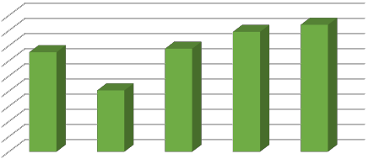Figure 29: Five-Year Flow of VAT
5-year flow of VAT
45,000,000
40,000,000
35,000,000
30,000,000
25,000,000
20,000,000
15,000,000
10,000,000
5,000,000
Amount (N'000)

Withholding Tax (WHT)

Withholding tax is an advance payment of income tax. Payable tax is deducted directly from the invoices of the taxpayer with the main purpose of checking tax evasion. Withholding tax rates are usually 10% or 5% depending on the type of transaction and collecting authority for the tax (which can either be Federal Inland Revenue or the State Board of Internal Revenue Service).

The total withholding tax paid in 2019 was N17,194,837,946 which represented a 39.96% (N4,909,141,416) increase over the N12,285,696,530 received in 2018. Appendix 4 contains details of companies that paid withholding tax in 2019.

Table 41: 5 years flow of WHT

Year | 2015 | 2016 | 2017 | 2018 | 2019
 | N"000 | N"000 | N"000 | N"000 | N"000
Amount | 32,851,491 | 7,175,637 | 10,250,628 | 12,285,697 | 17,194,837
Variance | (25,675,854) |  | 3,074,991 | 2,035,069 | 4,909,140
% Variance | -78.16% |  | 42.85% | 19.85% | 39.96%
Source: 2019 NEITI SMA Templates& NEITI Reports

0 | 2015 | 2016 | 2017 | 2018 | 2019
Amount (N'000) | 32,851,491 | 7,175,637 | 10,250,628 | 12,285,697 | 17,194,837

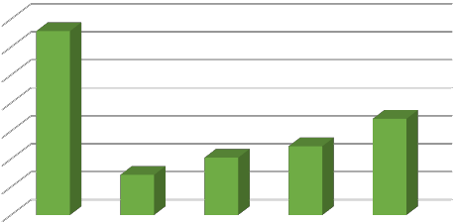Figure 30: Five-Year Flow of WHT
5-year flow of WHT
35,000,000

30,000,000

25,000,000

20,000,000

15,000,000

10,000,000

5,000,000
Amount (N'000)

Education Tax

Promulgated, under the Education Tax Act 7 of 1993 and amended by Act No 40 of 22nd December 1998 and the Finance Act 20198. It is a 2% rate charged on the assessable profits of a registered company in Nigeria. The total Education Tax paid in 2019 was N5,214,490,072, increasing by 37.58% from 2018 receipts of N3,790,263,831.

Table 42 shows a five-year trend analysis of Education Tax paid by the entities from 2015 to 2019. The highest was paid in 2019, while the lowest revenue was recorded in 2016 which is (N2.284billion).

Table 42: Five (5) year flow of EDT

Year | 2015 | 2016 | 2017 | 2018 | 2019
 | N"000 | N"000 | N"000 | N"000 | N"000
Amount | 4,493,119 | 2,284,104 | 2,521,937 | 3,790,264 | 5,214,490
Variance | -2,209,015 |  | 237833 | 1268327 | 1424226
% Variance | -49.16% |  | 10.41% | 50.29% | 37.58%
Source: 2019 NEITI SMA Templates& NEITI Reports

8 https://www.firsov.ng/TaxResources/FinanceAct2019

0 | 2015 | 2016 | 2017 | 2018 | 2019
Amount (N'000) | 4,493,119 | 2,284,104 | 2,521,937 | 3,790,264 | 5,214,490

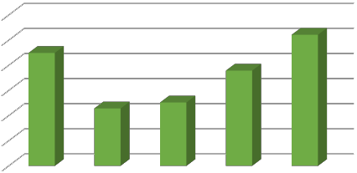Figure 31: Five -year Flow of EDT
5-year flow of EDT
6,000,000

5,000,000

4,000,000

3,000,000

2,000,000

1,000,000
Amount (N'000)

Stamp Duties and Capital Gain Tax
Stamp Duties: Under the Stamp Duty Act (SDA)9, stamp duty is payable on any agreement executed in Nigeria. It also relates to any property situated in or to any matter or thing done in Nigeria. Instruments that are required to be stamped under the Stamp Duties Act must be stamped within 40 days of first execution. In 2019 the total stamp duties paid was N 449,512,295 paid by 3 companies namely Julius Berger Plc, Salini Nigeria Ltd and NBHH Nig Ltd.

Capital Gain Tax: In line with the Capital Gain Tax Act (CGTA)10 all gains accruing to a chargeable person (individual or company) on the disposal of chargeable assets shall be subject to tax at the rate of 10%. All forms of assets, including options, debts, goodwill, and foreign currency, are liable for CGT. The gains on the disposal of shares are exempt from CGT. This is also applicable on the chargeable gains received or brought into Nigeria in respect of assets situated outside Nigeria. In 2019 only Dangote Cement Plc. paid the sum of N589,554,787 as CGT. Table 43 shows the total Stamp duty and Capital Gain paid in 2019.

Table 43: Other Taxes Paid

S/N | Name f Company | Stamp Duty | Capital Gain Tax
1 | Dangote Cement Plc. | - | 589,554,787
2 | Julius Berger Plc | 433,838,052.54 | -
3 | Salini Nigeria Ltd. | 12,128,885.99 | -
4 | NBHH Nig Ltd | 3,545,356.24 | -
 | TOTAL | 449,512,295 | 589,554,787

9 Stamp duty Act https://www.firs.gov.ng/stamp-duty-sd/
10 Capital Gain Tax https://www.wipo.int/edocs/lexdocs/laws/en/ng/ng032en.pdf

Source: 2019 NEITI SMA Templates

Sectorial Distribution of Revenue
A sectorial review of revenue distribution of taxes and royalties by the 74 covered entities shows that manufacturing and construction companies contributed 68.60% and 29.67% respectively in royalty and taxes while quarry, mining companies and buying centres contributed only 1.73% as presented in Table 44:

Table 44: Sectorial distribution of revenue

S/N | SECTOR | Number of Companie | VAT | CIT | EDT | WHT | ROYALTY | TOTAL | %  Contribution
 |  | Number of Companie | N’  million | N’  million | N’  million | N’  million | N’  million | N’  million
1 | Manufacturing11 | 4 | 32,835.38 | 2,428.07 | 3,227.49 | 9,167.05 | 1,090.84 | 48,748.83 | 68.60%
2 | Construction | 24 | 8,671.16 | 2,045.10 | 1,878.25 | 7,950.08 | 538.72 | 21,083.32 | 29.67%
3 | Quarry | 33 | 341.71 | 80.40 | 48.96 | 18.40 | 287.52 | 776.99 | 1.09%
4 | Mining | 11 | 64.37 | 2.96 | 7.59 | 59.30 | 277.24 | 411.46 | 0.58%
5 | Buying Centre | 2 | 0.38 | 0.49 | 2.20 | 0.00 | 36.12 | 39.19 | 0.06%
 | Total | 74 | 41,913.01 | 4,557.02 | 5,164.49 | 17,194.84 | 2,230.43 | 71,059.79 | 100.00%
Source: 2019 NEITI SMA Templates

Sub-National Payments
The subnational payments made by the covered companies are PAYE, ground rent and business premises tax. These payments were made to the various state board of internal revenue services. In 2019, the total reported subnational payment was N5,092,349,020 with PAYE constituting 89.35% of the total amount as presented in Table 45.

Table 45: Sub-National Payments

S/N | Description | % | N
i | Annual surface rents (Grounds Rents) | 10.32% | 525,381,008
ii | Pay As You Earn (PAYE) | 89.35% | 4,549,836,609
iii | Business Premises | 0.34% | 17,131,403
 | Sub Total of payment to States (D) | 100% | 5,092,349,020
Source: 2019 NEITI SMA Templates

11 The manufacturing companies represent Cement companies

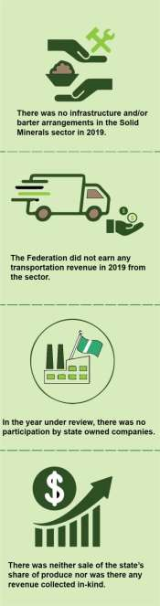Arrangements, which relates to provision of any form of goods and services including loans, grants and infrastructure works in partial or full exchange for oil, gas or mining exploration and production concessions entered between the government and any persons or corporate entities, the IA reviewed the NSWG position as contained in the NSWG materiality document6 and affirmed that there was no infrastructure and/or barter arrangements in the solid minerals sector in 2019.

Transportation Revenue
The IA reviewed the NSWG position on transportation revenue accruing from the solid mineral sector in 2019 as contained in NSWG materiality document12. After extensive interaction with various stakeholders i.e. the companies and staff of MMSD, the IA confirmed that the Federation did not earn any transportation revenue in 2019 from the solid minerals sector.

Transactions with SOEs
The IA’s review of the NSWG materiality document13 and transactions in the solid minerals sector in the year under review and confirmed that there was no participation by state- owned companies in 2019.

4.13.4. Sale of state’s share of production or revenue
collected in-kind.
Non-financial transactions are regarded as in-kind payments. These arise when companies use minerals produced to offset financial obligations such as taxes, royalties, levies, and other liabilities. In 2019, the IA confirmed that there was neither sale of the state’s share of production nor was there any revenue collected in –kind.

Other Revenue
    - Infrastructure and Barter Arrangements
In line with requirement 4.3 of the EITI Standard 2019 on Infrastructure and Barter

12 Appendix 2 2019 NSWG materiality Document

13 Appendix 2 2019 NSWG materiality Document

94

5

REVENUE ALLOCATION



The Federal government of Nigeria in accordance with laws based on fiscal federalism distributes revenue accruing to the Federation account amongst the three tiers of government (federal, state and local). The budgetary process, which includes budget monitoring and implementation, and the distribution of revenue based on the principle of derivation, is highlighted in this section.

The section also reviews the funding mechanism for the Solid Minerals Development Fund (SMDF); the prospects and challenges, and investments in the solid minerals sector.

5.1 The Budgetary System

The National Budget is prepared based on the Medium-Term Expenditure Framework (MTEF) in line with the provisions of the Fiscal Responsibility Act (FRA) 2007 (see: www.budgetoffice.gov.ng/index.php/the-2018-2020-medium-term-expenditure-framework- and-fiscal-strategy-paper).

It is also prepared in line with the National Charter of Account which includes income from the solid minerals sector, thus complying with the International Public Sector Accounting Standards (IPSAS) charter of account. The MTEF is a 3-year transparent planning and budget formulation that helps in the achievement of a purpose-driven budget with a platform for monitoring, evaluation, and performance analysis. The process creates credible models for allocating resources to strategic priorities with a view of ensuring moderate overall fiscal spending that minimize project abandonment.

The MTEF consists of a macroeconomic model that indicates estimates of revenues and expenditures, fiscal targets, risks, as well as government financial obligations. This way, policies, planning, and budgeting are linked over a medium-term.

The budgetary process follows three main stages: ministerial approval, executive approval, and legislative approval before it is generally accepted. However, in more detail, there are seven steps as shown here.

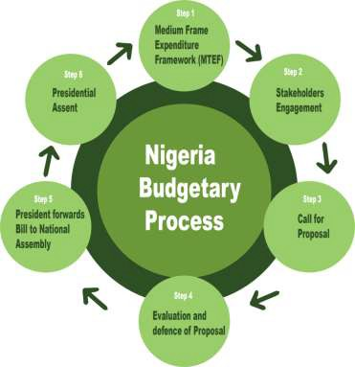
Figure 32: Budget Process

A Budget Monitoring and Evaluation (BME) unit is based at the Nigerian budget office, which is responsible for monitoring revenue and expenditure of MDAs, including statutory transfers and capital projects as detailed in the Appropriation Act. The BME evaluates and reports on the outcomes of government policies and how effective they have been in executing the programs they are planned for (see: About Us (budgetoffice.gov.ng)

5.2 Sub-National Distribution

The 1999 Constitution of the Federal Republic of Nigeria (as amended) established the Federation Account as a pool from which allocations are made to the three tiers of government. All revenue collected by the government, except those from the PAYE of the personnel of the Armed Forces, the Police Force, Foreign Service Officers and Residents of the Federal Capital Territory, Abuja (paid into the CRF) are paid into the Federation Account. Transfers to the federal, state and local governments are made based on two arrangements:

- Statutory Allocation: The Revenue Mobilization Allocation and Fiscal Commission (RMAFC), as tasked by the 1999 Constitution, prescribes the sharing formula of any amount standing to the credit of the Federation Account of Nigeria amongst the three tiers of government.

The RMAFC has a mandate under the Constitution to monitor accruals to and disbursements of revenue from the Federation Account with timely reviews to reflect changing realities. For 2019, the revenue sharing formula is as given in Table 46.

Table 46: Revenue Sharing Formula

S/N | Tier of Government | Applicable Rate
1 | Federal Government | 52.68%
2 | State Government | 26.72%
3 | Local Government | 20.60%
 | 100.00%
Source: RMAFC Record

- 13% Derivation: Section 162 of the 1999 Constitution provides that, as a matter of principle, an amount of not less than 13% accruing to the Federation Account directly from any natural resource shall be paid to the region where it is extracted on the principle of derivation (see: https://www.lawyard.ng/wp-content/uploads/2016/01/ALLOCATION-OF- REVENUE-FEDERATION-ACCOUNT-ETC.-ACT.pdf ). The sharing formula for the period under review is given in Table 47.
Table 47: Distribution of Derivation-based Transfers

S/N | Tier of Government | Applicable Rate
1 | Federal Government | 45.83%
2 | State Government | 23.25%
3 | Local Government | 17.92%
4 | Derivation | 13.00%
 | 100.00%
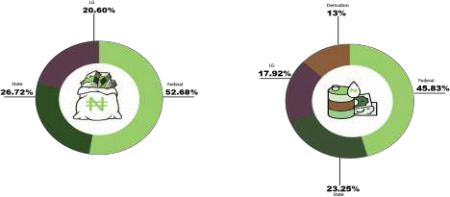Source: RMAFC Record

The revenue distribution account for the solid minerals sector has a closing balance of
₦8,887,109,360.22 as at 31st December 2019 which was distributed in May 2020 amongst the three tiers of government based on the revenue sharing formula. The fund has a closing balance of ₦3,948,064,066.12 as at 31st October 2020.

A reconciliation of the inflow and distribution of revenues as at 31st October 2020 is presented in Tables 48 and 49.

Table 48: Reconciliation of Revenue Distribution Account.

Description Total (₦)
Opening balance as at 1st January 2019 | 12,587,430,492.05
Revenue accrued from January- September 2019 | 4,195,372,560.71
Sub Total | 16,782,803,052.76
Distributed in October 2019 | (8,700,232,009.05)
Balance as at 31st October 2019 | 8,082,571,043.71
Revenue accrued from October- December 2019 | 804,538,316.51
Closing balance as at 31st December 2019 | 8,887,109,360.22
Revenue Accrued from January - May 2020 | 0.00
Sub Total | 8,887,109,360.22
Distributed as at May 2020 | (8,887,109,360.22)
Balance as at 31st May 2020 | 0.00
Revenue accrued from June – October 2020 | 3,948,064,066.12
Closing balance as at 31st October 2020. | 3,948,064,066.12
Source: RMAFC Record

Table 49: Solid Minerals Revenue Distribution

Beneficiary | Total (₦) | % Distribution
Federal Government | 4,073,104,413.54 | 45.83%
State Governments | 2,065,932,990.31 | 23.25%
Local Governments | 1,592,747,739.54 | 17.92%
13% Derivation Share | 1,155,324,216.83 | 13.00%
TOTAL | 8,887,109,360.22 | 100.00%
Source: RMAFC Record

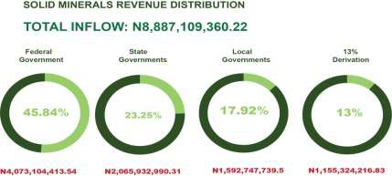

Figure 33: Solid Mineral Revenue Distribution

A total of ₦3,221,257,205.04 inclusive of 13% Derivation was distributed among the 36 states of
the federation and the FCT in May 2020 as presented in Table 50.

Table 9: State and LGA Distribution of Solid Minerals Revenue

S/N | State | Statutory Allocation (N) | Distribution 13% Derivation (N) | Gross Total (N)
1 | ABIA | 51,014,775.95 | 9,165,714.92 | 60,180,490.87
2 | ADAMAWA | 54,270,948.78 | 6,719,838.58 | 60,990,787.36
3 | AKWA IBOM | 54,775,284.44 | 2,705,159.07 | 57,480,443.51
4 | ANAMBRA | 54,169,278.55 | 5,207,403.45 | 59,376,682.00
5 | BAUCHI | 65,167,456.98 | 33,783,017.33 | 98,950,474.31
6 | BAYELSA | 48,205,395.47 | 1,746,621.28 | 49,952,016.75
7 | BENUE | 61,098,701.61 | 30,555,023.26 | 91,653,724.87
8 | BORNO | 67,688,607.29 | 3,566,322.01 | 71,254,929.30
9 | CROSS RIVER | 54,784,625.90 | 59,490,760.34 | 114,275,386.24
10 | DELTA | 55,317,185.57 | 5,742,093.67 | 61,059,279.24
11 | EBONYI | 48,740,623.83 | 39,722,762.67 | 88,463,386.50
12 | EDO | 50,941,763.54 | 43,189,423.07 | 94,131,186.61
13 | EKITI | 48,713,119.78 | 6,142,648.18 | 54,855,767.96
14 | ENUGU | 54,789,354.18 | 4,065,728.99 | 58,855,083.17
15 | GOMBE | 51,316,247.45 | 27,154,164.08 | 78,470,411.53
16 | IMO | 56,644,125.64 | 2,406,077.63 | 59,050,203.27
17 | JIGAWA | 60,926,011.67 | 3,284,475.07 | 64,210,486.74
18 | KADUNA | 71,381,909.00 | 30,796,159.42 | 102,178,068.42
19 | KANO | 86,415,747.79 | 15,544,864.08 | 101,960,611.87
20 | KATSINA | 66,969,745.14 | 6,171,762.76 | 73,141,507.90
21 | KEBBI | 57,527,345.20 | 14,790,195.74 | 72,317,540.94
22 | KOGI | 60,213,763.47 | 179,336,005.61 | 239,549,769.08
23 | KWARA | 48,495,937.86 | 13,768,282.05 | 62,264,219.91
24 | LAGOS | 72,983,705.04 | 25,969,278.42 | 98,952,983.46
25 | NASSARAWA | 50,241,895.83 | 29,695,281.75 | 79,937,177.58
26 | NIGER | 64,533,478.23 | 27,927,149.99 | 92,460,628.22
27 | OGUN | 50,615,042.48 | 251,237,586.29 | 301,852,628.77
28 | ONDO | 50,715,316.55 | 39,357,945.00 | 90,073,261.55
29 | OSUN | 49,687,168.15 | 20,564,792.13 | 70,251,960.28
30 | OYO | 61,105,454.28 | 45,503,922.15 | 106,609,376.43
31 | PLATEAU | 56,891,191.60 | 33,486,281.53 | 90,377,473.13
32 | RIVERS | 58,755,139.14 | 4,468,872.11 | 63,224,011.25

33 | SOKOTO | 60,042,418.25 | 13,904,884.14 | 73,947,302.39
34 | TARABA | 52,479,582.17 | 7,652,456.27 | 60,132,038.44
35 | YOBE | 54,099,712.44 | 3,956,266.18 | 58,055,978.62
36 | ZAMFARA | 54,214,929.04 | 40,247,616.20 | 94,462,545.24
37 | FCT-ABUJA | - | 66,297,381.33 | 66,297,381.33
 | TOTAL | 2,065,932,988.29 | 1,155,324,216.75 | 3,221,257,205.04
Source: RMAFC Record

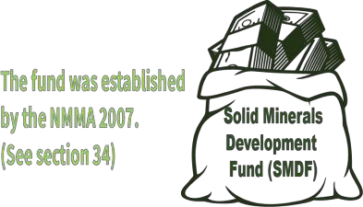

The SMDF was established under statutory provisions of section 34 of the Minerals and Mining Act, 2007 to act as a catalyst to accelerate the development of the Nigerian mining sector, in line with the Nigerian mining industry roadmap of 2016. The fund is to target at sustainable profit-oriented investment and interventions in key areas, and to collaborate with relevant stakeholders in the industry.

The Fund has specific mandates to equip mining institutions for efficient service delivery, fund mining development to support the development of capacity in the solid minerals sector; as well as enable funding for geoscientific data gathering, storage and retrieval to meet the needs of private sector-led mining industry, and to support small-scale and artisanal mining operators.

The Fund consists of the following:
- sums appropriated for solid minerals development under any Federal Law;
- sums appropriated for solid minerals development under the Small and Medium Industries Equity Investment Scheme (SMIEIS);
- funds received as grants, donations, foreign loans, bonds and long-term swaps; and
- sums appropriated to it by the Federal Government’s budgetary allocation.

This Fund is to address the financial gaps across the mining value chain, including geoscience activities, exploration, equipment financing, mines development, production, infrastructure and

capacity building. The SMDF also engages in sensitization projects that enables the public to be aware of its activities.

In June 2020, the Fund launched the Presidential Artisanal Gold Mining Development Initiative (PAGMI) in Kano to develop gold mining, processing and beneficiation14 . Currently, SMDF is developing two (2) other projects under the headings below: 15

- Presidential Salt Initiative (PSI): This involves the development of salt deposits in Ebonyi State to commercial levels in Uburu, Okposi and Enyim sites. The initiative aims to optimize Federal Government revenues through royalties16.

- Presidential Fertilizer Initiative (PFI): This initiative has been a beneficiary of N107 billion in investments from the Nigeria Sovereign Investment Authority (NSIA). The PFI has the objective to positively alter the agricultural and agro-business industry; make high quality fertilizers available to farmers at affordable prices while simultaneously reviving the fertilizer blending industry to help Nigeria achieve food security17.



14 Details of PAGMI see Everything You Need To Know About The Presidential Artisanal Gold Mining Development Initiative (PAGMI) - The Statehouse, Abuja
15See details at Solid Minerals Development Fund (smdf.gov.ng)
16 https://nipc.gov.ng/2019/12/03/fg-approves-salt-development-projects-in-ebonyi/
17 Presidential Fertilizer Initiative (PFI), Farmers To Benefit More-Abubakar – Federal Ministry of Agriculture & Rural Development | FMARD

102

6

SOCIAL EXPENDITURE

Social and Environmental Impact

    - Social Expenditure

Social expenditures are those payments or contributions made by companies to promote development and foster better partnerships with their host communities and can be made in cash or in kind depending on the arrangements or individual agreements in place. Companies in Nigeria carry out social expenditures, which are either mandatory or non-mandatory payments.

Mandatory social expenditures relate to payments that are required in line with section 116 of the Nigerian Minerals and Mining Act, 2007; these are Community Development Agreements (CDA) entered by the companies and the host communities. Basically, these social expenditures incurred by these companies covers the following areas:
      - Amenities and social infrastructure (road, potable water, health centres, etc.)
      - Educational scholarships (primary, secondary and tertiary)
      - Skills acquisition (fashion designing, hairdressing, cobbling etc.)
      - Agricultural support (provisions of seedlings, fertilisers, fishing gears, etc.)

In 2019, the sum of N2.598 billion was spent on 557 projects by 44 extractive companies18 as social expenditure, as detailed in Table 51. These payments were documented and validated by the IA. See appendix 11 for details.

Table 10: Social expenditure

S/N NAME OF COMPANY |  | NO. OF PROJECTS | AMOUNT | % CONTRIBUTION
1 | A.A.Y. International Mining Company ltd | 1 | 88,230,000 | 3.40%
2 | Al'Sa'ab Quarry Multipurpose Cooperative Society | 2 | 2,500,000 | 0.10%
3 | ARAB CONTRACTOR LIMITED | 5 | 30,000,000 | 1.15%
4 | OBU CEMENT PLC- Opella | 4 | 36,169,250 | 1.39%
5 | CCECC NIG LTD | 2 | 2,040,000 | 0.08%
6 | CHINA ZHONGHAO NIG. LTD | 7 | 31,797,000 | 1.22%
7 | CLC Technical and Engineering Nig. Ltd | 9 | 2,337,000 | 0.09%

18 Appendix 11 detail social expenditure

8 | CNC MINING COMPANY LIMITED | 1 | 400,000 | 0.02%
9 | Dangote Cement Plc | 68 | 676,160,336 | 26.03%
10 | Dantata & Sawoe Construction Co. Nig | 5 | 300,000 | 0.01%
11 | Datum Construction Ltd | 1 | 492,000 | 0.02%
12 | FIRST PATRIOT LIMITED | 46 | 603,955,031 | 23.25%
13 | Ganan Construction company Ltd | 1 | 500,000 | 0.02%
14 | Gilmor Engineering | 2 | 2,000,000 | 0.08%
S/N | NAME OF COMPANY | NO. OF PROJECTS | AMOUNT | % CONTRIBUTION
15 | Gitto Costruzioni Generau Nig. Ltd | 6 | 2,526,000 | 0.10%
16 | HITECH CONST. LTD | 12 | 8,310,000 | 0.32%
17 | Inorganic Earth Resources ltd | 1 | 3,500,000 | 0.13%
18 | JINZIANG QUARRY CO. LTD | 1 | 4,200,000 | 0.16%
19 | Julius Berger Plc | 16 | 145,263,103 | 5.59%
20 | KOPEK CONSTRUCTION LIMITED | 15 | 2,245,000 | 0.09%
21 | Kunlun Nigeria Limited | 3 | 3,400,000 | 0.13%
22 | Lafarge Plc | 72 | 613,643,959 | 23.62%
23 | Lake Petroleum Ltd | 10 | 1,050,000 | 0.04%
24 | LEVANT CONSTRUCTION LTD. | 7 | 8,559,297 | 0.33%
25 | Manhardi Nigeria Limited | 4 | 3,350,208 | 0.13%
26 | Mark-Sino Nig. Ltd | 3 | 5,350,000 | 0.21%
27 | MASTER ROCK LTD | 16 | 10,072,450 | 0.39%
28 | MERCURY MINING INVT. | 1 | 400,000 | 0.02%
29 | NBHH NIG LTD | 1 | 500,000 | 0.02%
30 | PLATINUM ASPHALT AND CRUSHING COMPANY LTD | 2 | 769,050 | 0.03%
31 | RATCON CONSTRUCTION COMPANY LIMITED | 2 | 26,400,000 | 1.02%
32 | REYNOLDS CONSTRUCTION COMPANY NIGERIA LTD | 6 | 20,265,302 | 0.78%
33 | Rock Bottom Mines & Power | 4 | 11,350,000 | 0.44%
34 | SALIINI NIGERIA LTD | 1 | 7,560,000 | 0.29%
35 | SETRACO NIG. LTD | 4 | 12,180,000 | 0.47%
36 | SOLID UNIT NIG. LTD | 9 | 134,000,000 | 5.16%
37 | Triacta Nig Ltd | 15 | 22,795,000 | 0.88%
38 | Venus Mining Co. | 15 | 13,510,000 | 0.52%
39 | WODA MOUNTAIN INVEST. NIG. LTD | 1 | 4,000,000 | 0.15%
40 | XinXin Mining Resources | 1 | 1,000,000 | 0.04%
41 | XVE GAO (NIG.) LIMITED | 8 | 770,000 | 0.03%
42 | Zeberced Limited | 21 | 2,326,758 | 0.09%
43 | ZHONG XING MINING INVESTMENT LTD | 6 | 10,740,001 | 0.41%
44 | ZUMA 828 LIMITED | 140 | 41,156,105 | 1.58%
 | TOTAL | 557 | 2,598,072,850 | 100%

Source: 2019 NEITI SMA Templates

Quasi-Fiscal Expenditure
Quasi-fiscal expenditure are expenditures or conditions where SOE(s) undertake public social expenditures outside of the national budgetary process. These may include, among other things payments for social services, public infrastructure, fuel subsidies, and national debt servicing. The IA reviewed the NSWG position on quasi-fiscal expenditure and confirmed that there was no quasi-fiscal expenditure in the solid minerals sector in 2019.

Contribution to the Economy
    - Contribution to GDP

In 2019, data from the National Bureau of Statistics (NBS) showed that the mining and quarrying sector contributed 0.26% to GDP. This was higher than the 0.18% contribution recorded in 2018. Nigeria’s GDP in 2019 was ₦144.210 trillion with contributions from the solid minerals sector totaling ₦368.998billion, representing 0.26% of the total amount.
The contributions of the various solid minerals sub-sectors are presented in Table 52.
Table 11: Contribution of Solid Minerals to the Economy.

MINING AND QUARRYING | 2018 | 2019
 | N ' billion | N ' billion | % Change
1. Coal Mining | 9.78 | 12.91 | 24.21%
2. Metal ores | 10.90 | 11.14 | 2.15%
3 Quarrying and Other Minerals | 204.10 | 344.95 | 40.83%
Total | 224.79 | 368.998 | 39.08%
Source: https://www.nigerianstat.gov.ng

Five-Year Trend
The total contribution of the solid minerals sector over the last five years was N917.02billion as presented in Table 53. There was a steady growth in the contribution of the solid minerals sector to the economy, from 0.12% in 2015 to 0.26% in 2019.

Table 12: Five-Year Trend

Year | 2015 | 2016 | 2017 | 2018 | 2019 | Total
National GDP (N’ billion) | 94,144.96 | 67,980.00 | 113,719.05 | 127,762.55 | 144,210.49 | 547,817.05
Sector contribution (N’ billion) | 109.59 | 87.61 | 126.03 | 224.79 | 368.998 | 917.02
Percentage contribution | 0.12% | 0.13% | 0.11% | 0.18% | 0.26%
Source: NEITI SMA Reports

Contribution to Government Revenues
The total revenue generated by the Federal government in 2019 was N10.215 Trillion19 with the solid minerals sector contribution standing at ₦74.87 billion as given in Table 54.

Table 13: Solid Mineral Revenue Contribution to Government Revenue

S/N Agencies/entities Contribution % Contribution
 | N ' Billion
A | Federal Government Revenue (FGN) 10,215.05 100%
B | Solid Mineral Sector Contribution
I | MMSD-MID&ASM 2.552 0.025%
II | MCO 2.379 0.023%
III | FIRS 69.918 0.66%
IV | Ministry of Environment 0.017 0.0017%
 | Sub Total (B) 74.87 0.73%
 | %Contribution 0.73%
Source: 2019 NEITI SMA Templates

Five-Year Trend Analysis of Contribution to Government Revenues

The total revenue accruing to the federal Government in the last five (5) years from all sectors was N 39.648 trillion with the solid minerals sector contributing N308.43 billion, representing 0.78% as presented in Table 55.

Table 14: Five-Year Trend Analysis of Contribution to Government Revenue

Year | 2015 | 2016 | 2017 | 2018 | 2019 | Total
 | N ' Billion | N ' Billion | N ' Billion | N ' Billion | N ' Billion | N ' Billion
FGN Collected Revenue | 6,959.57 | 5,679.03 | 7,350.00 | 9,444.49 | 10,215.05 | 39,648.14
Sector Mineral Revenue | 69.2 | 41.98 | 52.76 | 69.47 | 75.019 | 308.43
Percentage Contribution | 0.99% | 0.74% | 0.72% | 0.74% | 0.73% | 0.78%
Source: NEITI SMA Reports

19 CBN Economic Report Fourth Quarter 2019 https://www.cbn.gov.ng/Out/2020/RSD/CBN%20ECONOMIC%20REPORT%20FOURTH%20QUARTER%202019%20Fi
nal.pdf

Contribution to Export
The solid minerals sector accounted for N124 billion of the total National exports of N24.275 trillion in 2019, representing 0.51% of total export for the year. The details are given in Table 56.

Table 15: Five Year Trend of Solid Mineral Contribution to Export

Year | 2015 | 2016 | 2017 | 2018 | 2019 | Total
Total Export (N Million) | 134.68 | 8,527.43 | 13,598.28 | 19,099.55 | 24,274.64 | 65,634.58
Sector contribution (N million) | 1.942 | 11.163 | 77.24 | 64.41 | 124.23 | 278.99
Percentage contribution | 1.44% | 0.13% | 0.57% | 0.34% | 0.51% | 0.43%
Source: NEITI SMA Reports

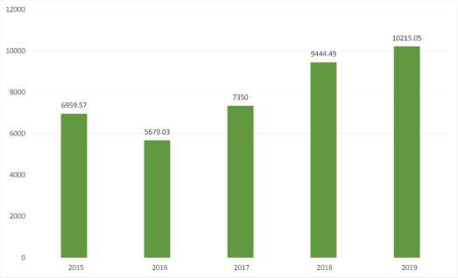
Figure 34: Five-Year Trend of Solid Mineral Contribution to Export

Contribution to Employment
The total number of persons in the labor force in 2019 was estimated to be 80,291,89420. The solid minerals sector accounted for 18,545 employees with 294 reportedly employed in 2019; however, this information is limited to the 74 companies covered in this report.

20https://nigerianstat.gov.ng/elibrary?page=19&offset=180

6.4 Employment Data
The IA received data from 63 of the 74 reporting companies, giving a response rate of 85%. Local employees accounted for 54.9% of total employment in 2019, nationals accounted for 39.9% and the rest (5.1%) were expatriates.

The proportion of male and female employees was 93.2% and 6.8% respectively, with no females employed in 11 of the 63 companies that responded for 2019. Physically challenged employees accounted for only 0.1%.

Table 16: Employment and Gender

S/N |  | Male Female Total
 | Number |  | % | Number | %
Local | 9,406 |  | 92.4% | 776 | 7.6% | 10,182
National | 6,960 |  | 94.0% | 443 | 6.0% | 7,403
Expatriate | 900 |  | 95.2% | 45 | 4.8% | 945
Physically challenged |  | 15 | 100.0% | 0 | 0.0% | 15
Total |  | 17,281 | 93.2% | 1,264 | 6.8% | 18,545
Source: 2019 NEITI SMA Templates

10,000

9,000

8654

8,000
6960
704
900
443
45

7,000
Number of Employees

6,000

5,000

4,000

3,000

2,000

1,000

0
Local National Expatriates

Female Male

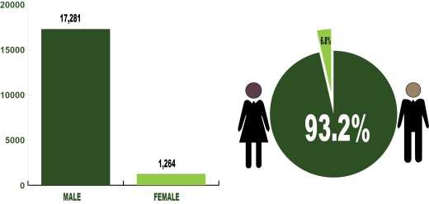
Figure 35: Employment and gender

Institutional Regulation of the Environment

The legal provisions and administrative rules governing environmental management in Nigeria are contained in the Environmental Impact Assessment (EIA) Act (Cap E12 LFN, 2004), National Environmental Standard Regulation and Enforcement Agency (NESREA) Act 2007, and Nigerian Minerals and Mining Act (NMMA), 2007.

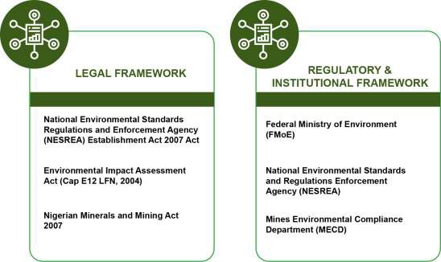
Figure 36: Environmental Legal, Regulatory and Institutional Framework

The environmental management and monitoring by extractive companies is undertaken by each company adhering to its environmental management plan earlier approved at licensing stages.

Companies are to submit monthly reports to NESREA. Companies that failed to comply in submitting monthly returns, and/or are found not to have implemented parts of remediation measures in their environmental management plan are sanctioned as appropriate.

In 2019, the IA observed that compliance with environmental controls by some mining and quarrying companies was low due to poor enforcement, with only a few companies complying with the provisions of the NMMA (2007) and other laws.

A review of the Mineral Act (2007) and the Nigeria Minerals and Mining Regulation (2011) showed the following:
    - No gender protection laws are in force to guard against gender-based inequality, crime, vulnerable rights and labour-influx-based problems.

    - Issues relating to social factors such as child labour protection, age limit for employment in mining, right of host communities and Occupational Health and Safety (OHS) guidelines are omitted in the act.

    - There has been a lingering issue over the management of mineral resources between the Federal and State governments due to the gaps in the Land Use Act, the 2007 Nigerian Minerals and Mining Act and the 1999 Constitution of the Federal Republic of Nigeria (as amended).

Though the 1999 Constitution (as amended) and the 2007 Mining Act gives the Federal Government ownership, power and legislation on solid mineral issues, the State governments claim that they have control over land in compliance with the right given by the Land Use Act to the State Governor. The State carries direct responsibility for degradation and depletion generated by mining activities, and as such it is important for the State Government to be involved in the management and supervision of the State's mining activities.

The 1999 Constitution and the Minerals & Mining Act 2007 bestow the control and ownership of Minerals to the Federal Government

110

Effect of Mining Activities on the Environment

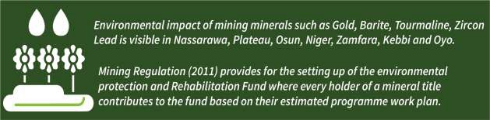

Mineral exploration in Nigeria has been in the hands of artisanal miners whose means of exploration and mining impact severely on the environment.

The potential of solid minerals to the economic development of the country is considerable. However, mining, quarrying and processing activities as well as transporting of mineral products has a great impact on both the environment and health of the miners. There are instances of environmental degradation from the activities of artisanal miners who focus on winning minerals such as gold, barites, tourmaline, zircon, lead, zinc, etc. The environmental impact of these operators is visible in Nasarawa, Plateau, Osun, Niger, Zamfara, Kebbi, and Oyo states.

A review of a recent visit to some communities in Nasarawa State by RMAFC-stakeholders- Committee showed environmental devastation as a result of action of some operators in the sector (see appendix 13 for pictorial evidence of environmental degradation by miners).

The Mineral Act (2007) and mining regulation of 2011 had envisaged the effect of mining activities on the environment by stipulating in section 120 of the Minerals Act (2007) and section 180 of Mining Regulation (2011) that any mining title holder must have in place an environmental protection and rehabilitation program that aims at providing a comprehensive rehabilitation while reclamation of the mining site must be submitted and approved by the ministry. However, a review of the activities of various companies operating in the sector showed that no company has carried out any such programs in recent times as required by law.

The IA identified major channels through which environmental degradation occurs: there are those caused by construction companies wherein they leave behind borrow pits across the various landscapes; abandoned mine sites caused by quarrying and mining activities; and those caused by artisanal and illegal miners.

Section 184 of the Mining Regulation (2011) provides for the setting up of environmental protection and rehabilitation fund, where every holder of a mineral title contributes to the fund based on their estimated programme work plan.

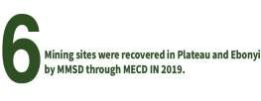

The Ministry of Mines and Steel Development through Mines Environmental Compliance Department (MECD) has in the past 18 years reclaimed 33 abandoned mine sites in Nigeria21 costing N2,394,889,383.22. In 2019, six mining sites were reclaimed in Plateau and Ebonyi states.

6.7 State Mineral Resources and Environmental Management Committee
To protect the environment from harm arising from mining activities in Nigeria, Section 19 (1) of Nigerian Minerals and Mining Act 2007 directed each state of the Federation to set up Mineral Resources and Environmental Management Committee (MREMCO). Consequently, in August 2008, MREMCO was inaugurated in all the 36 States and the Federal Capital Territory, Abuja (FCTA). In 2017, the MMDS through the Mines Environmental Compliance Department (MECD) wrote to each state reminding them of the need to resuscitate MREMCO. As at 2019, MREMCO has been fully functional in 34 States and FCTA while inactive in Bornu and Taraba States. The composition and functions of the committee are as contained in section 19 (2-3) of NMMA, 2007.

6.8 Status of Environmental Protection and Rehabilitation Fund
Notwithstanding the provision of Section 184 of the Mining Regulation (2011) to set up an environmental protection and rehabilitation fund, the fund is yet to kick off due to administrative bureaucracy.

The Mines Environmental Compliance Department (MECD) of the Ministry of Mines and Steel Development that is also saddled with the coordination of the programme is yet to commence sensitization of stakeholders on the fund. However, a TSA Account number for the fund has been opened.

21 Appendix 14 schedule of reclaimed abandoned mine sites in Nigeria

6.9. Environmental Expenditure
The total environmental expenditure reported in 2019 was N17,130,400 covering environmental fees, air quality & waste permits and registration fees for EIA as presented in Table 58.

Table 17: Environmental Expenditure

S/N | Company | Environmental fee (N) | Air quality & waste Permit (N) | Registration fees for EIA (N) | Total (N)
1 | CLC Technical and | - | 290,000 | - | 290,000
 | Engineering Nig. Ltd
2 | Dantata & Sawoe Construction Co. Nig | 4,050,000 | - | - | 4,050,000
3 | FIRST PATRIOT LIMITED | 290,000 | - | - | 290,000
4 | Lafarge Plc | 5,458,400 | - | - | 5,458,400
5 | Mark-Sino Nig. Ltd | 40,000 | - | - | 40,000
6 | Mother Cat Nig Ltd | - | - | 250,000 | 250,000
7 | SOLID UNIT NIG. LTD | - | - | 1,350,000 | 1,350,000
8 | Triacta Nig Ltd | 3,300,000 | - | 1,000,000 | 4,300,000
9 | XinXin Mining Resources | - | - | 1,100,000 | 1,100,000
10 | Zeberced Limited | - | - | 2,000 | 2,000
 |  | 13,138,400 | 290,000 | 3,702,000 | 17,130,400
Source: 2019 NEITI SMA Templates

6.10 Sector Reforms and Emerging Issues
The solid minerals sector in Nigeria is private sector driven with government providing policy direction and regulatory framework towards revamping the sector as a major source of revenue. Government efforts over the years have been towards creating an enabling environment through the systematic removal of identified barriers to sectorial development.

As part of the efforts toward revamping the sector, a multi stakeholder group (MSG) was constituted to develop a coherent strategy to rejuvenate the mining sector. This is summarized as follows:
- to create a globally competitive sector capable of contributing to wealth creation, providing jobs and advancing social and human security;
- making the mining sector a catalyst to drive domestic industrialization as well as competing in global markets;
- Develop a value-chain based growth plan.
A diagram summarizing the road map is presented below:

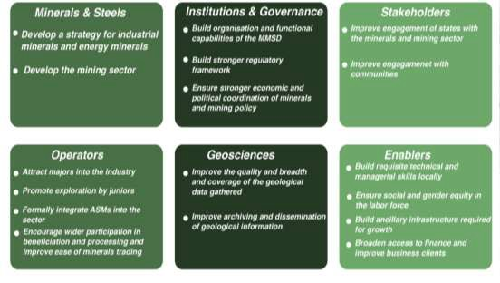
Figure 37: Mining Sector Road Map

To effectively, monitor and coordinate the short, medium and long-term goal of the roadmap, an implementation team tagged Mining Implementation & Strategy Team (MIST) was constituted. To date, the team has made three publications that focused on achieving the roadmap goals. However, the team met last in 2018 due to paucity of funds; hence it has not adequately monitored the implementation of the road map.

Despite identified challenges facing the sector, in 2019 the sector witnessed some significant development as enumerated below:

- To address funding issues facing the sector, the Federal Government provided an intervention fund of N30bn to fund exploration projects that will generate the needed geosciences data and to provide the necessary regulatory framework to enable sectoral growth (MMSD press briefing, 2019)

- The ministry is currently working on Mineral Export Guidelines that will address the lingering issue of evading royalty payment on export minerals. Similarly, independent pre- shipment inspection agents to inspect export minerals at ports.

- In line with the Mining Act (2007), the Minister of Ministry of Mines and Steel Development reduced the royalty rate for exported minerals by 50% to encourage disclosure and for more mineral exporters to obtain permit. This singular gesture has increased the numbers of companies that obtain permits for minerals export by over 100%.

- The government set up a Project Delivery Team (PDT) for the invigoration of the coal sub- sector. This was aimed at using coal as an alternative source of electricity. A Foreign Investment Promotion and Protection Agreement (FIPPA) was signed between the Federal Government of Nigeria and a Canada company to promote investments in the developments of the gold mining value chain, building of an ISO certified standard geochemical laboratory in Nigeria as well as to establish a USD $1bn Nigeria-Canada Solid Minerals Investment Fund.

Similarly, the National Council of Mining and Mineral Resources Development (NCMMRD) held a council meeting in 2019, and came up with the following recommendations towards promoting investment in the sector:
- Decentralise the NGSA laboratories by establishing one in each of the six geopolitical zones to enhance testing of products of local beneficiation and field samples from exploration.

- Establish mining registration points in each geopolitical zones and states so as to minimize apathy, while encouraging prospective informal miners to register.
- Increase synergy between federal, states, local governments and community leaders on information sharing to reduce conflicts on minefields, enhance security and in the implementation of CDAs.

- Construct basic infrastructure on the mines-field such as railway and roads, and health centers. Furthermore, encourage BOI and PPP infrastructural development for mine-fields.

- Enforcement and implementation of the law on land reclamation through close collaborate between MMSD and FMEnv to see to the urgent implementation of section 121 of NMMA 2007.

- In order to strengthen and improve mining operations the Nigerian Institute of Mining and Geo-sciences, Jos was established for manpower training of artisanal miners and other operators on mineral mining and beneficiation.

There are other ongoing initiatives and projects initiated by the ministry as contained in Table 59.

Table 18: Summary of on-going projects in the sector

S/N Project/Initiative Description Status

  - Gold Mining Development Expression of interest between the
Federal Government and Messrs La Mancha Incorporated to invest in gold mining in Nigeria
On going

  - Mapping of ASM and Buying Centre

  - Procurement of Airborne Geophysical Survey

  - Integrated Automated and Interactive Solid Mineral Portal (IAISMP).
This project is the comprehensive mapping of ASM sites and trading centres including existing initiatives (registered co-operatives) through the establishment of remote sensing monitoring system.22
Procurement of Airborne Geophysical Survey of selected areas under proof of concept programme; including High resolution magnetic & Radiometric equipment for identified areas. (TLM50). Scanning and digitization of licensing documents for E-recording and archiving of the Mining Cadastral Office.
On going

On going

On going

  - Development of geoscience data Bank for mineral exploration
The Federal Government has earmarked N15 billion for exploration of minerals in Nigeria through the generation of detailed geoscience data of quality and quantity of available minerals in the country.
On going

The project is domiciled in the Nigerian Geological Survey Agency (NGSA) and it is being supervised by the MMSD. It is also funded through the Natural Resources Development Fund.23

22 MinDiver Engages Firm to Develop the ASM Sub-Sector – Ministry of Mines and Steel Development

23 FG Invests N15bn on Geo-Science Data Bank – Ministry of Mines and Steel Development

6
Development of jewelry and
gemstone industry
Ministry of Mines and Steel
Development has entered into agreement with the Gemological Institute of Nigeria (GIN) to design and implement a strategy for the development of jewelries and gemstones in Nigeria.
MoU- ongoing
7
Automation of E-Collection
Automation of royalty payments and
documentation across the country
Pilot stage in 8
states

i). Revitalization of Ajaokuta Iron and Steel Project

Ajaokuta Steel Company Limited (ASCL) is Nigeria’s leading steel company. Guided by a philosophy to produce safe, sustainable steel, it is the leading supplier of quality steel products in all the major economic sectors including construction, packaging and wire drawing/nail making industry. ASCL once operated in all the major markets in Nigeria and employed about 3000 people. The plant has a 68km road network and is meant to accommodate 24 housing estates, a seaport and a 110mw power generation plant. It was designed to produce as much as 5 million metric tons of steel per annum.

ASCL was designed to be fed by Itakpe iron ore having an average Fe content of 34%. As a result of the low grade iron content of Itakpe iron ore, the National Iron Ore Mining Company (NIOMCO) was built and designed to process iron ore from NIOMCO to a grade suitable for Ajaokuta and Aladja steel plants. At present, however, the dilapidated ASCL has failed to produce the desired steel products despite government investment and multiple ownership changes over the years.
In September 2019, a consensus to revive the Ajaokuta iron and steel project was reached during a meeting between Nigeria and Russia with a view to signing a bilateral agreement that would culminate in the overall resuscitation of the moribund industrial complex after forty years of its initial conception. Consequently, a Memorandum of Understanding (MoU) with a Russian firm was signed in January, 2020 towards its revitalization. However, the outbreak of COVID-19 pandemic has retarded the progress of this agreement.

118

7

OUTCOMES
& IMPACTS

OUTCOMES AND IMPACTS

The EITI process aims to ensure transparency and accountability in the management of revenues from natural resources in member countries. This has, to a commendable extent; ensured judicious use of these resources for adequate development in the countries including Nigeria.

With the details of revenue from natural resources made available through its annual audit reports, NEITI has promoted accountability and improvement in government operations in the extractive sector. This has given key stakeholders and interest groups awareness and unrestricted access to relevant information, and an opportunity to hold government and companies to account.

Independent Administrator’s Findings

This section reviews the prior year’s findings and remediation issues, and key findings from the
current year audit, as well as its recommendations.

Prior Year Findings

The IA reviewed the status of the recommendations and remediation efforts from prior years’
audits. Table 60 sets out the status of prior years’ recommendations.

Table 19: Status of Prior Years’ Audit Recommendations

S/N | Issue | Findings | Recommendation |  | Status Updated
Royalty & Tax Issues
1 | Unauthorized operations | 302 companies (i.e., 42% of companies that paid royalty in 2018) but whose names/title are not found on the MCO register (in spite of the fact they paid royalty in 2018). | • | MID and MCO must collaborate, essentially to ensure only duly authorized individuals operate in the sector. | MID and MCO are in good collaboration in terms of information sharing related to mineral title holders.  It is pertinent to note

2 | however, that royalties are not only  - Going forward, royalty paid by mineral title payment should be holders but by based on valid titles. holders of Licence to  MID and MCO should purchase and process collaborate more to minerals and Mineral ensure royalty Buying Centres payment is tied to certificate holders valid titles. The who may not  State’s mines officers necessarily have are required to ensure mineral titles. compliance by royalty  payers.  - MCO should be periodically furnished.
2 | Issuance of IA noted that cash received • MID’s head office There is no cash treasury receipt from operators in some internal audit collection as payment of advance of states were not lodged on procedure should be is through Treasury payment time. Examples are shown strengthened to carry Single Account  in the inserted table below out oversight function (Remita) system.  to state’s mine offices  more effectively. Automation of royalty  collection has  - Work on automation commenced in about of government 8 States and the other revenue collection States are in the process should be processes of accelerated to automation.  minimize access to cash at all times.
2 |  | Company | Date on MID receipt | Receipt no | Amount received | Date of lodged in the bank
2 |  | Modakeke (Aanu Oluwapo Sand Gravel Women in Mining | 12/12/2018 | Z009456839 | 5,000 | 07/01/2019
2 |  | Opa, Ile-Ife Ifesowapo Sand & Quarry Women in Mining | 12/12/2018 | Z009456841 | 5,000 | 07/01/2019
2 |  | Ademog Nig. Ltd | 17/12/2018 | Z009456843 | 7,000 | 07/01/2019
2 |  | United Quarriable Associates Osun State | 28/12/2018 | Z009456844 | 50,000 | 16/01/2019

3

4

5
3  4  5 | Misstatement of government revenue/ receipts | IA noted that transaction charges, (otherwise referred to as remita charge of ₦157 per transaction under TSA) were recorded by some states’ Mine Offices as part of government revenue, which is misleading as government revenue. | MID to carry out capacity building and regularly conduct walk-through exercises to ensure receipts are issued in the form that is ethically acceptable. | Zonal/Federal Mines Officers have been informed to bring the issue to the notice of their respective Account officers.
3  4  5 | Titleholders that did not Pay Royalty in 2018 | A total of 1,801 holders of valid title did not make any royalty payment in 2018.  The IA also noted that out of the 291 titles held by the 69 reporting  companies, 143 or 49% of the titles were inactive during the reporting period. | - MMSD should constitute a task-force to review the status of these titles. Additionally, independent consultants with requisite experience should be engaged to unearth the causes and proffer  recommendations.  - MCO and MID to collaborate to ensure implementation of use it or lose it rule.  - Punitive levy  (minimum royalty) should be imposed on holders of inactive titles so as to discourage the speculative acquisition of titles. | MID and MCO are in collaboration to ensure that inactive mineral titles are revoked.  It is worthy to note that punitive levy (minimum royalty) can not apply because by law royalty is paid on mineral used or sold only. However, the payment of incremental annual service charge serves as deterrent.
3  4  5 | Delay in the issuance of payment receipt to operators | IA observed that some state mine officers unduly delay issuance of payment receipt to operators; e.g., Zuma 828 Coal Ltd was only issued receipts in 2019 even though the company made a payment since 2018. | - MMSD is encouraged to step up in its control functions over out- stations.  - There should be monthly reconciliation of all bank accounts. | The automation of royalty payment has eliminated delay in receipt issuance. The issuance of receipts is by the State Accountant Officers and not the Zonal/Federal Mines Officers.

6 |  | The need for proper reporting/ classification of government’s receipts |  | IA noted that withholding tax (WHT) receipts by the government have been erroneously classified as revenue in the past.  WHT is an advance tax which a taxpayer may utilize as tax credit when finally assessed to tax. | - Discontinue classification and disclosure of WHT as revenue to  government;  - If the inclusion of WHT in the flows is to be sustained, the word ‘REVENUE’ in EITI requirement number 4 (revenue collection) and 5 (revenue allocation) should be replaced with the word ‘RECEIPT’.
Export Issues
7 |  | Non-payment of  royalty by some minerals exporting companies |  | Out of 66 companies that engaged in export of solid minerals in 2018, there was no evidence that 30 (45%) paid royalty on minerals exported | - NCS should ensure that all exporters have duly issued export permits from MMSD.  - MMSD should follow up with the companies listed in appendix 25 to ensure compliance with extant regulation and recovery of unpaid revenues.  - Defaulters should be penalised accordingly to serve as a deterrent. | There is more collaboration with NCS to ensure that royalty is paid on minerals exported.
8 |  | Under declaration by mineral exporting companies |  | Two exporters, Xinye Mining Resources African Limited and Tongyi Allied Mining Ltd), as inserted below, understated production and royalty payable to Government in 2018. | - MMSD should investigate and ensure recovery of  underpayments;  - Any company discovered to have continued to indulge in the practice of evasion should be sanctioned according to applicable section of the Act. | The issue of under- payment is always been investigated and Demand notice is always issued to companies to pay any outstanding royalty.
 | Company |  | Declaration (volume) |  | Declaration (Royalty)

 |  |  | Export (ton) |  | Declaration (ton) | Difference (ton) | Royalty due NGN | Royalty paid NGN | Difference NGN
 | Xinye Mining Resources African Ltd |  | 6,722.80 |  | 553.70 | 6,169.10 | 9,075,780.00 | 747,500.00 | 8,328,280.00
 | Tongyi Allied Mining Limited |  | 3,124.20 |  | 1,926.00 | 1,198.20 | 6,309,360.00 | 3,202,200.00 | 3,107,160.00
 |  |  | 9,847.00 |  | 2,479.70 | 7,367.30 | 15,385,140.00 | 3,949,700.00 | 11,435,440.00
9 |  | Lukewarm approach to addressing identified remedial actions |  | A review of some of the keys findings in the previous audits revealed that required oversight on the implementation of IA recommendations is inadequate.  For example, in 2016, liability was established against some companies, yet there was no evidence that action had been taken to address the issues raised against such companies. |  |  | - Furtherance to IA  recommendation, MID Effort is being made and/or MCO should to recover any unpaid take proactive royalty due to under- measures on time to declaration of  seek redress of any production. anomaly reported in  the SMA report.  - MID to institute procedure to ensure recovery of royalty due in respect of under- declaration by Tongyi Allied Mining Limited and any other companies.
10 |  | Funding of the SMDF to attain its full potentials |  | The Solid Mineral Development Fund (the Fund) is established by the NMMA 2007.  However, the SMDF is yet to attain its full operation due to the paucity of funds. |  |  | - Federal  Government should ensure the SMDF is given required attention, including funding.  - The SMDF should follow up on the N127,162,591.04 being the amount due for the development of natural resources from FGN share of solid minerals revenue (distribution by the 3 tiers of government in

October, 2019).

11 Assessment to Royalty Payment based on Operators’ Self declaration

Contrary to the relevant section of the Act, IA confirmed that the Fund is yet to benefit from 1.68% (i.e. 3.19%
Development of Natural Resource) out of FGN share of Solid IA also notice that the N30billion intervention received from FGN, except it is not applicable under section 38 (b) of the Act, did not pass.

The common practice in the industry has been royalty payment based on self- assessment/declaration.

IA review revealed a wide disparity between declared production figures for royalty payment and potential production.

Taking the purchase and use of explosives as a major factor that determines production volume, we noted that a number of companies who did not meet the materiality threshold use as many explosives as those companies that met materiality.
- The SMDF should carry out back duty
investigation to ascertain the total amount due to the SMDF from FGN distribution of 1.68% and be remitted to it without further delay.

- Out of N30billion intervention received by the Ministry from FGN, proportionate amount should be transferred to the Fund.
- MID to carry out back duty investigation to uncover production under reporting and recover the resulting royalty under payments accordingly and, erring companies should be sanctioned in line with the extant provisions

- MID should complement self-
declaration with regular spot checks to validate
companies’ returns.

- MID encouraged to carry out audit of use of explosive at all times

There has been increase in monitoring of mining sites to check production figures and to ensure that royalty payment are commensurate with the actual production.

Explosives usage is been checked on monthly basis by the department using the powder factor effect for hard rock minerals

More worrisome is the fact that some of the companies appear to spend more on blasting

 | permits yet.
Nigeria’s Strategic Minerals
12 | Lack of activity in some of the nation’s strategic minerals | The strategic minerals that have remained largely untapped are; bitumen, barite and gold.  a) Bitumen  Nigeria’s bitumen deposit is estimated at 37 billion barrels.  Bitumen is an essential component in the building (manufacture of asbestos and water-proofing materials) and construction (production of asphalt for road building) sector.  Despite the abundant deposit yet Nigeria depends on importation to meet its bitumen requirement.  IA review revealed that bitumen has attracted very little attention over the years. | •  • | Deliberate efforts by government to encourage exploratory and mining activities on our bitumen to meet local  requirements and discourage importation.  Strategies to phase out importation of bitumen for forex conservation. | Government is intensifying effort to explore for Bitumen to encourage investors into Bitumen mining.
12 | Lack of activity in some of the nation’s strategic minerals | b) Barite | • | IA reiterate a | There is exploratory
12 | Lack of activity in some of the nation’s strategic minerals | Nigeria’s barite | • | IA reiterate a | There is exploratory
12 | Lack of activity in some of the nation’s strategic minerals | endowment is estimated |  | deliberate government | activities on barite by
12 | Lack of activity in some of the nation’s strategic minerals | at 15 million metric tons. |  | policy aimed at | National Integrated
12 | Lack of activity in some of the nation’s strategic minerals |  |  | encouraging | Mineral Exploration
12 | Lack of activity in some of the nation’s strategic minerals | Barite is a key material |  | exploratory and | Project (NIMEP) to
12 | Lack of activity in some of the nation’s strategic minerals | input in the oil and gas |  | mining activities on | boost barite mining
12 | Lack of activity in some of the nation’s strategic minerals | industry (for drilling |  | our barite and of great | activities
12 | Lack of activity in some of the nation’s strategic minerals | and exploration activities), |  | importance to ban or | activities
12 | Lack of activity in some of the nation’s strategic minerals | besides other uses. |  | discourage | activities
12 | Lack of activity in some of the nation’s strategic minerals |  |  | importation of barite. | activities
12 | Lack of activity in some of the nation’s strategic minerals | It is estimated that over |  |  | activities
12 | Lack of activity in some of the nation’s strategic minerals | ₦5billion is expended in | • | Strategies to phase out | activities
12 | Lack of activity in some of the nation’s strategic minerals | the importation of barite | • | importation of barite | activities
12 | Lack of activity in some of the nation’s strategic minerals | on annual basis despite | • | for forex conservation | activities
12 | Lack of activity in some of the nation’s strategic minerals | the local availability of the | • | . | activities
12 | Lack of activity in some of the nation’s strategic minerals | mineral. | • | . | activities

c) Gold
Gold has potential to attract foreign exchange for Nigeria. Unfortunately, the mineral has not received the attention it deserves in form of investments.

This has been left at artisanal operation and mostly smuggled out of the country.

IA review revealed that the mineral has received sustained interest in the past two years, evidenced as shown on the table.
However, this has not reflected in production volumes or royalty payments.

Government should expedite action on the proposed national gold policy so as to arrest further revenue loss and return sanity to the gold mining environment to make it attractive to world class investors.

Government to also step up strong measures to rid the gold mining environment of unauthorized miners whose activities pose security threat.

Increased monitoring of holders of gold titles, including their banking activities so as to detect under reporting for prompt action.

MID, collaborating with MCO is encouraged to pay closer attention to activities of gold title holders and or activities in identified gold corridors.
The Ministry has encouraged gold mining through:
- Exploratory activities on gold by National Integrated Mineral Exploration Project (NIMEP) to boost gold mining activities.
- Licensing of two
(2) gold refineries with one at advanced stage of construction.
- Facilitating Thor Exploration Limited, world class Segilola gold project in Osun State to an advanced stage of development. Mining is to commence in 1st quarter of 2021.
- Facilitating further incentives for gold miners through the Federal Ministry of Finance.

Current Finding and Recommendations

The findings and recommendations from the 2019 audit are set out in Table 61.

Table 20: Findings and Recommendations from the 2019 Audit

S/N | Issue | Findings | Implications | Recommendations
Royalty Issues
1 | Under Payment of Royalty | - There was no evidence of royalty payments by 25 Companies that exported minerals in 2019.The Royalty payable by these companies is N 482,005,247.55. (See Table 24 and Appendix 12 for details) | - The implication of this is loss of revenue to government | - The MMSD should ensure the recovery of all outstanding royalty payment of the 25 companies.  - MMSD should automate the online verification process of all submitted permits for export and payment of royalties. This will reduce the incidences of tax evasion and non-payment of royalty.  - Inter-agency collaboration should be increased, most especially between NCS and MMSD, to mitigate this loss.  - The MMSD should consider having its representatives at the export terminal/borders to validate the export clearance permit presented by exporters and confirm whether the applicable royalty has been paid.
 | - Taxes and Other Related maters
2 | Non payment of taxes | - The companies listed below did not pay VAT, EDT and CIT:  - A.A.Y. International Mining Company ltd  - Afdin Const. Co  - Al'Sa'ab Quarry Multipurpose Cooperative Society  - First Patriot Limited  - Prossy Investment Limited  - Kunlun Nigeria Limited  - Rock Waters Integrated Services Nig. Limited | - Non-payment of taxes contravenes section 235 of CITA (2017) and reduces government revenue.  - These companies did not provide their AFS which made it impossible to calculate their liabilities. | - The FIRS should carry out a comprehensive tax audit to recover all unpaid taxes by these companies.

S/N | Name | No of TIN
1 | Arab Contractors | 3
2 | CCECC Nig. Ltd. | 3
3 | China Zhonghao | 2
4 | CLC Tech Limited | 4
5 | CGC Nig. Limited | 2

3 | Companies with Multiple Tax Identification Numbers (TIN) | - The IA uncovered 6 companies which had multiple TINs. This resulted in different tax clearances and various related payments in each TIN for these companies  . | - The duplication of TINs by companies can make Monitoring and tracking of payments due by companies difficult.  - It may lead to tax evasion and an avenue for revenue loss to the government. | - A comprehensive tax audit should be carried out on these companies by the respective tax offices to achieve a single TIN for each company.  - The MMSD and the FIRS need to work closely to achieve synergy in tax payments from the sector.
 | Licence and Documentation
4 | Non- Regularization of Transfer of mineral title. | - The audit revealed that Inorganic Earth Resources Limited, the holder of title No. Qls 8630, was acquired by Tigong Investment Limited in 2016. However, the company failed to regularize the transfer title with MCO and MMSD.  - The company paid royalty and other fees using Inorganic Earth Resources Limited's name and paid its taxes using the name of Tigong Investment Limited. | - It has made reconciliation quite tricky and thus shows the inefficiencies in the monitoring of companies’ activities. The non-payment of the applicable fees for the transfer is a loss of revenue to the government | - The company should accelerate the process of regularizing the transfer with MCO and MMSD  - The Company should also be made to pay the applicable transfer fees with penalty.  - The MCO and MMSD should ensure the immediate regularization of the transfer. The company should pay the applicable transfer fee and the possible penalty for non- payment, as stated in the guidelines for the transfer of titles.
 | Control and Policy Issues
5 | Lack of Effective Monitoring and Supervision. | - The audit came across incidences of illegal mining activities, some of the observed locations include Ribi Village, Azara, Ugya in Toto LGA, Obo LGA in Nasarawa State and Kutulku in Wushishi LGA, Igade/Kati in Mashebu LGA of Niger State.  - The minerals involved in these activities are Barites, Gold, lead/zinc, magnesium | - The activities of these operators have a far- reaching consequence on the environment, health, and economy of the nation.  - The activity of the buying centre (open market) contravenes section 94, of the Mining Act (2007). These activities lead to smuggling of minerals which | - MMSD should investigate the activities of buying center, and activities of artisanal miners with a view to enforcing full compliance with Government Regulations.  - Government should make mineral buying centres more effective in buying products from artisanal miners to curtail smuggling of such products.

 |  | and gemstones.  - The IA also discovered an open market named Strabag Precious stone International market in Ojoor Ibadan, where Gold and Gemstone are traded. | distorts the  production records of the sector. All of this has led to environmental degradation and loss of revenue to the Government
6 | Access to Funds in the Sector | - From the interactions with the major players in the sector, the IA observed that credit facilities provided by the government to the industry were challenging to access, this is due to the stringent conditions attached such as collateral and other requirements and this makes it difficult for most of the players in the sector to access. | - The growth of small- scale mining companies is impeded by the inability to access capital. It has led some to raise funds from other sources, which affects their sustainability due to the high- interest rates. | - The government should make access to credit facilities easier, which will accelerate the sector's development rate. The government can also allow the use of minerals titles certificates as a guarantee for getting a loan, while there should be the establishment of solid minerals development bank as obtained in the Agricultural sector.  - The government should adequately support and strengthen the SMDF to enable it to fund the sector
7 | Non- implementation of the Environmental Protection and Rehabilitation Fund (EPRH) | - The IA observed that the environmental protection and rehabilitation fund is yet to commence operation in line with section 121(4) of the Minerals and Mining Act (2007) and Section 184 of the Mining Regulation (2011). | - The non-contribution by extractive companies to the Fund directly impacts the realization and achievement of the Fund’s objectives of saving money for the mine reclamation after mining has stopped. | - MMSD should kick start the process of sensitizing the stakeholders; appoint the Board of Trustees for the Fund to enable them to select the fund manager
Production and Export Related Issues
8 | Non- Standardization of Mineral Classification. | - The audit observed discrepancies in the record of Nigeria Customs Service, Central Bank of Nigeria, and the Ministry of Mines and Steel Development, which was due to the customs' misclassification of solid minerals. Some of these items are lead oxide, aluminium ingot, lead ingot, limestone flux etc | - This difference reveals lack of coordination between MMSD and NCS. Similarly, it indicates that some of the exporting companies do not obtain the perquisite export permit from MMSD.  - This could lead to distortion in available data for national planning, and revenue | - This difference reveals a lack of coordination between MMSD and NCS. Similarly, it indicates that some of the exporting companies do not obtain a permit from MMSD.  - There is the potentiality of revenue loss - as companies declare different records for different purposes.  - This could lead to over bloating of export volume. It could also lead to the concealing of contraband minerals.

classification.
- There is potentiality of revenue loss - as companies declare different records for different purposes.
- This could lead to over bloating of export volume. It could also lead to the concealing of contraband minerals.
9 | Development of Strategic Minerals | - Limestone and granite aggregates formed the bulk of minerals produced, with about 42.3 million tonnes produced, however with a combined royalty payment of N1.73billion, this represents 68.17% of production and 23.0% of total revenue from the sector.  - However, lead/zinc and columbite with a combined production of 25,546t contributed the most revenue in the sector with 36.05% and 25.93%, respectively.  - There has been a slow pace in the development of metallic minerals and the seven strategic minerals. Except for gold that has received massive government focus, they are yet to receive such considering their industrial growth input. | - This poses as a potential loss of future revenue to the Government by not encouraging/ promoting the specialization into the aforementioned minerals. | - The Government, through MMSD, should promote investment in strategic and metallic minerals. Also, a focus on beneficiation of lead/zinc, columbite and other strategic minerals as they pose to bring more revenue to the government due to their global pricing.

